**Common laboratory diets differentially influence zebrafish gut microbiome’s successional development and sensitivity to pathogen exposure**

Michael Sieler, Colleen Al-Samarrie, Kristin Kasschau, Michael Kent, Thomas J. Sharpton

**Abstract**

Despite the long-established importance of zebrafish as a model organism and their increasing use in microbiome-targeted studies, relatively little is known about how husbandry practices involving diet impact the zebrafish gut microbiome. Given, the microbiome’s important role in mediating host physiology and the potential for diet to drive variation in microbiome composition, we sought to clarify how three different dietary formulations that are commonly used in zebrafish facilities impacts the gut microbiome. We reared approximately 60 fish on each diet throughout their lifespan and compared the composition of their microbiomes at both 4- and 7-months-old. Our analysis finds that diet has a substantial impact on the composition of the gut microbiome at both 4- and 7-months-old. Moreover, the developmental dynamics of the microbiome differ as a function of diet. We further evaluated whether the 7-month-old fish microbiome compositions that result from dietary variation are differentially sensitive to infection by a common laboratory pathogen: *Mycobacterium chelonae*. Our analysis finds that the impact of *M. chelonae* infection on the gut microbiome differs as a function of diet, especially for moderate and low abundance taxa. Overall, our results indicate that diet drives the successional development of the gut microbiome as well as its sensitivity to exogenous exposure. Consequently, investigators should carefully consider the role of diet in their microbiome zebrafish investigations, especially when integrating results across studies that vary by diet.

**Introduction**

The gut microbiome plays an important role in supporting the health of its host through nutrient metabolism, supporting the immune system, and protecting against pathogens. To better understand the gut microbiome, zebrafish (*Danio rerio*) have emerged as an important model organism due to their extensive homology to early human development, high-throughput experimental methods and ability to directly manipulate their gut microbiomes1. Despite zebrafish’s their increasing use in microbiome-targeted studies, key knowledge gaps remain about how diet influences their microbiome and their health2. In contrast to mice, zebrafish do not have a standard reference diet3. Instead, zebrafish are fed a variety of diets, which impact zebrafish physiological and reproductive outcomes4–6. Moreover, diet has been linked to shaping the gut microbiome as well as a variety of health outcomes in other systems, such as humans and mice (citation). In zebrafish, diet’s impact on the microbiome has been investigated, but these diets differ vastly in nutritional content from diets commonly used in zebrafish laboratory studies7–9. Given the role of the microbiome supporting host health and diet’s influence on the gut microbiome, common zebrafish diets may have differentially impact their gut microbiomes and consequently their health.

Zebrafish have a core microbiome, but there is much inter-individual variation that could be explained by diet10,11. Early in life, larval zebrafish are often fed a live feed diet, consisting of rotifers, ciliates, and artemia12. In addition to microbes found in the surrounding tank water, these live organisms are believed to be contributors of microbiome assembly in young zebrafish13,14. As zebrafish transition from larval to juvenile and adult life stages, they also transition through a variety of live and dry food diets to support their growth5,12. At 3 months of age, zebrafish are considered adults and are fed exclusively dry food diets3. Here, we chose three diets as representative of the variety of commonly used dry food diets across zebrafish facilities. These diets will subsequently be referred to as the Gemma (a commercial diet), Watts (a laboratory, defined diet), and ZIRC (combination of multiple commercial diets) diets. While these diets are relatively similar in nutritional content, they differ in ingredients are used, ingredient sources, methods of production and exact nutritional content (see methods and materials). These factors can be an inadvertent contributors nonprotocol induced variation, intestinal inflammation, and microbial transmission2,15. Given, that the microbiome mediates host health and is relatively stable once established, any diet-related influences to early-life microbiome assembly could have lasting impacts to the successional development of the gut microbiome and consequently health of the zebrafish, for instance sensitivity to pathogens16.

Zebrafish facilities are known to host many pathogens, which can introduce inconsistencies in study outcomes17. *Mycobacterium chelonae* is a common intestinal pathogen found in 40% of zebrafish facilities, and is hypothesized to be introduced through diet early in life17–19. *M. chelonae* forms granulomas in the gut intestine, which can cause gut inflammation, decreased fecundity and lifespan17. Previous work of ours has shown that an intestinal parasite *Pseudocapillaria tomentosa* disrupts and restructures the gut microbiome20. However, little is known about the effects of *M. chelonae* infection on zebrafish gut microbiomes. Some studies suggest that having a diverse microbiome can protect against pathogen infection21,22, while others show diverse or highly varied microbiomes could be indicative of pathogensis20,23. Given the influence of diet on the gut microbiome, there could be an interaction between diet, pathogenesis and the gut microbiome in zebrafish. Elucidating these relationships could offer microbiome-targeted tools for diagnosing, preventing, or mitigating the impacts of *M. chelonae* and other intestinal pathogens on zebrafish and other host organisms.

In this study we show how three different dietary formulations that are commonly used in zebrafish facilities impacts the gut microbiome. Zebrafish manifest distinct gut microbiomes at 4 months of age, which persist across their development at 7 months old. Additionally, we show that the gut microbiomes of some diets are more stable to the effects of development, while others are more impacted by diet. Moreover, we find that gut microbiome diversity may be linked to body mass of zebrafish fed certain diets. Furthermore, we show that gut microbiomes of fish fed different diets vary in their sensitivity to pathogen exposure of *M. chelonae*, but diet’s overall impact is more substantial. Collectively, our study clarifies the role of diet on successional development of adult zebrafish gut microbiomes, and the microbiome’s sensitivity to pathogen exposure. Consequently, investigators should carefully consider the role of diet in their microbiome zebrafish investigations, especially when integrating results across studies that vary by diet. Moreover, microbiome zebrafish research may benefit from applying consistent husbandry choices involving diet.

**Results**

**1. Experimental design and data collection**

|  |
| --- |
|  |
| **Figure 1:** Experimental design showing treatments and husbandry events during the course of the study. An “X” indicates when an event occurred (e.g., fecal sampling took place when fish were age 129 and 214). |

In this study, our main goals were to reveal the influence of different commonly used laboratory diets on the zebrafish physiology, the successional development of the gut microbiome and its sensitivity to pathogen exposure. To that end, we reared 176 zebrafish that were assigned one of three diets from 1- to 7-months-old (Figure 1; see Methods and Materials). At 4-months-old, we exposed a cohort of fish to the intestinal pathogen: *Mycobacterium chelonae.* Approximately 3 months later when fish were 7-months-old, we collected 87 fecal samples from each diet and exposure group and performed histopathology checks on exposed fish to assess infection burden. Our questions focused on the effect of diet on physiology, microbial gut diversity, community composition and bacterial abundance, as well as the gut microbiome’s sensitivity to *M.* *chelonae* exposure.

**2. Diet differentially influences physiology and gut microbiome**

|  |  |
| --- | --- |
|  |  |
|  |  |
| **Figure 2:** Effects of fish fed one of three diets (Gemma, Watts, or ZIRC) on physiology and microbiomes of zebrafish. **(A)** Weight of ZIRC significantly differs from Watts and Gemma. Gemma and Watts do not differ from each other. **(B)** Body condition score is a length normalized measure of weight. Fish fed the ZIRC Diet have significantly higher body condition scores from Gemma and Watts diets. **(C)** Simpson’s Index of diversity shows that gut microbiome diversity significantly differs between Gemma and Watts, ZIRC and Watts, but not between Gemma and ZIRC. **(D)** Capscale ordination based on the Bray-Curtis dissimilarity of gut microbiome composition. The analysis shows that physiology and gut microbiome composition significantly differs between the diets. “ns” indicates not significantly different, *, **, *** indicates significant differences below the 0.05, 0.01, and 0.001 levels, respectively. | |

Zebrafish physiology and gut microbiome has been previously associated with diet, but these studies considered diets that differed greatly in nutritional content (e.g., high fat and protein vs. low fat and protein)7–9. Our study is unique in that fish were fed three commonly used laboratory diets similar in nutritional composition. Moreover, fish were fed the same diet from 30 to 214 days (7 months) old. Here, we investigated how commonly used laboratory diets may impact the zebrafish physiology and gut microbiome diversity, composition, and relative abundance at 4 months old.

To determine if physiology was differentially impacted by diet we compared the weight and body condition scores of fish fed the three diets. Wilcoxon Signed-Rank Tests found that diet and sex significantly associated with weight and body condition. Female fish had higher weight (Z = 1,530, P < 0.001; Table S1.1.2) and body condition scores (Z = 1,631, P < 0.001; Table S1.1.4) compared to males. Between the three diets, ZIRC-diet fed fish had the highest mean body condition score compared to fish fed Gemma- (Z = 150, P < 0.001) and Watts-diet (Z = 197, P < 0.001, Table S1.1.3). Gemma- and Watts-diet fed fish did not significantly differ from one another in terms of weight and body condition scores. These results indicate that ZIRC-diet contributes to heavier fish compared to Gemma- and Watts-diet fed fish.

Next, we asked if diet associated with gut microbiome diversity. First, we built generalized linear models (GLM) to determine if diet associated with variation in one of three measures of microbiome alpha-diversity: richness, Simpson’s Index, and Shannon Entropy. An ANOVA test of these GLMs revealed that alpha-diversity varies as a function of diet for all three measures of diversity we assessed (P < 0.05; Fig 1C; Table S1.2.2). A post hoc Tukey test clarified that ZIRC- and Watts-diet fed fish exhibited significant differences in alpha-diversity as measured by richness and Shannon Entropy (P < 0.001, Table S1.2.3). Moreover, we observed significant differences in diversity between Gemma- and Watts-diet fed fish in terms of richness (P < 0.001; Table S1.2.3), and between Gemma- and ZIRC-diet fed fish when considering the Simpson’s Index (P < 0.001; Table S1.2.3). These results indicate that diet associates with fish gut microbiome diversity, and that diet may differentially impact rare and abundant microbial members of the gut.

To evaluate how diet associates with microbiome community composition, we used the Bray-Curtis, Canberra and Sorensen dissimilarity metrics. We detected a significant clustering of microbial gut community composition based on diet as measured by all beta-diversity metrics (PERMANOVA, P < 0.05; Figure 2C, Table S1.3.1). These results indicate that microbial communities of fish fed the same diet are more consistent in composition to one another than to fish fed other diets. Additionally, we assessed beta-dispersion, a measure of variance, in the gut microbiome community compositions for each diet group. We find the beta-dispersion levels were significantly different between the diet groups as measured by Bray-Curtis and Canberra metrics (P < 0.05; Table S1.4.1). Beta-dispersion levels were significantly reduced in Gemma-diet fed fish compared to Watts-diet fed fish when measured by Bray-Curtis metric, as well as significantly reduced compared to Watts- and ZIRC-diet fed fish when measured by Canberra metric (Table S1.4.1). These results indicate that Gemma-diet fed fish are more consistent in community composition than Watts- and ZIRC-diet fed fish at 4 months old. Collectively, these results indicate that 4-month-old fish gut microbiome communities stratify by diet, but the composition of these microbial communities differ in consistency depending on diet.

Finally, to better understand the interactions between the diet and the members of the gut microbiome community, we quantified differential abundance using ANCOM-BC2. We observed 24 significantly abundant taxa at the genus level in at least one of the three diets (Figure S1.5.1 and Table S1.5.1). Gemma-diet fed fish enriched for *Chitinibacter*, and were depleted of *Aeromonas* and *Flavobacterium*. Watts-diet fed fish enriched for *Flavobacterium*, *ZOR0006*, *Peptostreptococcus*, *Cetobacterium*, *Tabrizicola*, Cellvibrio, and unnamed genera of *Microscillaceae* and *Chitinibacteraceae*, and depleted of *Crenobacter* and a *Sutterellaceae* genus. ZIRC-diet fed fish enriched for *Cloacibacterium* and *Acinetobacter*, and depleted of *Fluviicola*. Many of these taxa are identified as common members of the zebrafish gut microbiome11,24. These results indicate that diet differentially supports particular members of the zebrafish microbiome community.

**3. Diet impacts the successional development of the zebrafish gut microbiome**

|  |  |  |
| --- | --- | --- |
|  |  |  |
|  |  |  |
| **Figure 3:** Development is associated with altered microbiome composition. **(A)** Shannon Entropy of diversity shows that gut microbiome diversity significantly differs between Watts-diet fed fish to fish fed the Gemma- and ZIRC-diets in 7-month-old zebrafish. **(B)** Capscale ordination based on the Bray-Curtis dissimilarity of gut microbiome composition in 7-month-old zebrafish. **(C)** Shannon Entropy for diversity shows microbial gut diversity increases with development in 4- to 7-month-old zebrafish fed the Gemma- and ZIRC-diets, but not Watts-diet fed fish. Capscale ordination of gut microbiome composition based on the **(D)** Bray-Curtis dissimilarity by diet and **(E)** Canberra measure by time. **(F)** Body condition score negatively associates with gut microbiome diversity as measured by Simpson’s Index across 4- and 7-month-old zebrafish fed the ZIRC diet. The analysis shows that physiology and gut microbiome composition significantly differs between the diets across development, and there may be diet-dependent link with physiology. A “ns” indicates not significantly different, “*” indicates significant differences below the 0.05 level. | | |

We investigated physiology and the gut microbiome diversity and composition of fish fed the three diets at 7 months of age. We found similar significant associations between diet and physiology of 7-month-old fish as we did of 4-month-old fish (P < 0.05; Table S2.7.1). Additionally, linear regression analysis revealed statistically significant main effects of diet on microbial gut diversity in zebrafish for all alpha- and beta-diversity metrics (P < 0.05; Fig 3A&B, Table S2.7.2). These results demonstrate that diet has impacts the physiology and gut microbiome of 7-month-old fish.

Next, we compared our results between the 4- and 7-month-old fish to determine how diet impacts the successional development of the gut microbiome. Linear regression revealed microbial gut diversity was significantly associated with the main effect of time (P < 0.05; Table S2.2.2.2) for each alpha-diversity metric, but the interaction effect between diet and time did not meet our threshold for significance for any alpha-diversity metric we assessed (P > 0.05; Table S2.2.2.2. A post hoc Tukey test clarified microbiome diversity was significantly different between 4- and 7-month-old Gemma- and ZIRC-diet fed fish as measured by the Shannon and Simpson’s alpha-diversity metrics (P < 0.05; Figure 3C, Table S2.2.2.3). We did not find a statistically significant association between 4- and 7-month-old Watts-diet fed fish with any alpha-diversity metric (P > 0.05; Table S2.2.2.3). These results indicate that the microbial gut diversity of Watts-diet fed fish were temporally stable, while Gemma- and ZIRC-diet fed fish diversified.

A PERMANOVA test using the Bray-Curtis dissimilarity metric revealed that community composition was best explained by diet (P < 0.05; Figure 2C, Table S2.4.1), but an analysis using the Canberra measure found that variation in microbiome composition was best explained by time (P < 0.05; Fig 2D, Table S2.4.2). Given how these metrics weight the importance of abundant and rarer taxa between communities, these results indicate that abundant members of the microbiome community are more sensitive to the effects of diet, while rarer community members are sensitive to the effects of time. Moreover, we found beta-dispersion levels were significantly elevated between 4- and 7-month-old Gemma-diet fish and between 4- and 7-month-old ZIRC-diet fed fish when considering the Bray-Curtis and Sorensen metrics (P < 0.05; Table S2.5.3). Conversely, beta-dispersion levels were only significantly elevated between 4- and 7-month-old of Watts-diet fed fish when considering the Sorensen metric (P <0.05; Table S2.5.3). These results indicate that the microbiome communities of Watts-diet fed fish are generally more consistent between each other across the development of zebrafish, while the communities of Gemma- and ZIRC-diet fed fish become more varied across development. Collectively, these results indicate that diet has a substantial impact on the successional development of gut microbiome communities.

Development was significantly associated with 20 taxa at the genus level in at least one of the diets (Table S2.6.1). Of these taxa, *Fluviicola*, *Macellibacteroides*, *Bacteroides* and an unnamed genus in the *Barnesiellaceae* family were some that were enriched, while *Phreatobacter* and Flavobacterium were depleted. Unique to each diet only a few taxa were identified as being significant (Figure S2.6.2.5). The Gemma-diet fed fish were uniquely enriched for *Exiguobacterium* (Table S2.6.2.1). *Exiguobacterium* are gram-positive facultate anaerobes in the phylum Bacillota, and are found across a variety of organisms and extreme environments25. Interesingly, they are found to increase lipid droplet number in zebrafish26. The Watts-diet fed fish were uniquely depleted of *Gemmobacter* (Table S2.6.2.2). *Gemmobacter* is a potential pathobiont in zebrafish due to its positive association with parasite exposure and infected zebrafish20,27. The ZIRC-diet fed fish were uniquely enriched for *Pseudomonas* and *Haliscomenobacter* (Table S2.6.2.3). *Pseudomonas* is a common member of the gut microbiome and found to increase lipid droplet growth in zebrafish26. Less is known about the *Haliscomenobacter* genus, but an analysis of its genome revealed presence of denitrifying genes28. Together, these results indicate that particular members of the gut microbiome associate with diet and development.

To determine if physiology associated between diet across development, we used Wilcoxon Signed-Ranks Tests to identify parameters that best explained the variation in body condition score between fish 4- and 7-month-old. Within each diet, linear regression did not observe a significant association of body condition score between diet and time (P > 0.05; Fig 2E, Table S2.1.1). This result indicates that while fish differ in body condition between diets at 7 months old, they grow at a similar rate between 4 and 7 months of age. Interestingly, we observed a significant negative association of body condition score and microbial gut diversity uniquely in fish fed the ZIRC diet as measured by Shannon Entropy and Simpson’s Index (P < 0.05; Fig 2F, Table S2.2.1). This result indicates that fish gut microbiomes with higher body masses are lower in diversity compared to fish with lower body mass. For Canberra and Sorensen beta-diversity metrics, there were significant main effects of body condition score, and significant interaction effects between body condition score and diet (P < 0.05; Table S2.2.1.3). However, the model coefficient for the effect of body condition score and its interaction with diet is far smaller than the coefficient for the effect of diet (Table S2.2.2). We did not find a significant association between body condition score and specific taxon abundance (Table S2.2.2). Collectively, these results indicate that the gut microbiome may be sensitive to body condition of fish, but the influence of diet is much stronger.

**4. Diet influences gut microbiome’s sensitivity to pathogen exposure**

|  |  |
| --- | --- |
|  |  |
|  |  |
| **Figure 4:** Exposure to *Mycobacterium chelonae* inhibits diversification of gut microbiome. **(A)** Shannon Index for diversity of pre-exposed 4-month-old fish, 7-month old exposed and unexposed fish, and **(B)** for exposure groups within each diet. Capscale ordination based on the Bray-Curtis dissimilarity of gut microbiome composition of fish by **(C)** diet. **(E)** Log fold change of *Mycobacterium* of pre-exposed, exposed and unexposed fish within each diet as calculated by ANCOM-BC. Values are in reference to exposed fish within each diet. The analysis shows gut microbiome’s sensitivity to pathogen exposure is linked to diet, but *Mycobacterium*’s abundance is diet-dependent. A “ns” indicates not significantly different, and * indicates significant differences below the 0.05. An “X” indicates a group is significantly differentially abundant compared to the exposed treatment reference group. | |

Lastly, we sought to elucidate the potential interactions between the gut microbiome, diet and exposure to the intestinal pathogen *Mycobacterium chelonae*. Briefly, after collecting fecal samples of 4-month-old fish, we injected *M. chelonae* into the coelomic cavity of fish in the exposed treatment group. At 7 months old, we collected fecal samples to measure microbial gut diversity, composition, and taxon abundance, performed a histopathology check to assess infection counts and severity, and collected physiological measurements. Fecal samples collected prior to *M. chelonae* exposure are labeled as “pre-exposure”, and samples collected after exposure are labeled as either “exposed” or “unexposed”.

We first assessed whether there was an association between diet and infection status (positive or negative presence of the pathogen). A pairwise Fisher Test did not find the proportion of infections differed between diets (P > 0.05; Table S3.5.1). This result indicates that diet does not appear to influence whether a fish is infected or not. Next, we assessed infection status on the physiological endpoint body condition score and measures of gut microbiome diversity and composition. We did not find significant associations between infection status and body condition score (P > 0.05; Table S3.5.2) or any of the gut microbiome diversity and composition measures (P > 0.05; Table S3.5.4&S3.5.5). Together, these results indicate that infection status was not predictive of physiological or microbiome analysis endpoints. However, we find that microbial gut diversity significantly differs between exposure groups as measured by richness and Shannon Entropy alpha-diversity metrics (P < 0.05; Figure 4A, Table S3.1.2.2). We did not find a statistically significant interaction effect between diet and exposure groups and any metric of alpha-diversity (P > 0.05; Table S3.1.2.2). These results indicate that the gut microbiome is sensitive to pathogen exposure, but its sensitivity is not diet-dependent. Furthermore, we used a post hoc Tukey test to clarify whether microbial gut diversity of fish differed between exposure groups by diet. Unique to ZIRC-diet fed fish, we observed microbiome diversity differed in unexposed controls compared to exposed fish as measured by all alpha-diversity metrics (P < 0.05, Table S3.1.2.3). Watts-diet fed fish differed in unexposed controls compared to exposed fish in terms of richness (P < 0.05, Table S3.1.2.3). These results suggest that the ZIRC-diet, and to some extent Watts-diet fed fish, are sensitive to the effects of *M. chelonae* exposure. Collectively, these results indicate that gut microbiome diversity is sensitive to *M. chelonae* exposure, but the sensitivity to diet is greater.

Next, we evaluated how pathogen exposure influenced microbial community composition across fish fed each diet. PERMANOVA tests as measured by each beta-diversity metric found the main effects of diet and pathogen exposure were statistically significant, but the main effect of diet was greatest (P < 0.05; Fig 4C, Table S3.2.3). Furthermore, a PERMANOVA test found the model coefficient effect for the interaction of diet and pathogen exposure was statistically significant as measured by Canberra and Sorenson beta-diversity metrics, but the effect was less than the main effects of diet and pathogen exposure. Moreover, an analysis of beta-dispersion levels showed significant levels of dispersion across exposure and diets (P < 0.05; Table S3.3.2.1), but levels did not differ between exposed and unexposed groups (P > 0.05; Table S3.3.2.2). These results indicate that dispersion is likely driven by diet, rather than exposure. Collectively, these results indicate that the gut microbiome is sensitive to pathogen exposure, diet has a greater influence on microbiome community composition.

An analysis of differential abundance found several taxa associated with pathogen exposure. Unexposed Gemma-diet fed fish enriched for *Macellibacteroides* and *Aurantisolimonas* (Table S3.4.2), unexposed Watts-diet fed fish enriched for an unnamed genus of *Barnesiellaceae*, *Fluviicola*, *Paucibacter*, and *Brevibacterium* (Table S3.4.3), and unexposed ZIRC-diet fed fish enriched for *Macellibacteroides*, *Bacteroides*, *Mycobacterium* and unnamed genera of *Barnesiellaceae* and *Sutterelaceae* (Table S3.4.4). Across all the diets, unexposed fish enriched for *Macellibecateroides*, *Fluviicola*, *Bacteroides*, Aurantisolimonas, *Cerasicoccus*, and three unnamed genera of *Barnesiellaceae*, *Commonadaceae*, and *Sutterellaceae*. Exposed fish enriched for *Plesiomonas* (Table S3.4.5). These results indicate that pathogen exposure impacts the abundance of certain taxa within and across the diets. Next, to see if *Mycobacterium* species abundance differed from background, pre-exposure levels we compared *Mycobacterium* abundance between pre-exposure and unexposed control fish to that of exposed fish within each diet. Unexposed Gemma- and ZIRC-diet fed fish had significantly higher abundances of *Mycobacterium* to exposed (Figure 4D, Table S3.4.6). Pre-exposed Watts-diet fed fish had significantly more *Mycobacterium* compared to pre-exposed fish, but they did not differ significantly from unexposed control fish. These results indicate that *Mycobacterium* species abundance changes in response to exposure to a pathogenic species, but these changes depend on diet.

**Discussion**

Zebrafish are an important emerging model organism for understanding the microbiome. Yet, there is little consistency across microbiome-targeted studies in husbandry practices involving diet. Given, the microbiome’s important role in mediating host physiology and the potential for diet to drive variation in microbiome composition, choice of diet could introduce variation in study outcomes. This study represents, to our knowledge, the first to assess how different dietary formulations that are commonly used in zebrafish facilities impacts the development of the zebrafish gut microbiome and their physiology, as well as sensitivity to pathogen exposure. We show that diet drives the successional development of the gut microbiome, as well as its sensitivity to pathogen exposure.

We find that commonly used laboratory diets with relatively similar nutritional compositions stratify the gut microbiome of adult 4-month-old zebrafish. Previous research has found that diets with varying compositions of key macronutrients: protein, lipids and fiber impacts zebrafish physiology and gut microbiome4,7–9. However, the nutritional compositions used in these studies targeting the gut microbiome vastly differ from what are commonly used in zebrafish husbandry and research. A unique strength of our study is that we demonstrate that minor differences in a diet’s nutritional composition can have profound impacts on the gut microbiome in adult zebrafish. Despite the diets used in this study having similar nutritional compositions and ingredients, there can be variation between diets (e.g., ingredient sources, exact nutritional composition of macro- and micronutrients, methods of production). Studies in common carp and zebrafish larvae found soybean meal, a common protein source for hatchery-reared fish, induces intestinal inflammation15,29. Moreover, variation in sources of ingredients may inadvertently introduce contaminants, such as phytoestrogens, or pathogenic microbes, such as *M. cholonae*, to zebrafish 3,17. Even if the same diets are used between studies, variation could exist due to differences between production batches3. Taken together, these factors could contribute variation seen in zebrafish gut microbiomes across studies and facilities. One way of minimizing the confounding factor of diet is to utilize a standard reference diet, as has been suggested by Watts *et al*3. Benefits of a standard reference diet would be transparent disclosure of ingredient sources, nutritional compositions, and methods of preparation. However, in some instances variability in diet may be beneficial to researchers seeking to model the variability of diets found in human and wildlife populations. Additionally, a challenge to creating a standard reference diet are developing sterile diets that are commiserate with their non-sterile counterparts for the gnotobiotic study of zebrafish30.

We also observed variation in the successional dynamics of gut microbiomes of fish fed different diets across their development from 4 to 7 months old. We find the composition of abundant taxa are driven primarily by diet, but rarer taxa are sensitive to the effects of time. Additionally, we found an interaction effect of diet and development on the gut microbiome, where microbial diversity and composition increased across development in fish fed the Gemma and ZIRC diets, but remained stable in Watts-diet fed fish. In line with previous microbiome-targeted zebrafish studies, we find similar overall increases to microbial diversity with age20,31,32. However, these studies investigated fish less than 4 months old, making it difficult to directly compare our results14,31. Stephens *et al.* investigated the successional development of the gut microbiome in zebrafish finds zebrafish gut microbiome diversity is higher in juvenile fish but declines as they age13. Our results contrast these results, but when we compare similar time points between studies, we do find a similar increase in diversity between 4 and 7 months of age. Moreover, Stephens *et al.* used a combination of live and dry food diets and had several dietary and environmental changes prior to adulthood, which could have contributed to the high levels of variability in the juvenile zebrafish. Other studies using defined diets observed more consistency in the microbiome and might explain the stability of the gut microbiomes of Watts-diet fed fish9,31. Another important point of consideration is the transition of fish from juvenile to adult diet formulations at 4 months of age. The Gemma diet juvenile formulation differs in feed size from the adult diet, but the nutritional content is similar. Due to the Gemma diet being a commercial diet, the exact ingredients used are not known and might be a source of variability between formulations. The adult Watts diet includes more lipid content from the juvenile formulation, but otherwise the ingredients remain consistent. The adult ZIRC diet is a combination for four commercial diets that differ in ingredients and nutritional content. The introduction of new diets into the ZIRC adult diet might explain the variability in the gut microbiomes of ZIRC-diet fed fish compared to the stability of Watts-diet fed fish. Taken together, the minor differences in formulations between these diets and the substantial differences observed in the gut microbiomes between fish fed these diets highlights the importance of diet’s influence on shaping the gut microbiome and challenging efforts for cross study comparisons.

Our analysis of differential abundance identified abundance of particular bacterial genera associated with diet and development. Many of these bacteria have been previously identified as common members of the zebrafish gut microbiome11,33. Of those, *Fluviicola*, *Cloacibacterium*, *Bacteroides*, *Bosea*, and *Cellvibrio* increased in abundance across development, while others such as *Shewanella*, *Plesiomonas*, *Chitinibacter* and *Flavobacterium* decreased. We also found taxa uniquely positively and negatively associated with diet across development, suggesting that each diet may have differential impacts to the zebrafish gut microbiome community and could explain the variation we see across microbiome zebrafish studies. These differences in early-life assembly of the gut microbiome influenced by diet could have long-term impacts on the health of the host16. For instance, diets that select for microbes that more efficiently metabolize nutrients early in life could provide a fitness advantage to the host and improve their reproductive success, longevity, and ability resist disease34,35. Previous studies showed diet-related impacts to physiology and reproduction4, as well as implicated certain taxa to physiological outcomes in zebrafish8,9. Indeed, in the case of ZIRC-diet fed fish we found body condition score linked to the gut microbiome, where body condition score and microbiome diversity are negatively associated. However, we did not find specific taxa that associated with physiological measurements of body condition score across any of the diets, even within ZIRC-diet fed fish. This result suggests that ZIRC diet may not be enriching for particular taxa that influence body condition score. Alternatively, body condition score may not be an ideal metric for identifying physiologically important bacteria. Previous studies measuring more specific physiological measurements such as fat tissue, intestinal length, and gut enzymatic activity where able to identify bacteria that associated with physiology8,9,36. Future studies could integrate a variety of physiological metrics in conjunction with mono-associated gut microbiomes to better identify physiologically important microbes.

We find that exposure to the intestinal pathogen *Mycobacterium chelonae* inhibited diversification of gut microbiomes, and microbiome community composition was sensitive to *M. chelonae* exposure it was driven primarily by diet. The gut microbiome diversity of ZIRC-diet fed fish is uniquely sensitive to pathogen exposure, while Gemma- and Watts-diet fed fish were more stable. Higher gut microbiome diversity is linked to higher stability and greater ability to resist pathogens because of competition for habitat space and nutrient availability21. When assessing effects of pathogen exposure on microbiome community composition, we find they were secondary to diet and might explain why our results differ from previous microbiome-pathogen studies that saw increased microbiome community variation following pathogen exposure20. Specifically, Gaulke *et al.* found microbiome diversity and community composition increased in variation within pathogen exposed fish, while we find the opposite effect of exposed fish microbiome communities becoming more similar to one another and decreased diversity compared to controls. Additionally, differences could be due to the differences in pathogens, where Gaulke *et al.* exposed fish to an intestinal helminth and we used a bacterial pathogen. We were interested in identifying if specific taxa abundance was linked to *M. chelonae* exposure. Compared to unexposed fish, *Plesiomonas* was depleted in exposed fish regardless of diet. *Plesiomonas* has been shown to reduce fat tissues in zebrafish37. Each diet had specific associations between pathogen exposure and taxon abundance. Interestingly, *Mycobacterium’s* abundance differed between exposure groups within each diet. Compared to control fish, the exposed Watts-diet fed fish had more *Mycobacterium*, but Exposed Gemma- and ZIRC-diet fed fish had fewer relative to control fish. *Mycobacterium* taxa might have taken advantage of the low diversity environment of Watts-diet fed fish to gain habitat space or utilize nutrients to increase in abundance. It’s important to note that nonpathogenic *Mycobacterium* species are a common member of the zebrafish gut microbiome community. Due to the limitations of 16S analysis it’s not possible to disentangle whether the *Mycobacterium* abundance we observed is the injected pathogenic strain or non-pathogenic species naturally present in the fish. Additionally, to ensure exposure to *M. chelonae* we injected fish with the pathogen, but this is not the natural route of transmission. Furthermore, priority effects may have inhibited *M. chelonae* from successfully colonizing zebrafish guts due to there being an already established microbiome community. These factors might explain why we did not find an effect of infection on the gut microbiome. However, there could have been other indicators of *M. chelonae’s* effect on the gut microbiome. For instance, presence of *M. chelonae* may induce an immunological inflammatory response that affects the gut microbiome and explain the inhibition of diversification in the pathogen exposed fish. Collectively, our results demonstrate that the gut microbiome is sensitive to *M. chelonae* exposure, but diet plays a significantly greater role in shaping the gut microbiome. Future studies should include additional immunological endpoints, expose zebrafish using a natural route of transmission, and expose fish to a variety of pathogens to clarify the effect of pathogen exposure on the gut microbiome and host’s health.

Beyond zebrafish husbandry, our results have important implications to the field of conservation biology for wildlife management and rehabilitation, particularly for threatened fish species such as salmonids. Salmon are a keystone species in many aquatic systems in North America and are threatened by anthropogenic impacts to their environment, such as expansion of human urbanization disrupting migration, spawning and nutrient acquisition38,39. The differences in nutritional composition found across the diets we investigated here can be seen as analogous to the variability in nutritional or resource availability caused by habitat fragmentation40. These challenges to wild salmons’ ability to acquire necessary nutrition could have negative downstream impacts on the development of their gut microbiome41. Moreover, previous research finds gut microbiomes of wildlife in their natural environments differ from those in captivity42. Two proposed reasons for the variation in wild and captive animal microbiomes are the differences in diet and immune system development between their natural and captive environments. These differences are suspected as playing a role in the success or failure of wildlife reintroduction given the microbiomes role in digesting nutrients and supporting the immune system. However, more research is needed to clarify the microbiome’s impact on successful reintroduction of wildlife. Our insights into the influence of diet on zebrafish gut microbiome across their development provides a useful resource for researchers and wildlife managers seeking to integrate the microbiome in their conservation efforts.

In conclusion, we find diet is one of the most important factors driving variation in the zebrafish gut microbiome. Unlike prior studies, including the extensive research conducted in mammalian models, that have evaluated dietary effects on the gut microbiome using diets that fundamentally differ in macronutrient composition, our study reveals that even relatively consistent diets that are commonly selected as normal husbandry practices elicit these large impacts on microbiome composition. It may be worth establishing a standard reference diet for microbiome-targeted zebrafish studies to improve our understanding of zebrafish health and nutrition, advance knowledge of how the diet and microbiome interact, and support efforts towards reproducibility and interpretability of results across studies. Although, zebrafish diets may benefit from a variety of diets to model the variation in diets and microbiomes we see in human populations. One important challenge to establishing a standard reference diet is its ability to be made germ-free and nutritionally equivalent to conventional diets30. Significant progress is being made on this front, which supports efforts to better understand the connection between diet and the microbiome in zebrafish. Collectively, our results indicate that researchers should carefully consider the role of diet in zebrafish microbiome studies, and the microbiome should be considered an important factor to support wildlife management and rehabilitation efforts.

**Methods**

**Fish Husbandry**

A total of 270 30 day-old AB line zebrafish were randomly divided into eighteen 2.8 L tanks (15 fish/ tank). During the experiment, temperature was recorded daily and ranged from 25.5-28.3°C, with the exception of two isolated overnight temperature drops below that range due to two separate power loss events that affected the source water sump heater. All other water conditions were monitored weekly, pH ranged from 7.0-7.6, total ammonia ranged from 0-0.25 ppm (measured with pH and ammonia API test kits; Mars Fishcare North America Inc. Chalfont, PA), and conductivity ranged from 109 −166 microsiemens. Light in the vivarium was provided for 14 hours/day. One plastic aquatic plant piece approximately 6 inch in length was added to each tank for enrichment when fish were 214 days old. A stock of similarly aged Casper line fish were maintained for the duration of the experiment, with a third of the stock being maintained on each of the diet regimens matching the AB line zebrafish. These fish served as filler fish and were added to the tanks after each histological sampling time point to maintain the 15 fish/tank ratio required to maintain the prescribed diet volumes per feeding.

**Diets**

Fish were all fed the same nursery diet until 30 days old, a combination of paramecia, brine shrimp, and the ZIRC Nursery Mix: Zeigler AP Larval Diet (Ziegler Bros Inc., Gardners, PA) and freeze dried rotifers. Fish were then transferred to the OSU facility and assigned randomly to one of three juvenile diets: Gemma Micro 150/300 (Skretting, Fontaine­les-Vervins, France), Watts High-Fat Juvenile Mix, or ZIRC Juvenile Mix, twice daily (9 AM and 3 PM local time) until 60 days old. From 60 days of age onward, OSU fish were not fed on weekends and 1-day holidays as per the facility institutional animal care and use protocol. The total quantity fed daily was 3% fish body weight. This continued until fish were 214 days old and then they were transitioned to the adult version of their previously assigned juvenile diet: Gemma Micro 500 (Skretting, Fontaine­les-Vervins, France), Watts Low-Fat Adult Mix, or ZIRC Adult Mix, twice daily (9 AM and 3 PM local time), except weekends and 1-day holidays. The total quantity fed daily was 3% fish body weight. The prescribed amounts of each diet regiment, for both the juvenile and adult diets were delivered by 3D printed spoons specific to the diet and stage of life. These spoons were paired with conical tubes retrofitted with leveling wires to ensure consistent feeding volumes as prescribed. All fish were only fed once, in the afternoons, on sampling days.

**Diet and Pathogen Exposure**

Each of the eighteen tanks was assigned one of the three diet regimens: Gemma, Watts, or ZIRC. There were three tank replicates per diet regimens for a total of nine tanks that were exposed to *M. chelonae* via intraperitoneal injection. The remaining nine tanks were similarly assigned to diet regimens and were exposed to a sterile 1X-phosphate buffered saline (PBS) solution via intraperitoneal injection. Each fish was injected with 10 uL of either the *M. chelonae* inoculum or saline solution. The injections were completed over the course of two days and the *M. chelonae* inoculum was prepared as a 0.5 McFarland each day. Day 1 *M. chelonae* inoculum was afterwards determined by plating to be 3.1x10^3 dose per fish. Day 2 *M. chelonae* inoculum was determined by plating to be 1.0x10^5 dose per fish.

**Growth Parameters and Sex Determination**

Growth and sex parameters were collected when fish were 101-102, 129-130, 213-214 days old for interfacility comparison. Additionally these parameters were also collected at 164-165 days old which was 5 weeks post exposure that were evaluated in comparison to the 213-214 days old measurements which were 15 weeks post exposure for evaluation of disease effects.

Sex was determined by gross differences in morphology and confirmed by histology for all samples collected for disease severity evaluation. Following overnight fecal collection, individual fish would be placed in a pre-anesthetic solution of 50 ppm MS-222 prepared with Tricaine-S (Western Chemical Inc., Ferndale, WA; a subsidiary of Aquatic Life Sciences Inc.) briefly before being transferred to a 150 ppm MS-222 anesthetic solution in a petri dish on centimeter grid paper to be photographed. Standard length and width were evaluated via photographs taken with an iPhone (Apple Inc., Cupertino, CA) and analyzed with ImageJ software (https://imagej.net).

Body condition score (BCS) was calculated using the following equation: BCS = Weight/Length^3. Body condition score is a length normalized metric of weight (for equation, see Methods) and serves as a general indicator of health in zebrafish.

Weight was taken while the fish was still under the effects of anesthesia by transferring them from the photography petri dish to the petri dish on a scale with a volume of tared fish water. Excess water was removed

**Histopathology**

Fish were preserved in Dietrich’s solution, processed, and slides stained with Kinyoun’s acid-fast. Severity was scored by counting total numbers of granulomas containing acid fast bacteria in the coelomic cavity, ovaries, and kidney. Score of 1 was 1–2 granulomas, 2 = multiple granulomas observed, 3 = prominent infections with granulomatous lesions occupying a large amount of the coelom or gonad. In addition, an overall severity of infection score was assigned based on the average scores of the individual structures evaluated (cite previous Kent lab paper).

**Fecal Collection**

Fecal material was collected from individual fish at the same sample intervals as outlined for the growth parameters. Fecal collection was set up the day before growth parameter sampling. Fish were transferred to 1.4 L tanks (1 fish/tank) containing ~0.4 L of fish water at least 30 minutes after the last feeding of the day. Fish were left to defecate overnight and all feces present were collected from each tank the following morning. Fecal samples were immediately snap frozen on dry ice and stored at -80 ˚C until processing.

**16S Sequencing**

Microbial DNA was extracted from zebrafish fecal samples and 16S rRNA gene sequence libraries were produced and analyzed following established approaches (Kundu et al., 2021). Briefly, the DNeasy PowerSoil Pro DNA kits (Qiagen) were used to extract and purify DNA. The V4 region of the 16S rRNA gene was PCR amplified using the Earth Microbiome Project 16S index primers and protocols (Walters et al., 2016). PCR products were visualized on a 1.5% agarose gel and quantified on a Qubit 2.0 (Thermofisher Scientific) using the Qubit dsDNA HS Assay. One hundred ng of each PCR sample was pooled, cleaned using the QIAquick PCR Purification Kit (Qiagen), and quality was verified on the Agilent TapeStation 4200. The prepared library was submitted to the Oregon State University Center for Quantitative Life Sciences (CQLS) for 300 bp paired-end sequencing on an Illumina MiSeq System (RRID:SCR_016379).

**Analysis**

All microbiome DNA sequence analyses and visualizations were conducted in R (v 4.2.1). Fastq files were processed in using the DADA2 R package (v 1.18.0). Briefly, forward and reverse reads were trimmed at 280 and 230 bp, respectively, subsequently merged into contigs, and subject to amplicon sequence variant (ASV) identification. ASVs unannotated at the Phylum level were removed to result in 292 remaining detected ASVs. We used Wilcoxon Signed-Ranks Tests to identify parameters that best explained the variation in weight and body condition scores. Alpha-diversity was calculated using the estimate_richness function (Phyloseq v 1.38.0) and transformed using Tukey’s Ladder of Powers. After transformation, scores were normalized from 0 to 1 by dividing each score by the maximum value, which allowed us to compare results across alpha-diversity metrics using general linear models (GLMs). Two-way ANOVA assess these GLMs. Beta-diversity models were generated using methods described previously (Kundu et al., 2021). Briefly, we evaluated three beta-diversity metrics—Bray-Curtis, Canberra, and Sorensonand resolved the relationship between experimental parameters and beta-diversity by applying a step-wise model selection approach as implemented in the capscale function (vegan package v2.5). Optimal models were subsequently subject to PERMANOVA analysis to determine if the selected model parameters significantly explained the variation in microbiome composition across samples. Differential abundance was measured using ANCOM-BC (v ).

**References**

1. Stagaman, K., Sharpton, T. J. & Guillemin, K. Zebrafish microbiome studies make waves. *Lab Anim (NY)* **49**, 201–207 (2020).

2. Watts, S. A., Lawrence, C., Powell, M. & D’Abramo, L. R. The Vital Relationship Between Nutrition and Health in Zebrafish. *Zebrafish* **13**, S-72-S-76 (2016).

3. Watts, S. A. & D’Abramo, L. R. Standardized Reference Diets for Zebrafish: Addressing Nutritional Control in Experimental Methodology. *Annu Rev Nutr* **41**, 511–527 (2021).

4. Fowler, L. A. *et al.* Influence of Commercial and Laboratory Diets on Growth, Body Composition, and Reproduction in the Zebrafish Danio rerio. *Zebrafish* **16**, 508–521 (2019).

5. Fowler, L. A., Williams, M. B., D’Abramo, L. R. & Watts, S. A. Zebrafish Nutrition—Moving Forward. in *The Zebrafish in Biomedical Research* 379–401 (Elsevier, 2020). doi:10.1016/B978-0-12-812431-4.00033-6.

6. Fowler, L. A. *et al.* Both Dietary Ratio of n–6 to n–3 Fatty Acids and Total Dietary Lipid Are Positively Associated with Adiposity and Reproductive Health in Zebrafish. *Curr Dev Nutr* **4**, nzaa034 (2020).

7. Leigh, S. C., Nguyen-Phuc, B.-Q. & German, D. P. The effects of protein and fiber content on gut structure and function in zebrafish (Danio rerio). *J Comp Physiol B* **188**, 237–253 (2018).

8. Leigh, S. C., Catabay, C. & German, D. P. Sustained changes in digestive physiology and microbiome across sequential generations of zebrafish fed different diets. *Comparative Biochemistry and Physiology Part A: Molecular & Integrative Physiology* **273**, 111285 (2022).

9. Wong, S. *et al.* Ontogenetic Differences in Dietary Fat Influence Microbiota Assembly in the Zebrafish Gut. *mBio* **6**, (2015).

10. Evidence for a core gut microbiota in the zebrafish | The ISME Journal. https://www.nature.com/articles/ismej201138.

11. Sharpton, T. J., Stagaman, K., Sieler Jr., M. J., Arnold, H. K. & Davis, E. W. Phylogenetic Integration Reveals the Zebrafish Core Microbiome and Its Sensitivity to Environmental Exposures. *Toxics* **9**, 10 (2021).

12. Westerfield, M. *The Zebrafish book*. (Institute of Neuroscience, University of Oregon, 2007).

13. Stephens, W. Z. *et al.* The composition of the zebrafish intestinal microbial community varies across development. *ISME J* **10**, 644–654 (2016).

14. Burns, A. R. *et al.* Contribution of neutral processes to the assembly of gut microbial communities in the zebrafish over host development. *ISME J* **10**, 655–664 (2016).

15. Urán, P. A. *et al.* Soybean meal induces intestinal inflammation in common carp (Cyprinus carpio L.). *Fish & Shellfish Immunology* **25**, 751–760 (2008).

16. Shaw, L. P. *et al.* Modelling microbiome recovery after antibiotics using a stability landscape framework. *ISME J* **13**, 1845–1856 (2019).

17. Whipps, C., Matthews, J. & Kent, M. Distribution and genetic characterization of Mycobacterium chelonae in laboratory zebrafish Danio rerio. *Dis. Aquat. Org.* **82**, 45–54 (2008).

18. Kent, M. & Varga, Z. Use of Zebrafi sh in Research and Importance of Health and Husbandry. *ILAR Journal* **53**, 89–94 (2012).

19. Chang, C. T., Benedict, S. & Whipps, C. M. Transmission of Mycobacterium chelonae and Mycobacterium marinum in laboratory zebrafish through live feeds. *Journal of Fish Diseases* **42**, 1425–1431 (2019).

20. Gaulke, C. A. *et al.* A longitudinal assessment of host-microbe-parasite interactions resolves the zebrafish gut microbiome’s link to Pseudocapillaria tomentosa infection and pathology. *Microbiome* **7**, 10 (2019).

21. McLaren, M. R. & Callahan, B. J. Pathogen resistance may be the principal evolutionary advantage provided by the microbiome. *Phil. Trans. R. Soc. B* **375**, 20190592 (2020).

22. Gerardo, N. M. & Parker, B. J. Mechanisms of symbiont-conferred protection against natural enemies: an ecological and evolutionary framework. *Current Opinion in Insect Science* **4**, 8–14 (2014).

23. Zaneveld, J. R., McMinds, R. & Vega Thurber, R. Stress and stability: applying the Anna Karenina principle to animal microbiomes. *Nat Microbiol* **2**, 17121 (2017).

24. Roeselers, G. *et al.* Evidence for a core gut microbiota in the zebrafish. *ISME J* **5**, 1595–1608 (2011).

25. Vishnivetskaya, T. A., Kathariou, S. & Tiedje, J. M. The Exiguobacterium genus: biodiversity and biogeography. *Extremophiles* **13**, 541–555 (2009).

26. Semova, I. *et al.* Microbiota Regulate Intestinal Absorption and Metabolism of Fatty Acids in the Zebrafish. *Cell Host & Microbe* **12**, 277–288 (2012).

27. Tian, C., Jiang, D., Hammer, A., Sharpton, T. & Jiang, Y. Compositional Graphical Lasso Resolves the Impact of Parasitic Infection on Gut Microbial Interaction Networks in a Zebrafish Model. Preprint at https://doi.org/10.48550/arXiv.2207.00984 (2022).

28. Daligault, H. *et al.* Complete genome sequence of Haliscomenobacter hydrossis type strain (OT). *Standards in Genomic Sciences* **4**, 352 (2011).

29. Hedrera, M. I. *et al.* Soybean Meal Induces Intestinal Inflammation in Zebrafish Larvae. *PLOS ONE* **8**, e69983 (2013).

30. Melancon, E. *et al.* Best practices for germ-free derivation and gnotobiotic zebrafish husbandry. *Methods Cell Biol* **138**, 61–100 (2017).

31. Xiao, F. *et al.* Interactions and Stability of Gut Microbiota in Zebrafish Increase with Host Development. *Microbiol Spectr* **10**, e01696-21 (2022).

32. Xiao, F. *et al.* Host development overwhelms environmental dispersal in governing the ecological succession of zebrafish gut microbiota. *npj Biofilms Microbiomes* **7**, 1–12 (2021).

33. Evidence for a core gut microbiota in the zebrafish | The ISME Journal. https://www.nature.com/articles/ismej201138.

34. Kinross, J. M., Darzi, A. W. & Nicholson, J. K. Gut microbiome-host interactions in health and disease. *Genome Medicine* **3**, 14 (2011).

35. Sharpton, T. J. Role of the Gut Microbiome in Vertebrate Evolution. *mSystems* **3**, e00174-17 (2018).

36. Arias-Jayo, N. *et al.* High-Fat Diet Consumption Induces Microbiota Dysbiosis and Intestinal Inflammation in Zebrafish. *Microb Ecol* **76**, 1089–1101 (2018).

37. Canny, S. G. de la T., Mueller, O., Craciunescu, C. V., Blumberg, B. & Rawls, J. F. *Tributyltin exposure leads to increased adiposity and reduced abundance of leptogenic bacteria in the zebrafish intestine*. 2021.07.09.451869 https://www.biorxiv.org/content/10.1101/2021.07.09.451869v2 (2021) doi:10.1101/2021.07.09.451869.

38. May, C. W., Horner, R. R., Karr, J. R., Mar, B. W. & Welch, E. B. THE CUMULATIVE EFFECTS OF URBANIZATION ON SMALL STREAMS IN THE PUGET SOUND LOWLAND ECOREGION. 26.

39. Hyatt, K. D. & Godbout, L. A Review of Salmon as Keystone Species and Their Utility as Critical Indicators of Regional Biodiversity and Ecosystem Integrity. 2.

40. Mullu, D. A Review on the Effect of Habitat Fragmentation on Ecosystem. *Journal of Natural Sciences Research* **6**, (2016).

41. Zhu, L., Wang, J. & Bahrndorff, S. Editorial: The Wildlife Gut Microbiome and Its Implication for Conservation Biology. *Frontiers in Microbiology* **12**, (2021).

42. Uren Webster, T. M. *et al.* Environmental plasticity and colonisation history in the Atlantic salmon microbiome: A translocation experiment. *Molecular Ecology* **29**, 886–898 (2020).

**Supplementary Tables and Figures**

**1) Diet**

**1.1) Physiology**

1.1.1)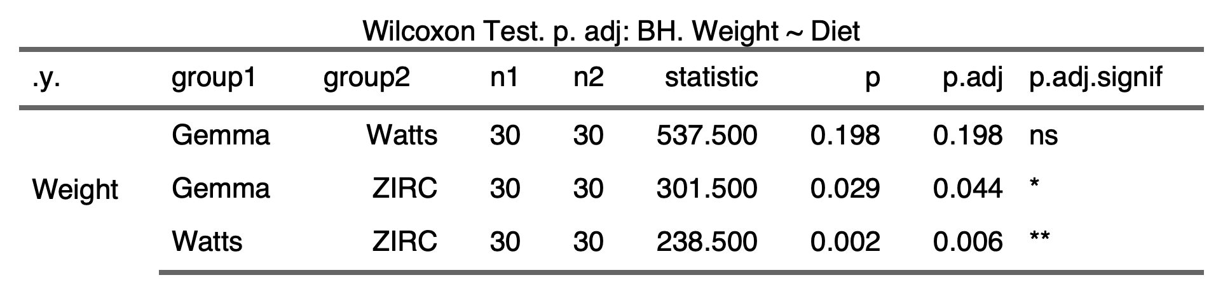

1.1.2)

1.1.3)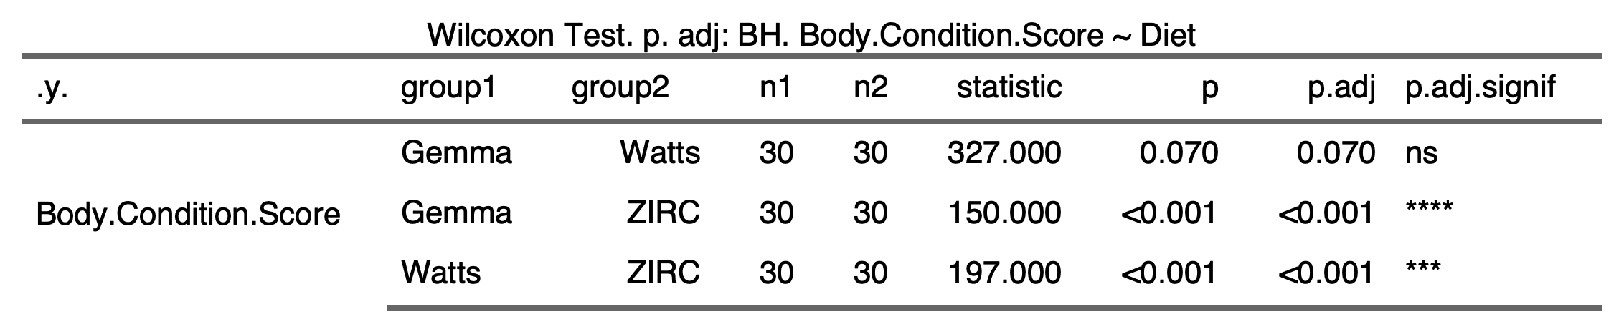

1.1.4)

**1.2) Alpha-diversity**

1.2.1) 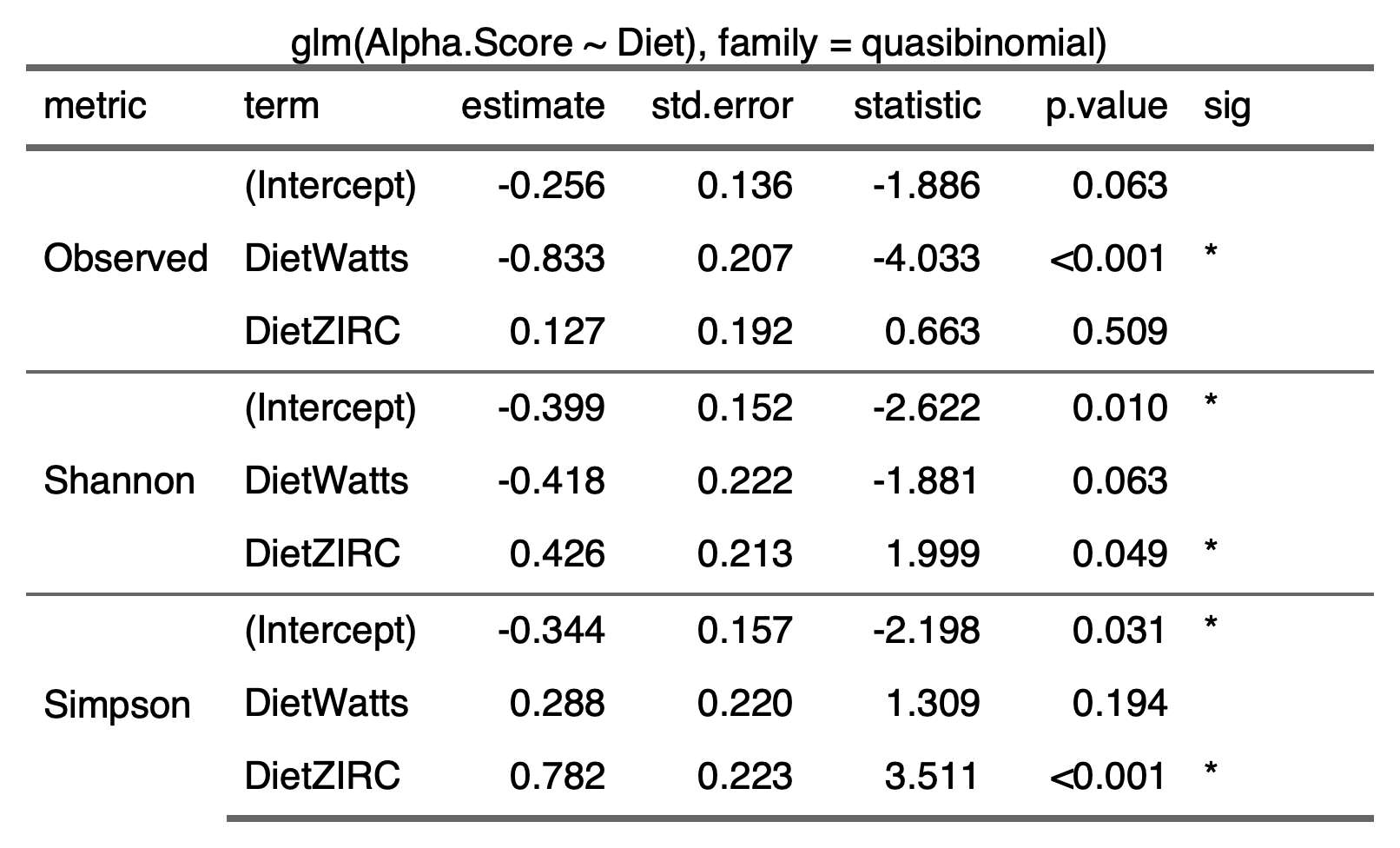

1.2.2) 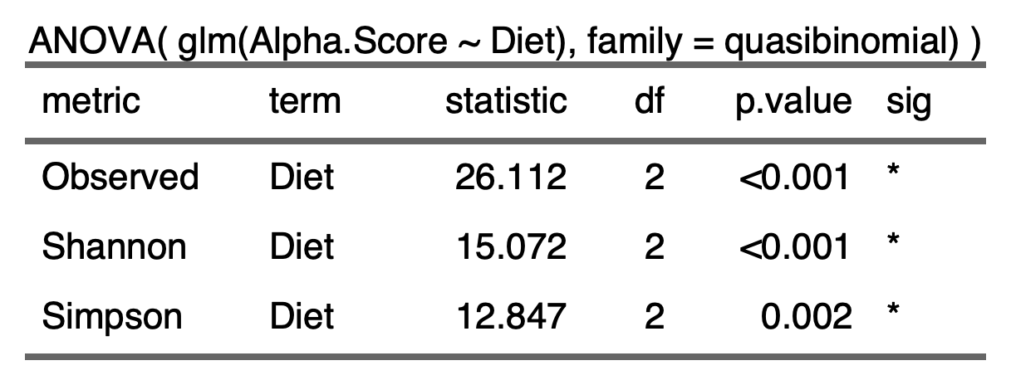

1.2.3)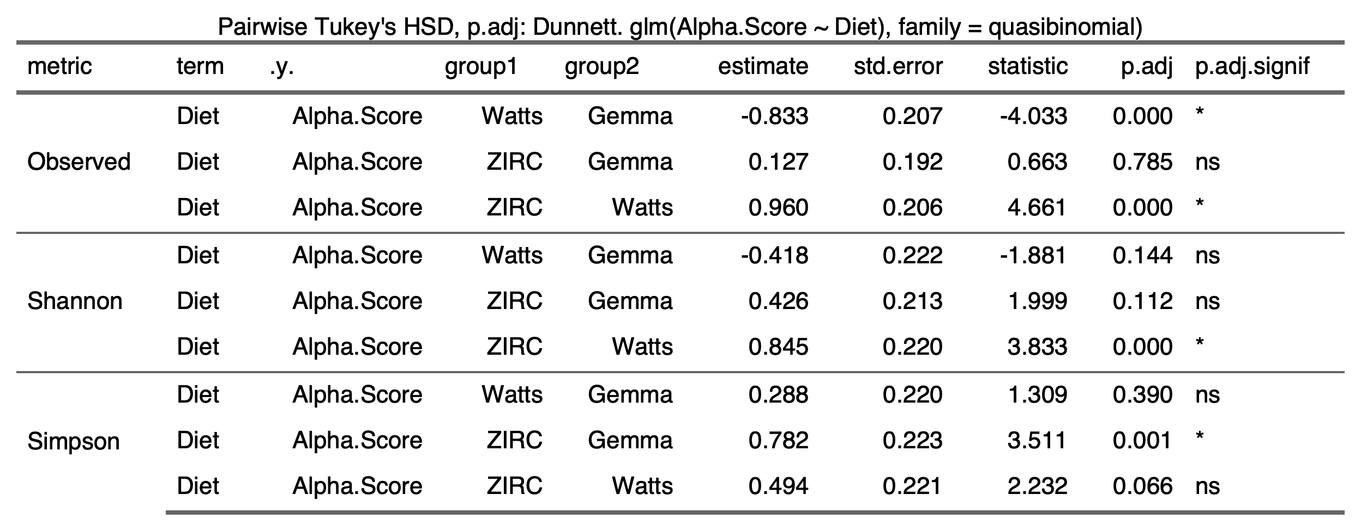

**1.3) Beta-diversity**

1.3.1)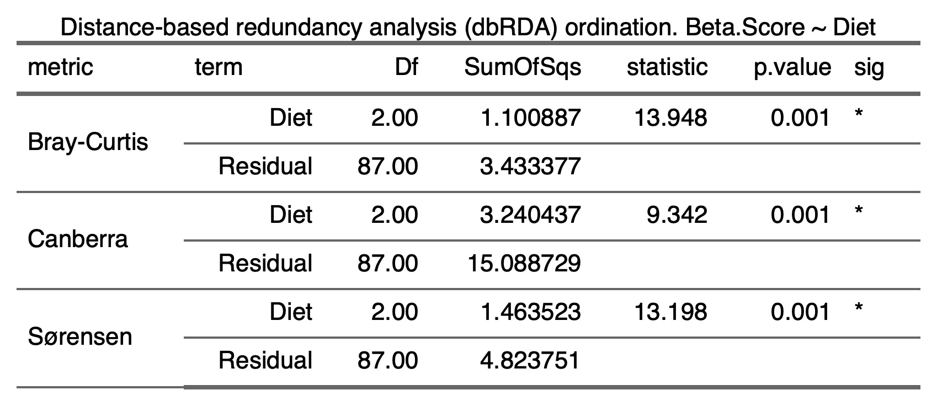

**1.4) Beta-Dispersion**

1.4.1) Diet

|  |  |  |
| --- | --- | --- |
| Bray-Curtis   | Canberra   | Sorensen   |
|  |  |  |

1.5) Differential Abundance

1.5.1) 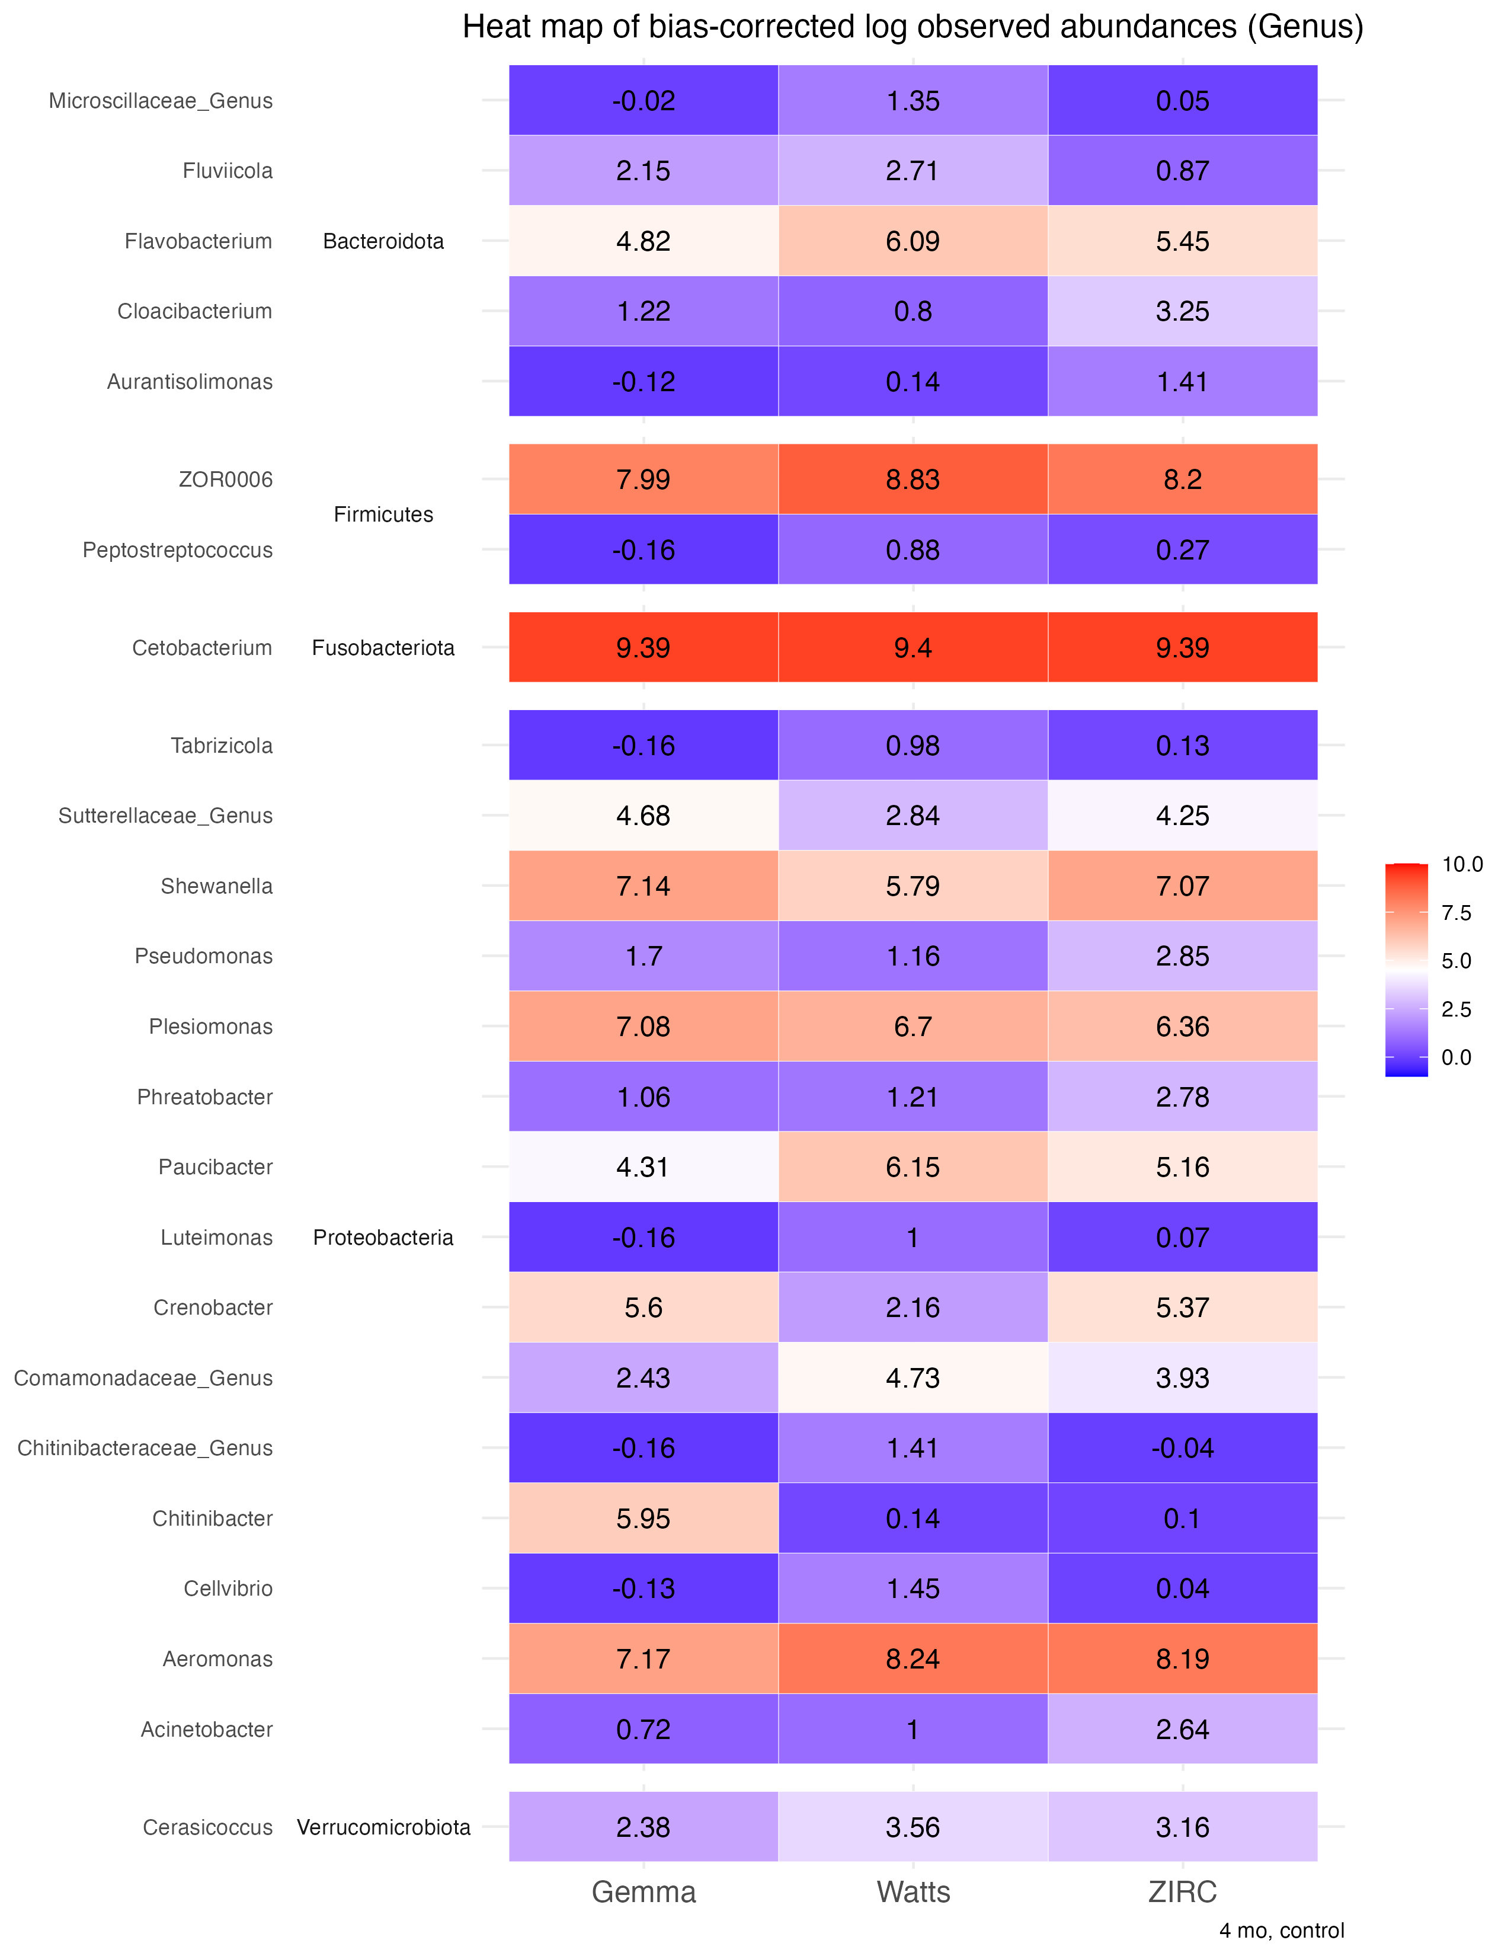

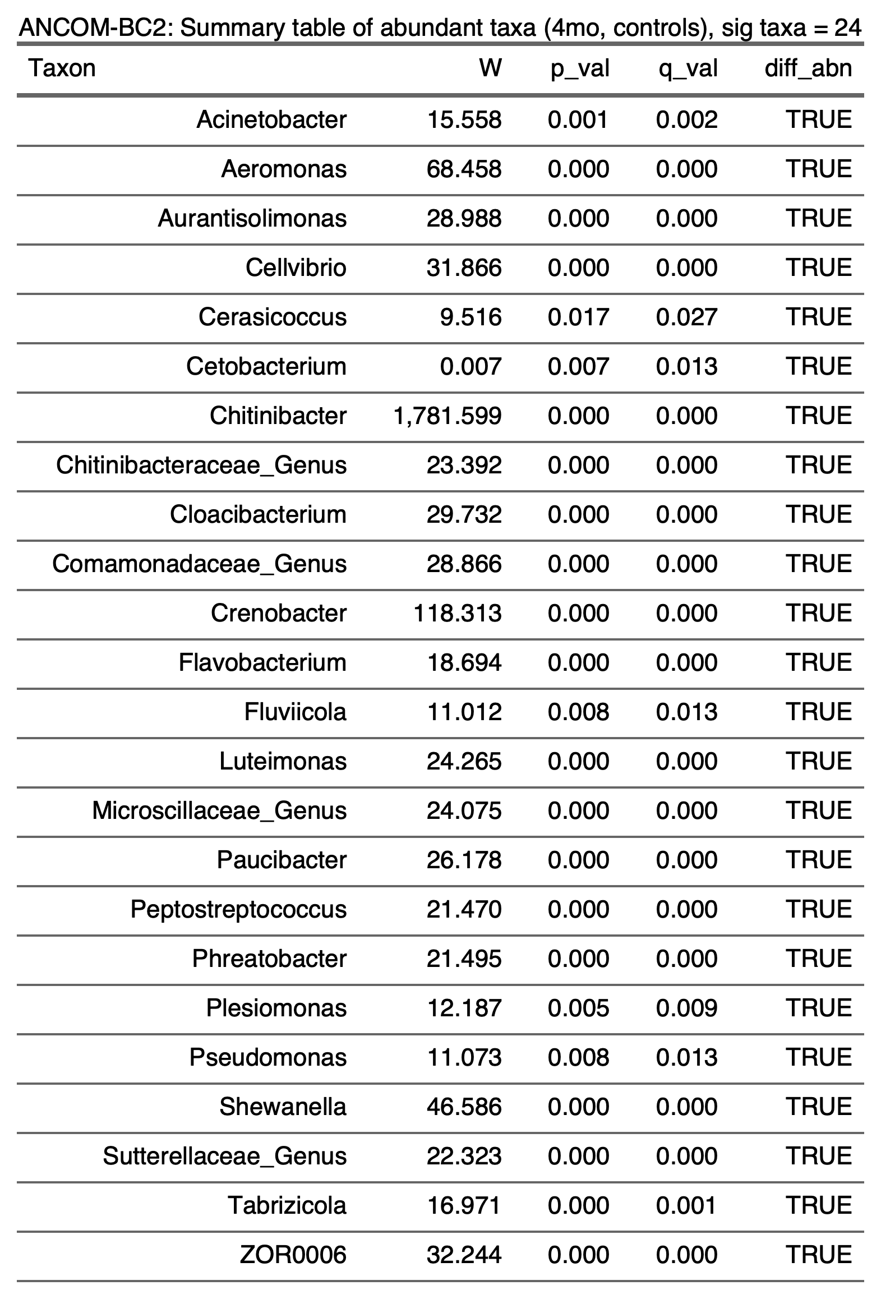

1.5.2)

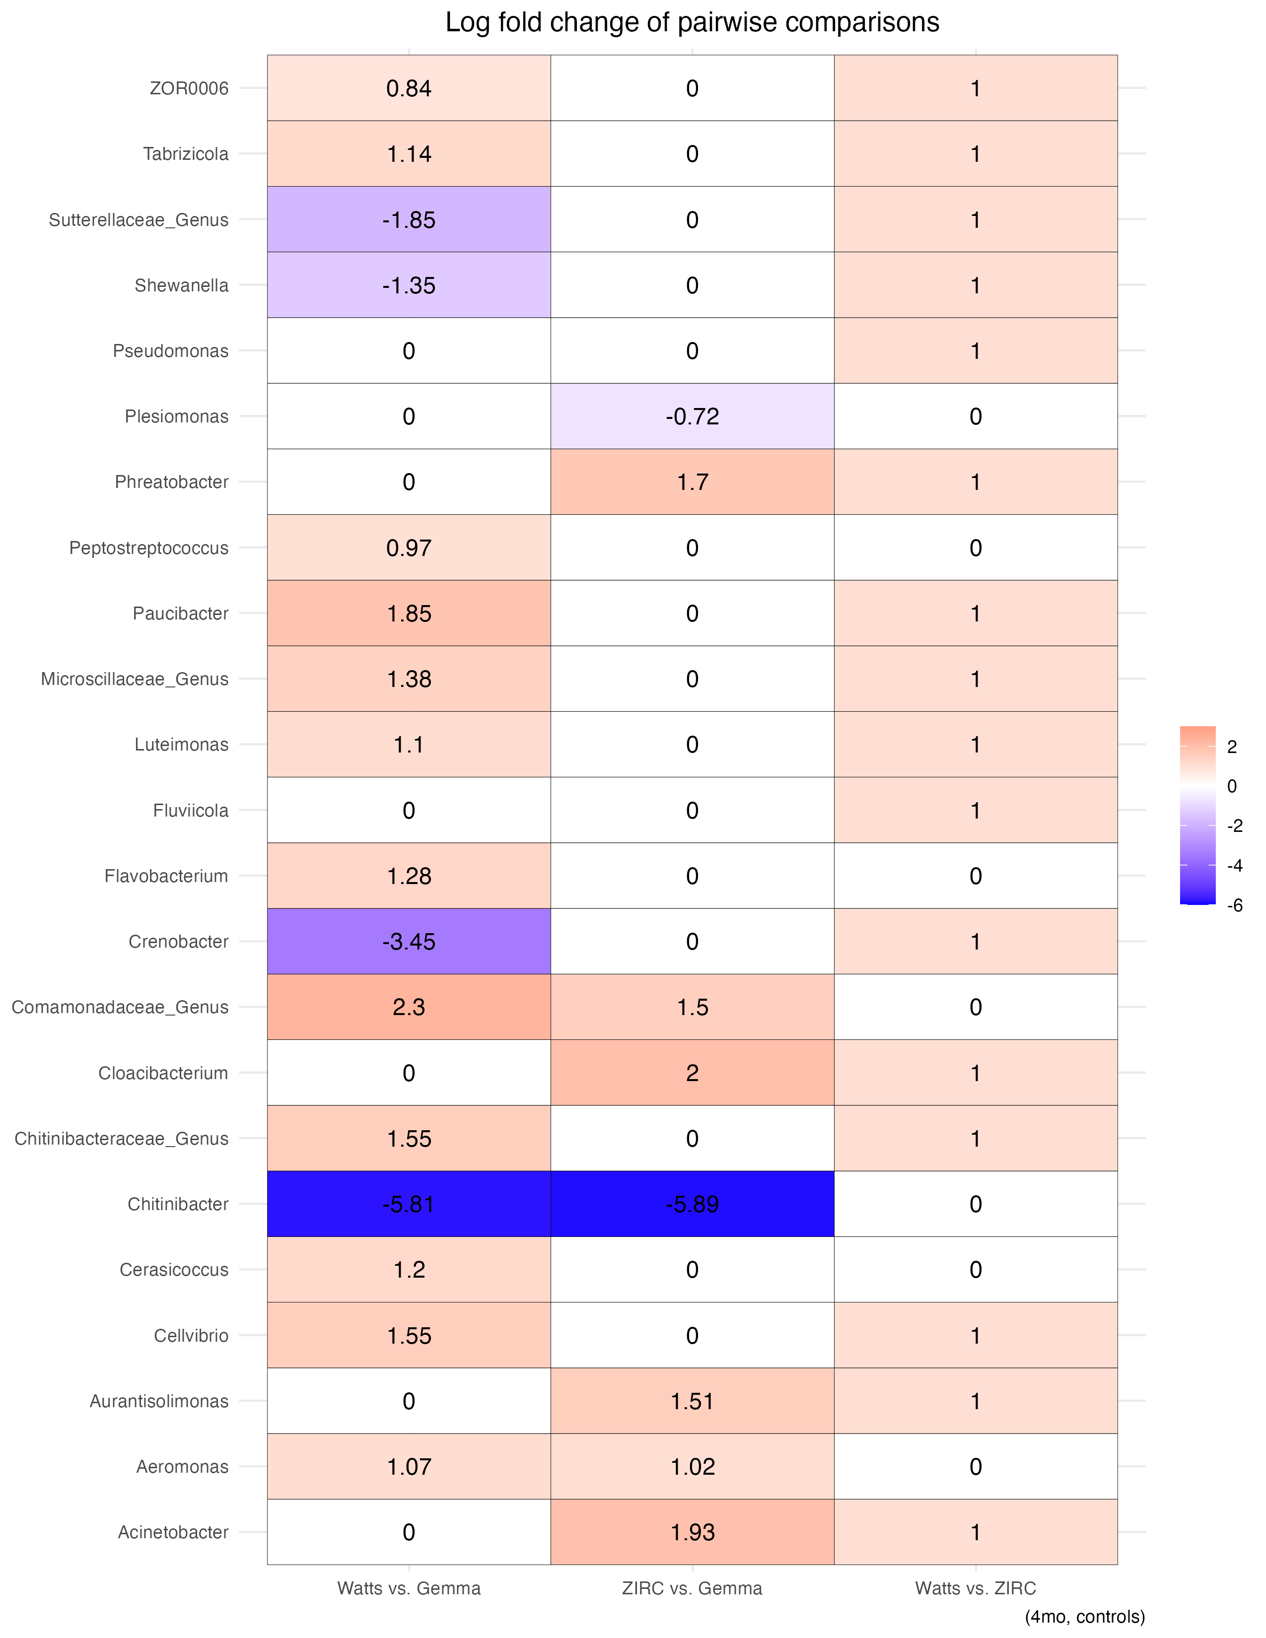

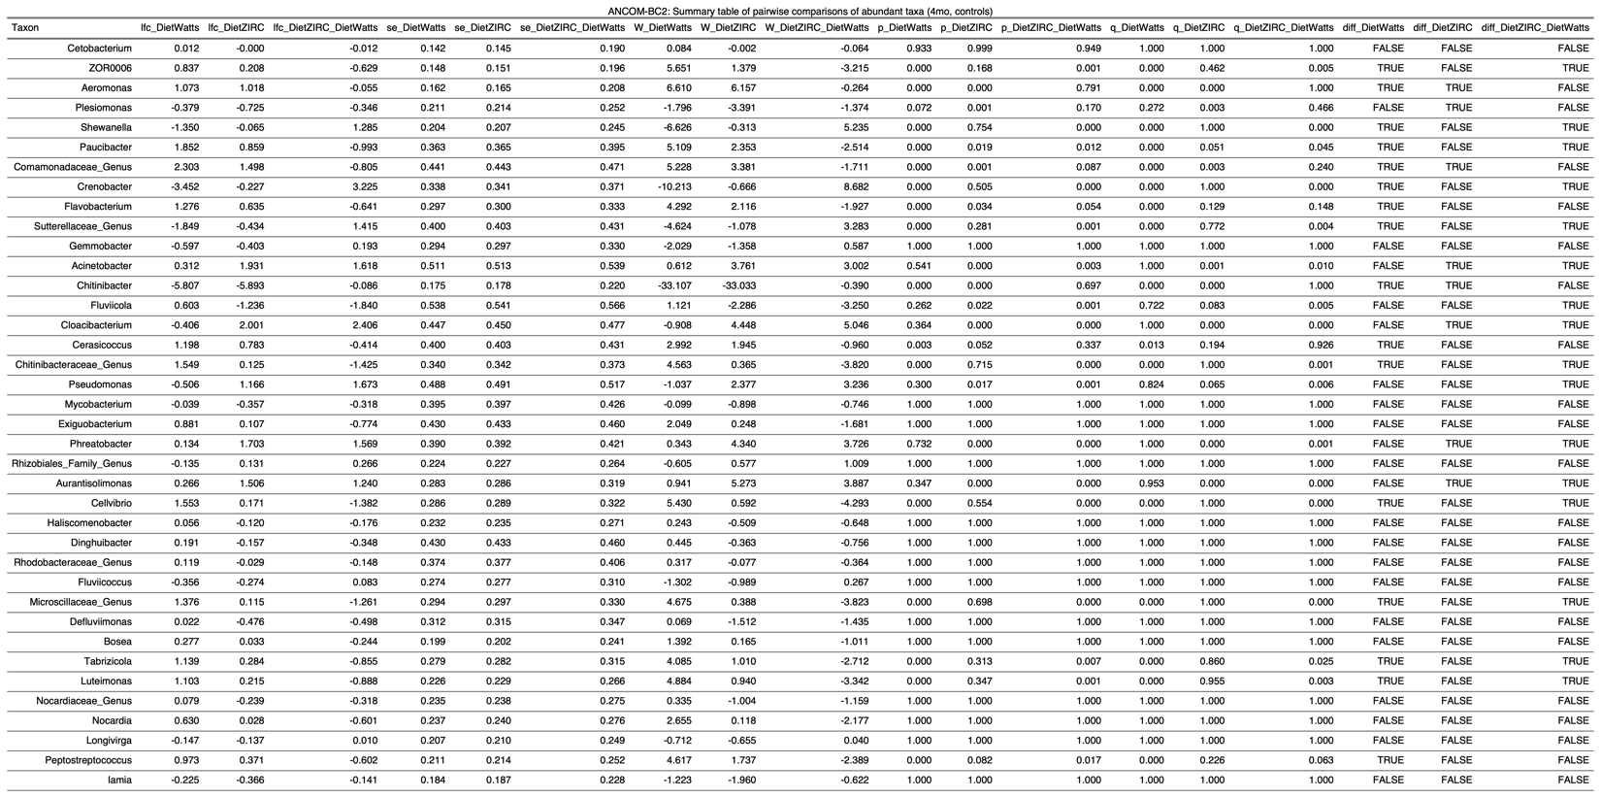

**2) Development**

**2.1) Physiology**

2.1.1)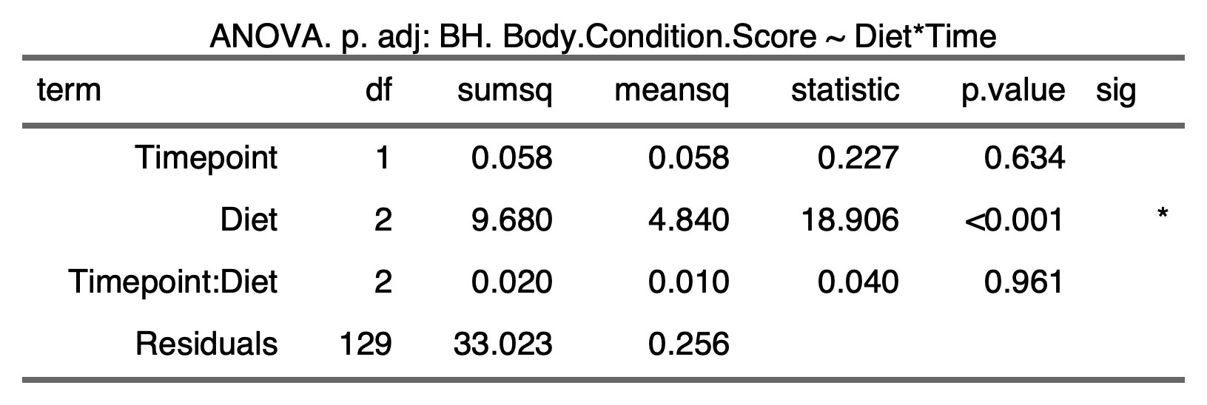

**2.2) Physiology ~ Microbiome**

2.2.1) 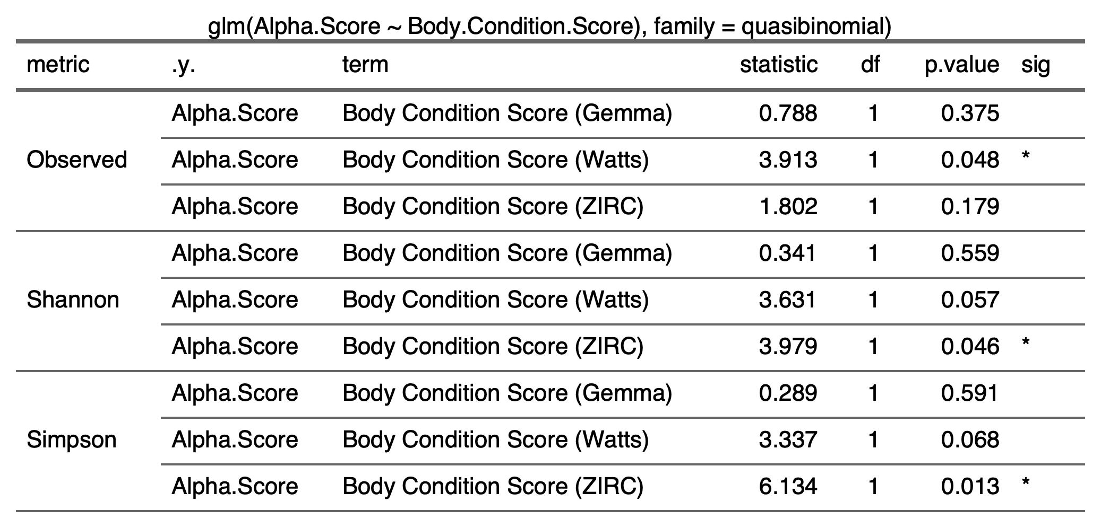

2.2.2) 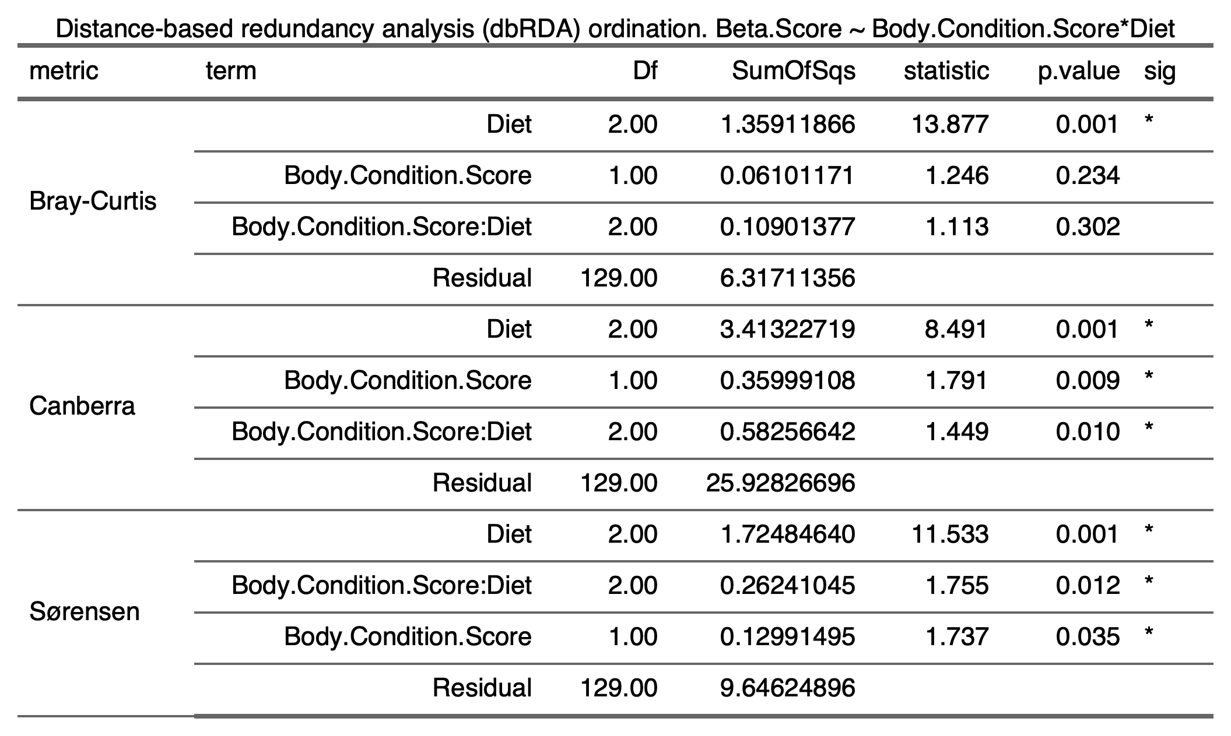

**2.3) Alpha-diversity**

2.3.1) **Time**

2.3.1.1) 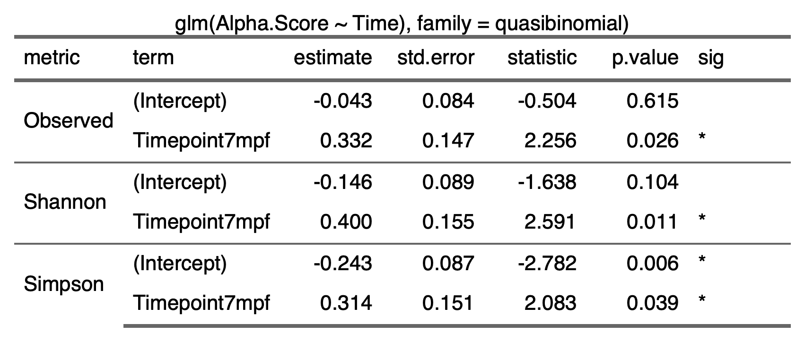

2.3.1.2) 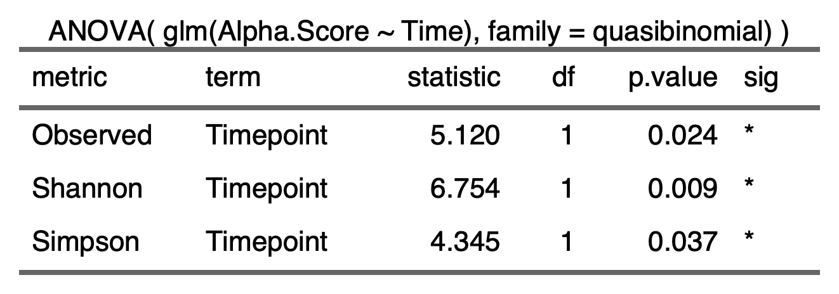

2.2.1.3) 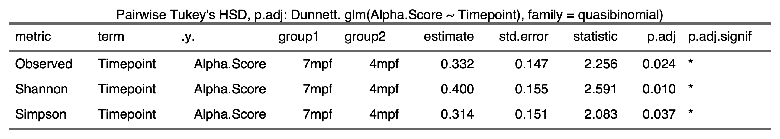

2.2.2) **Time:Diet**

2.2.2.1) 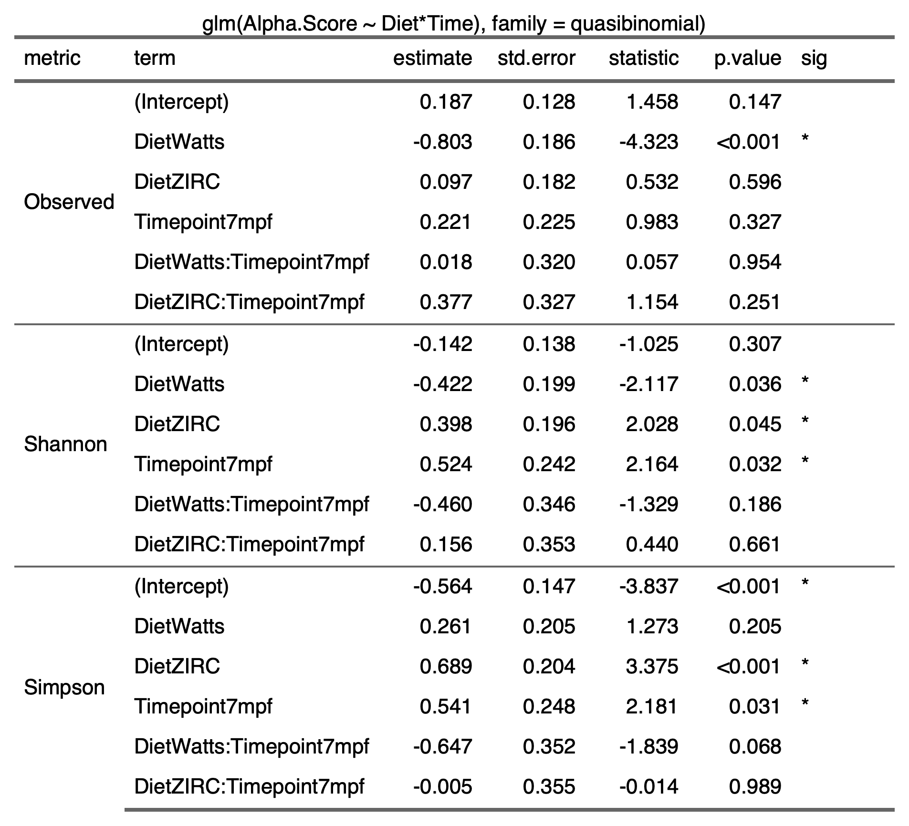

2.2.2.2) 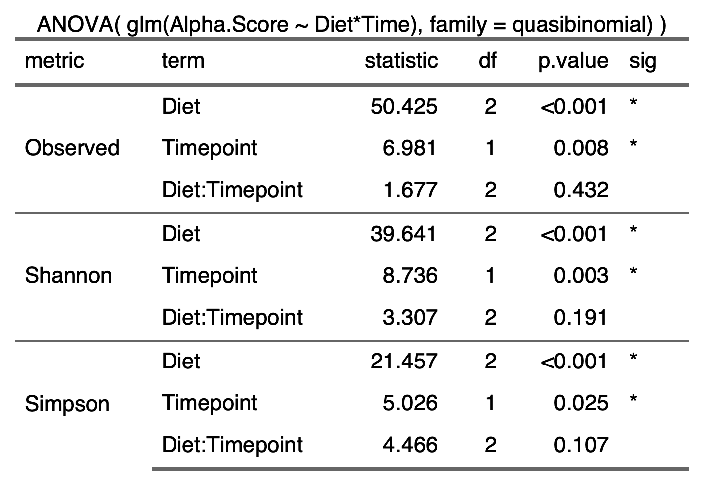

2.2.2.3) 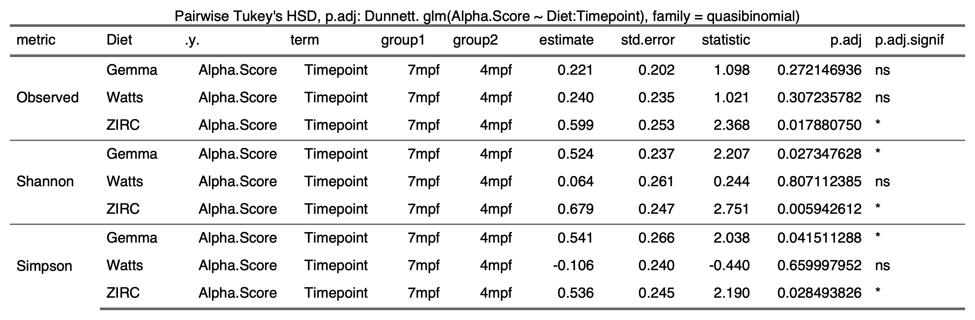

**2.4) Beta-diversity**

2.4.1)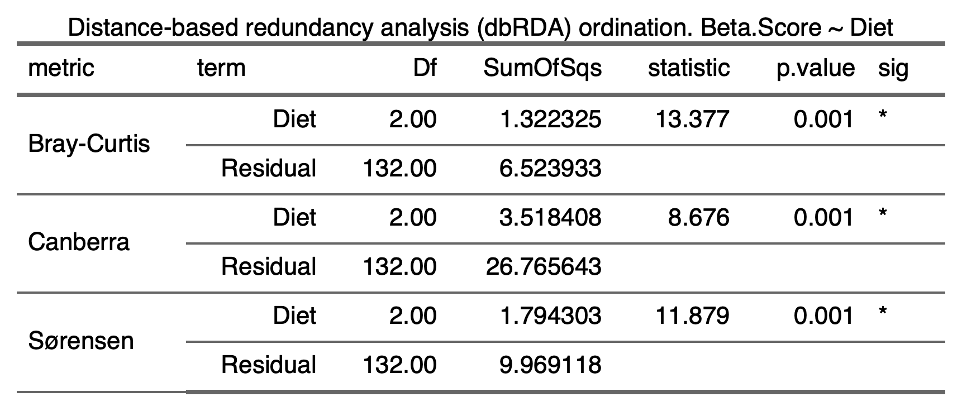

2.4.2)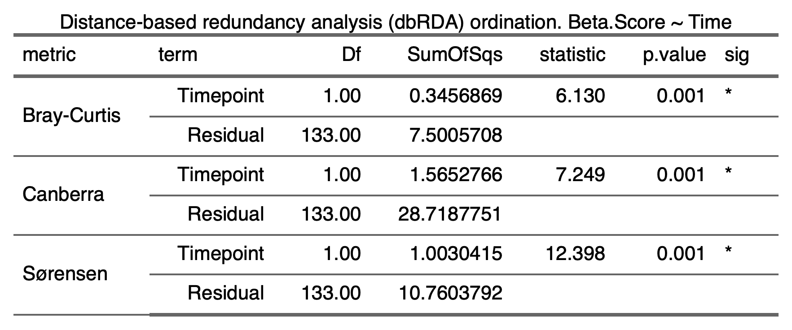

2.4.3)

**2.5) Beta-Dispersion**

**2.5.1) Diet**

**2.5.2) Time**

**2.5.3) Diet:Time**

|  |  |  |
| --- | --- | --- |
|  |  |  |
|  |  |  |

**2.6 Differential Abundance**

2.6.1)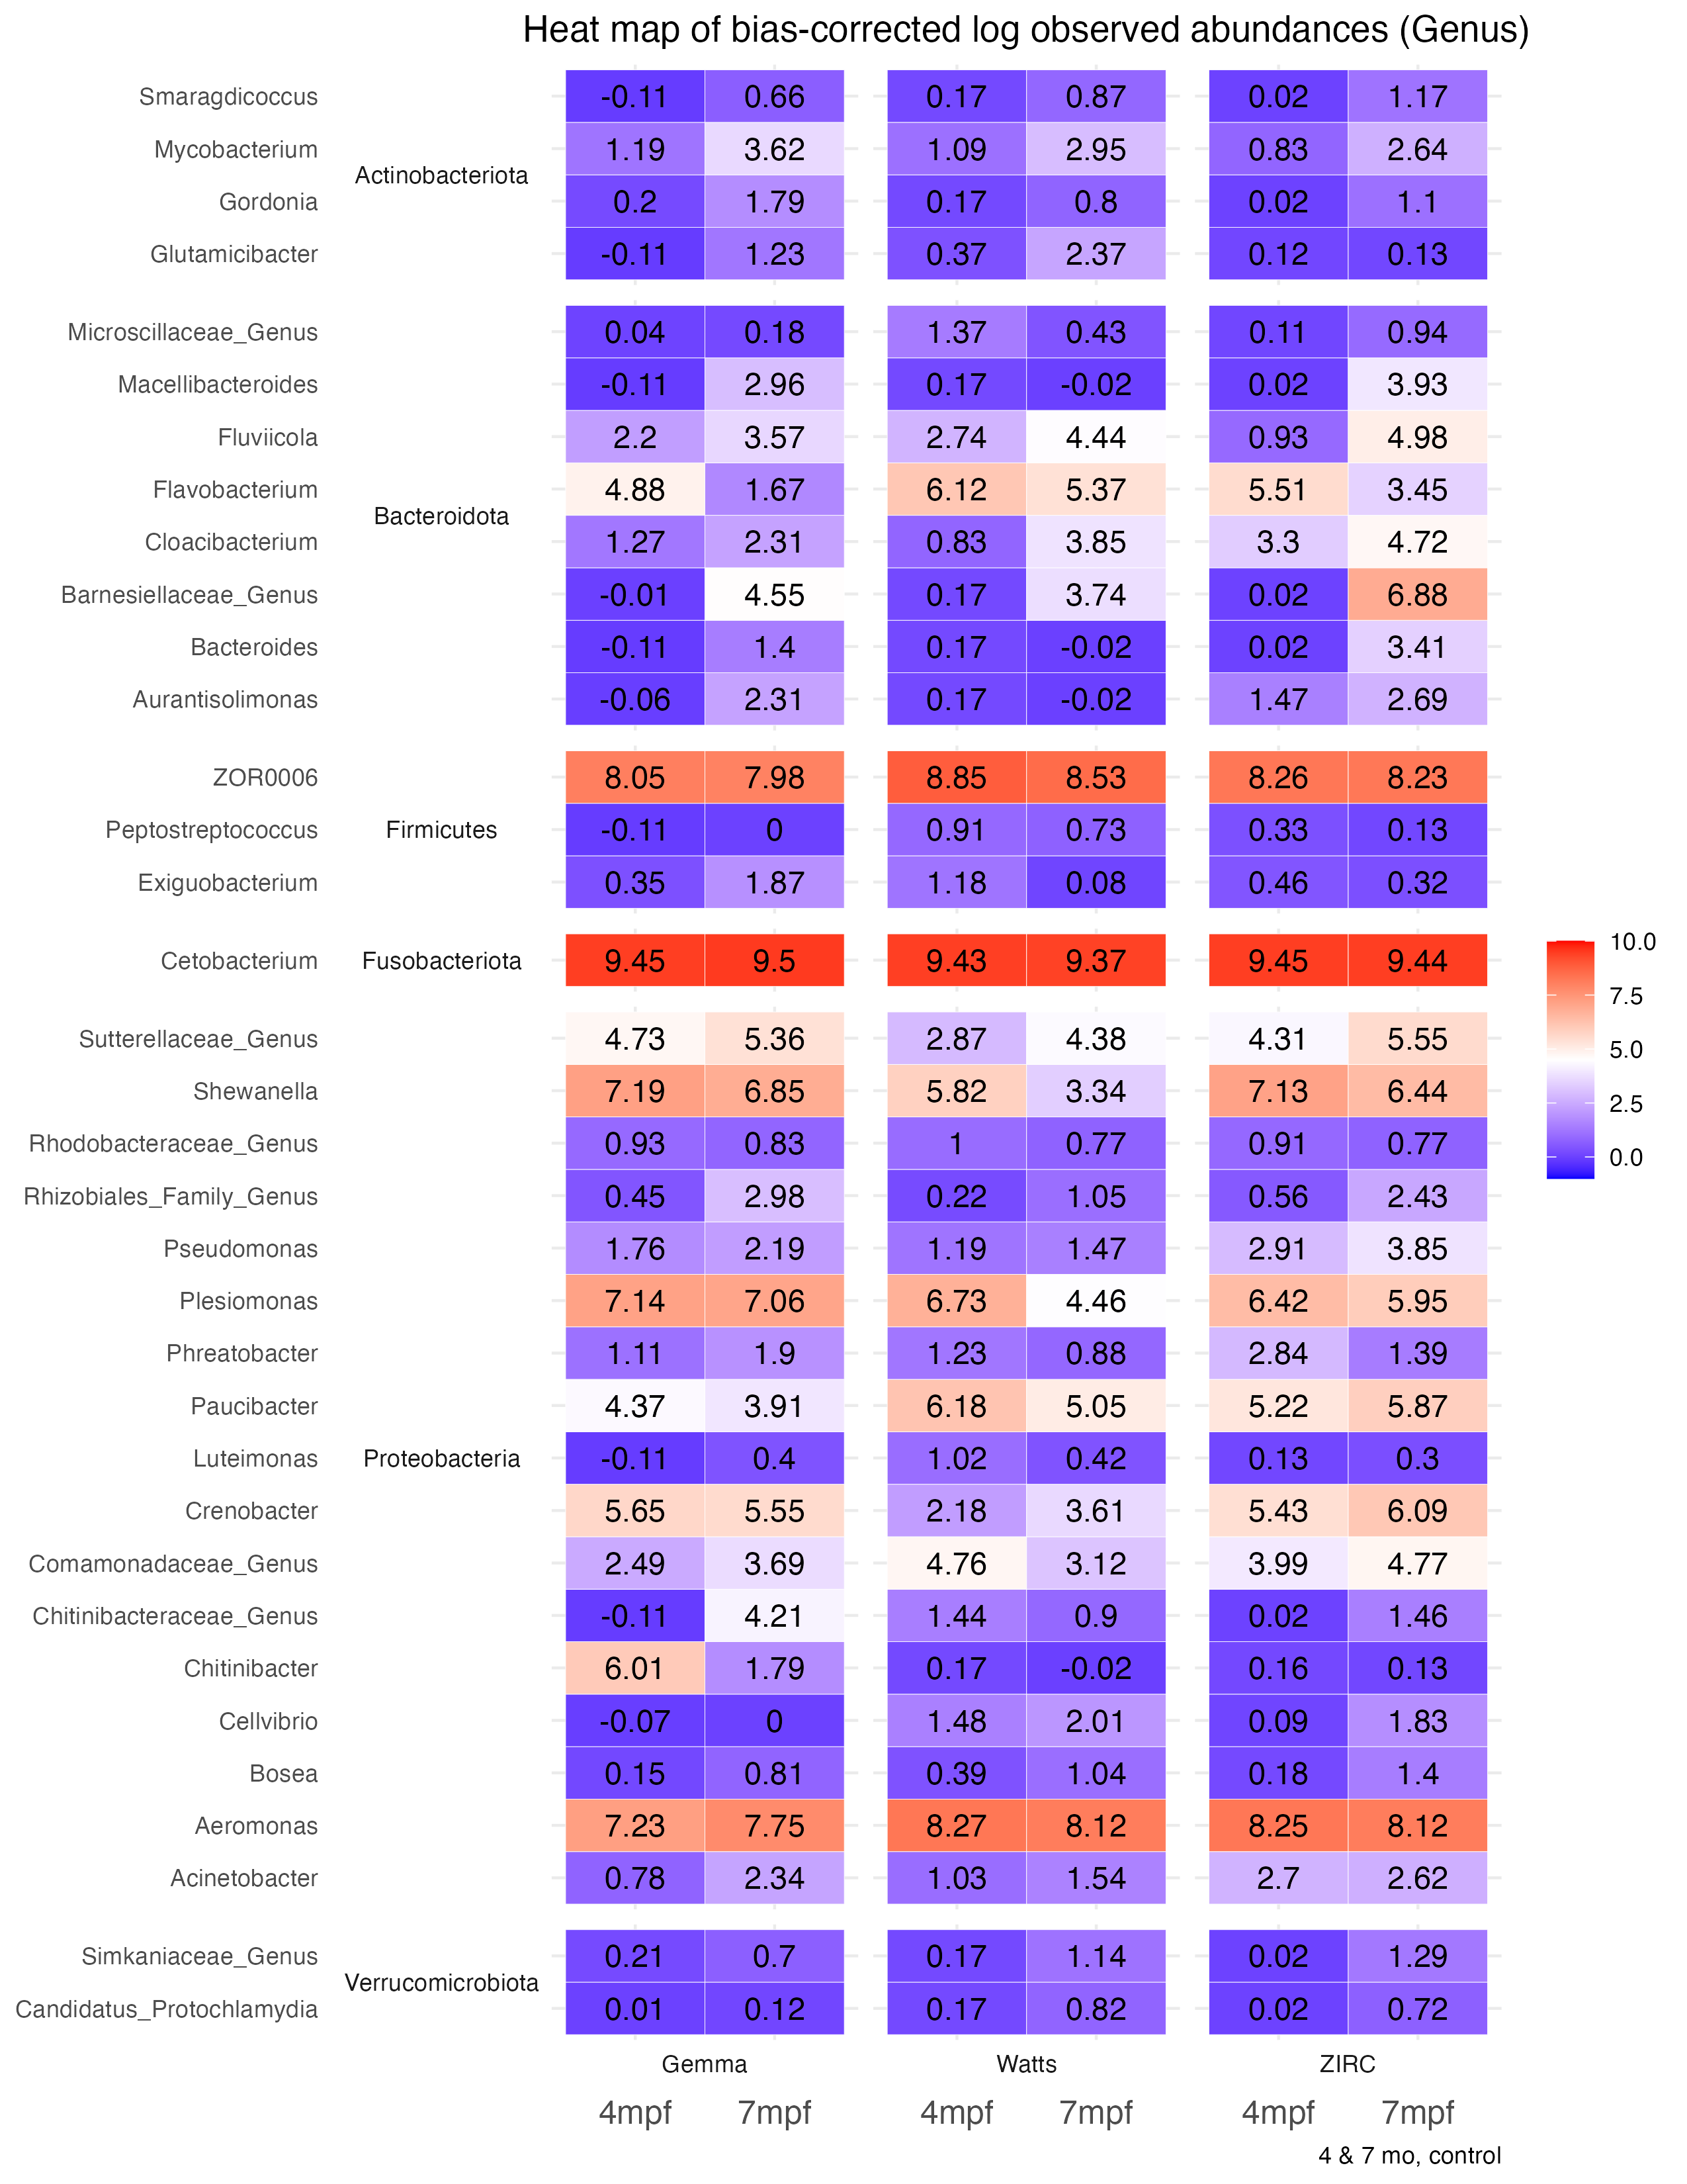

2.6.2)

2.6.2.1) 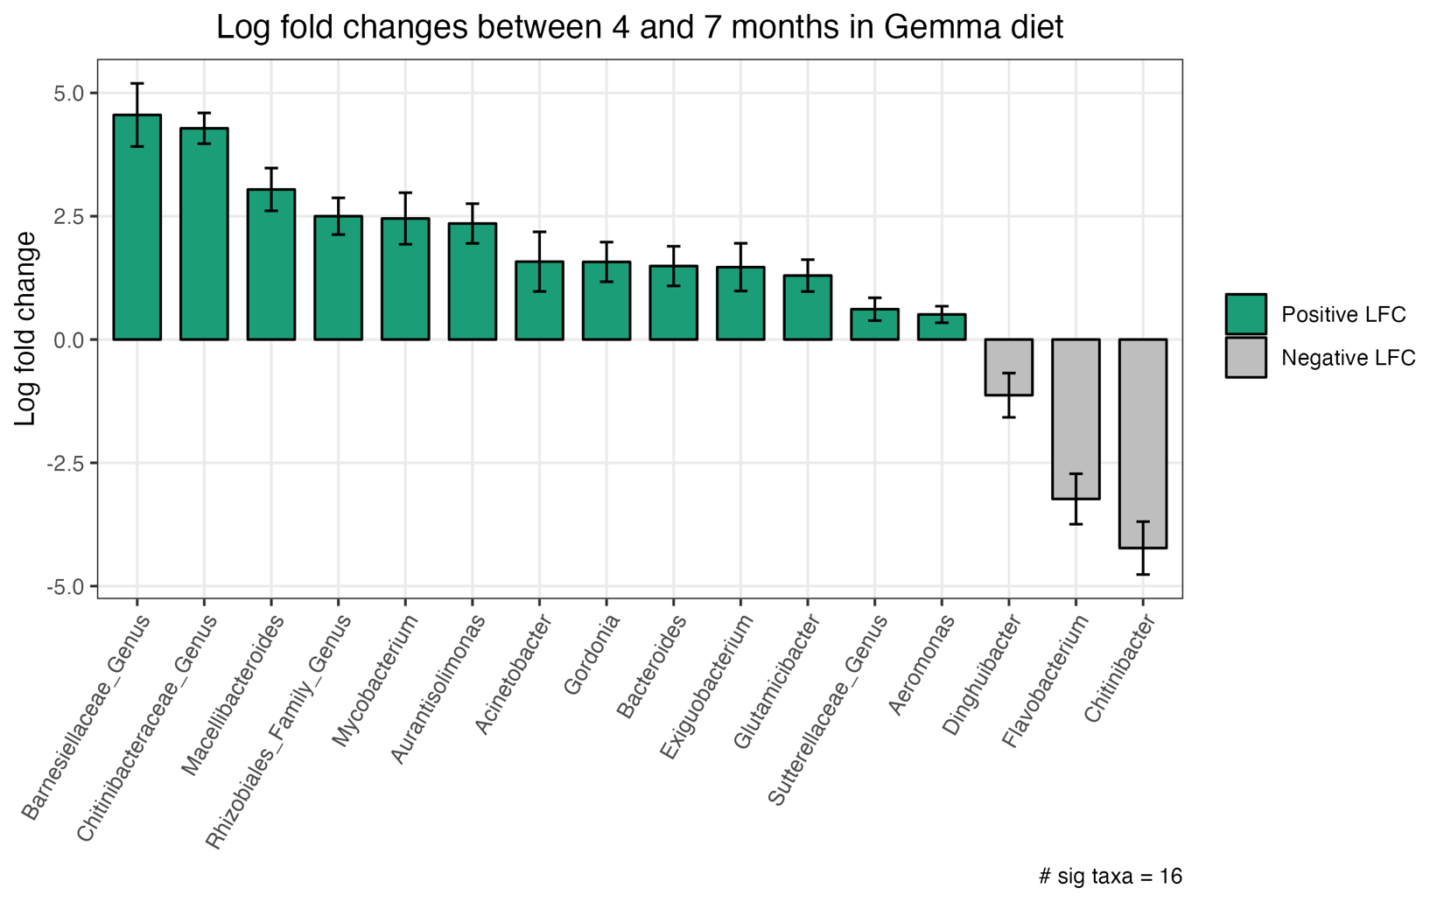

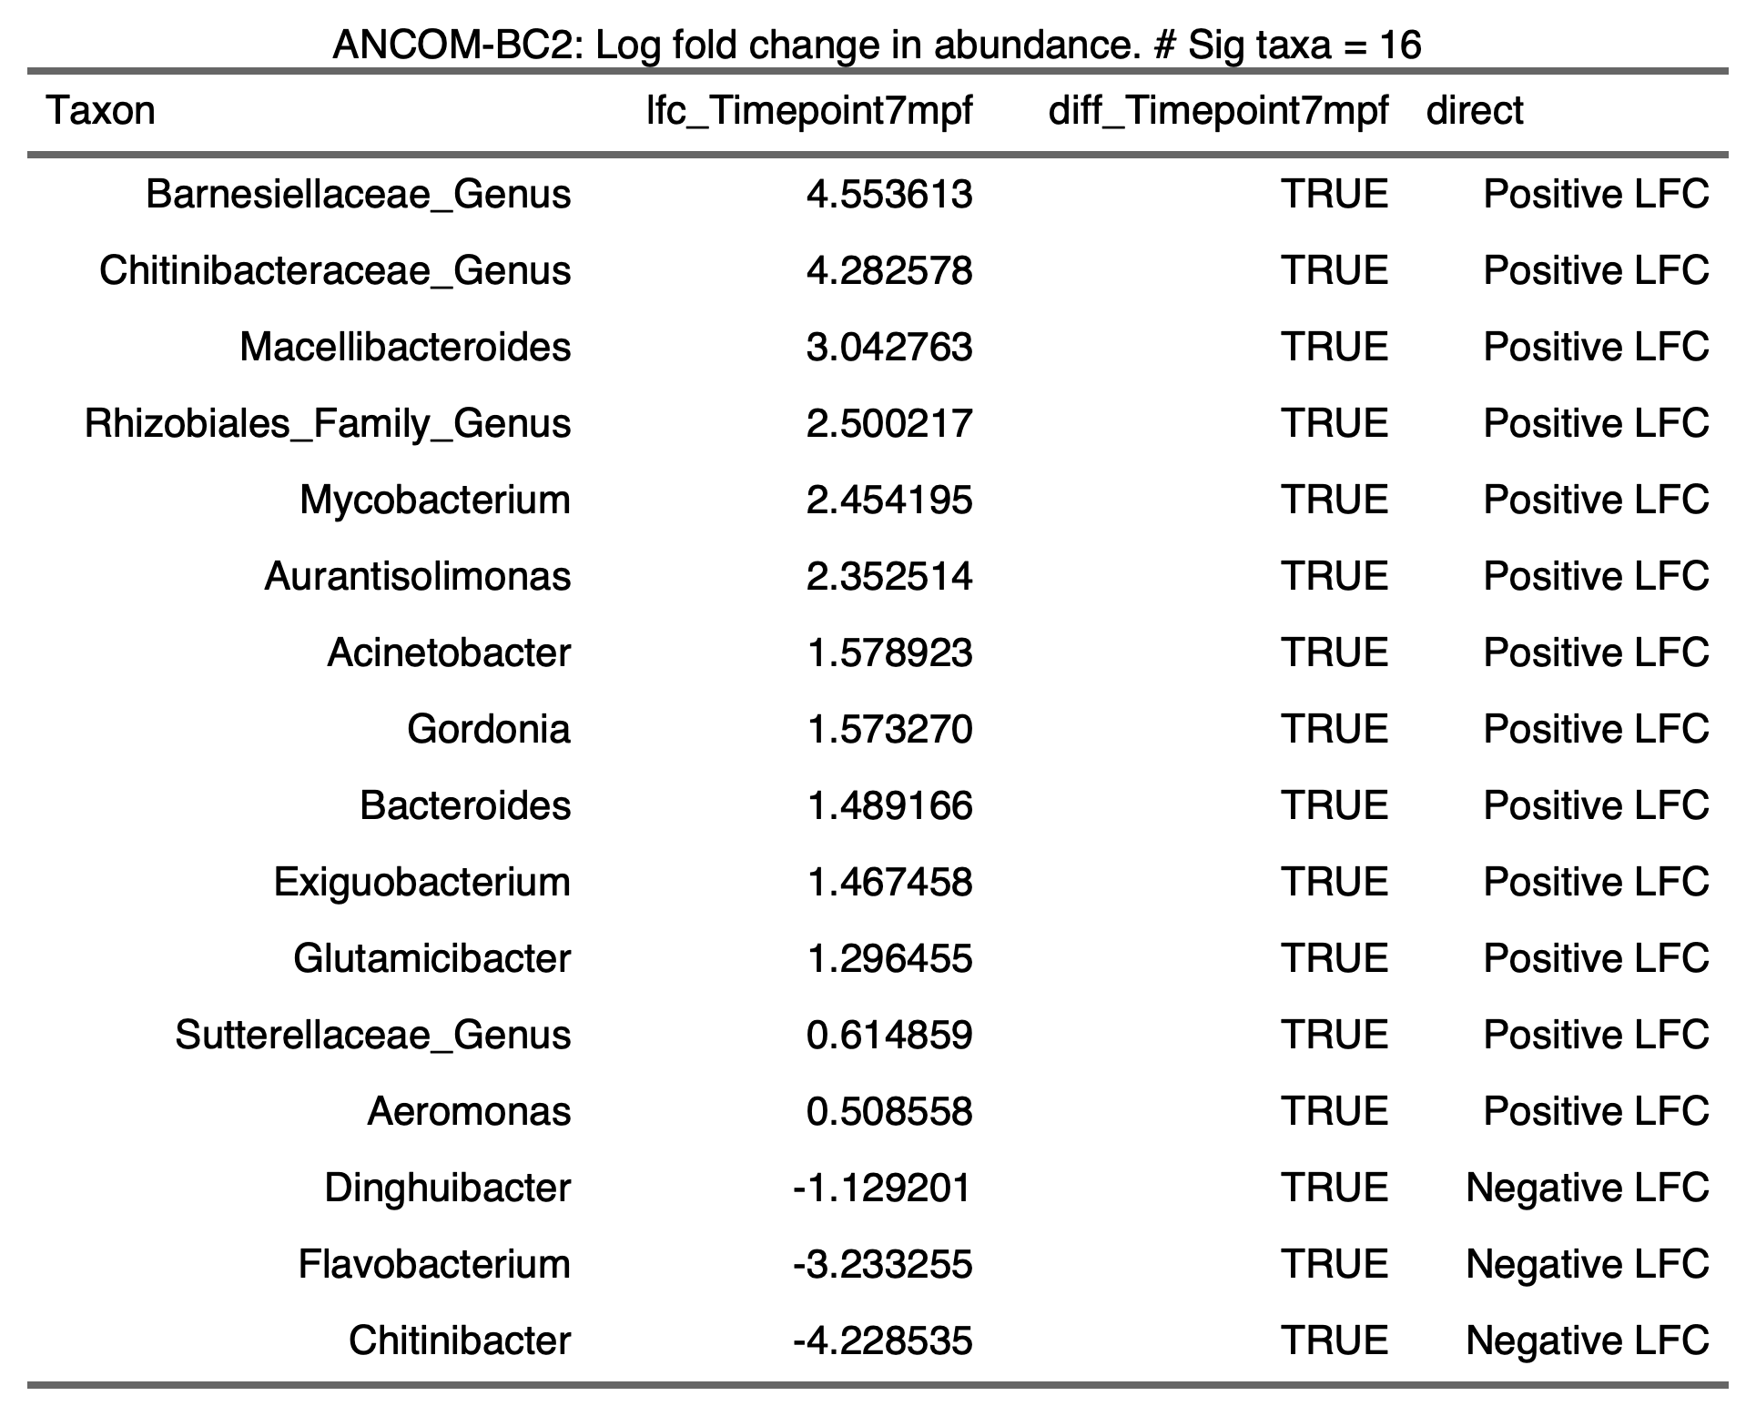

2.6.2.2)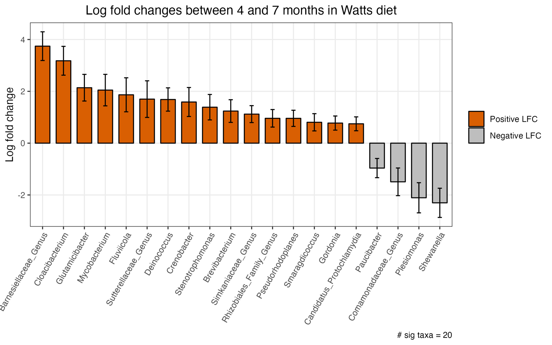

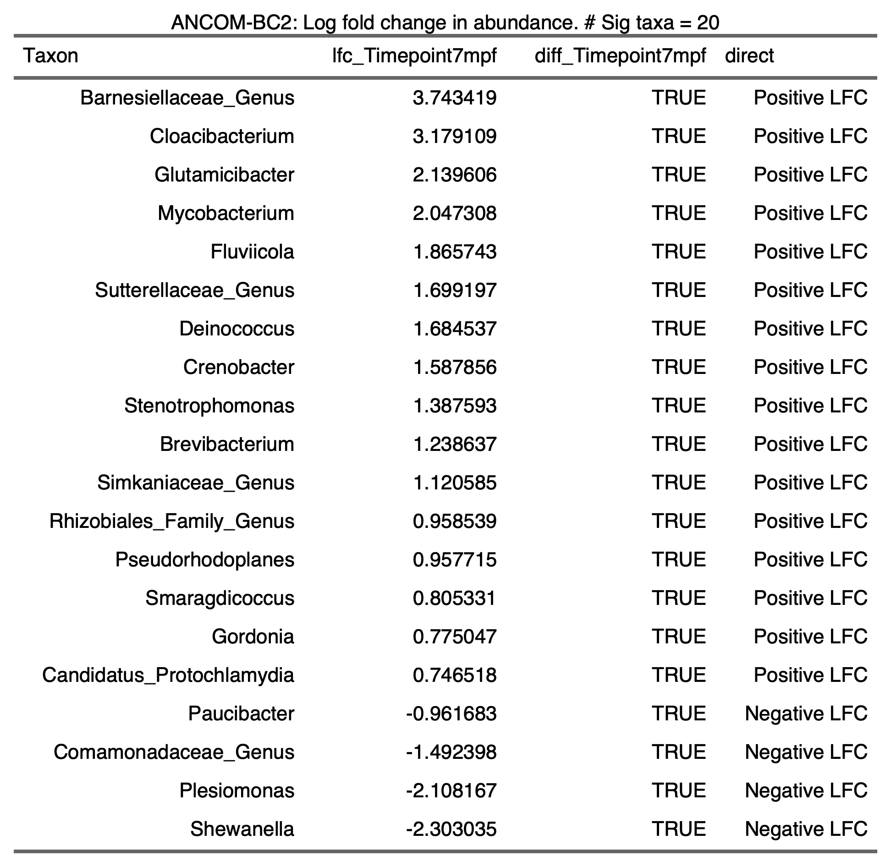

2.6.2.3)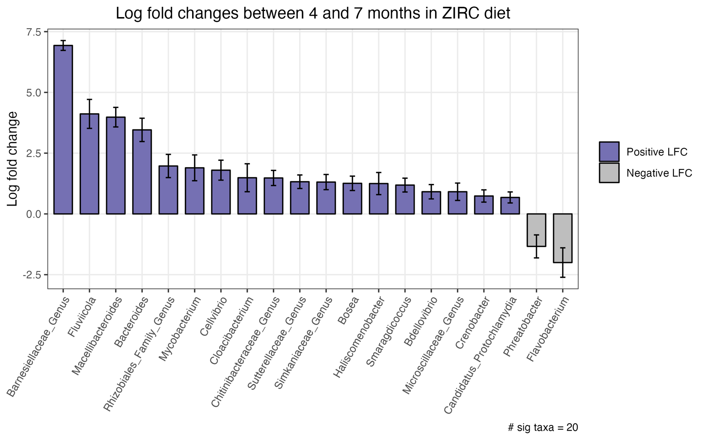

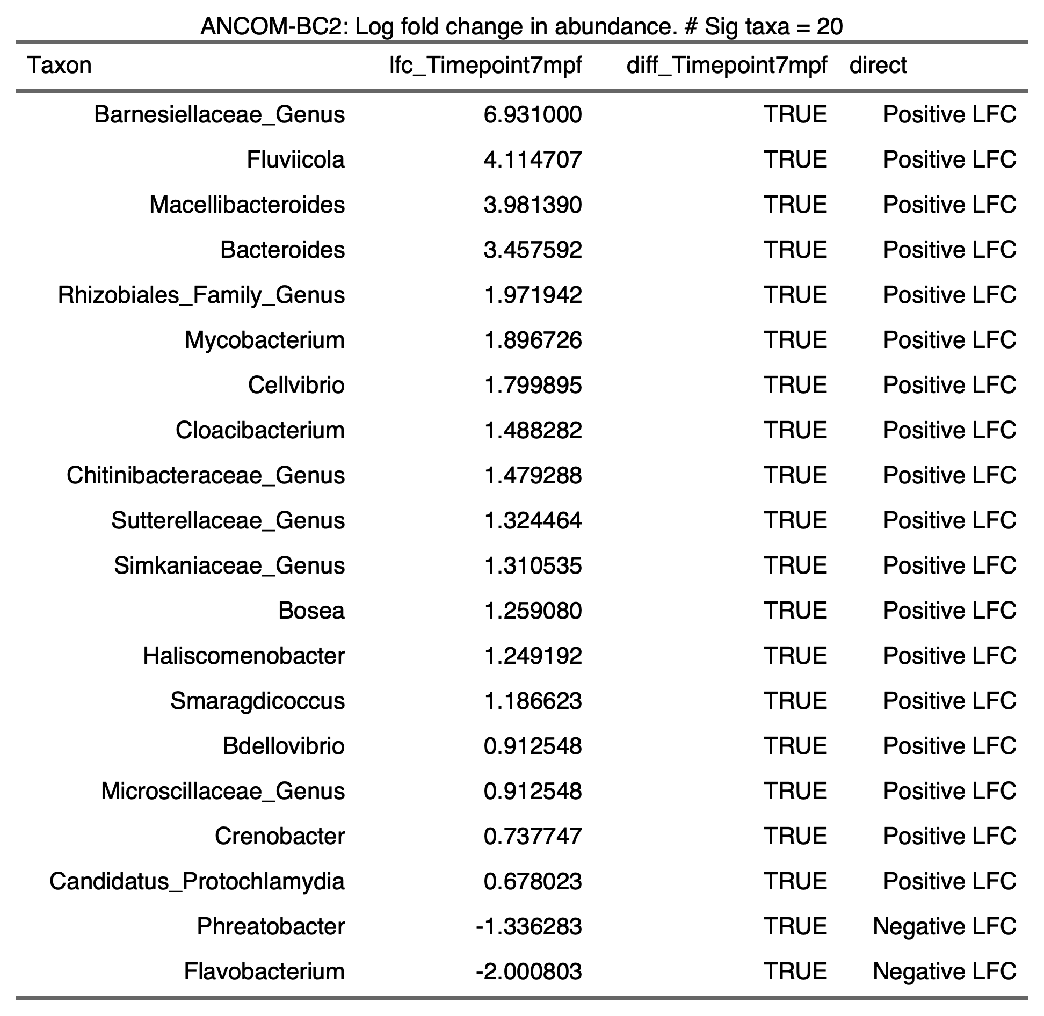

2.6.2.4)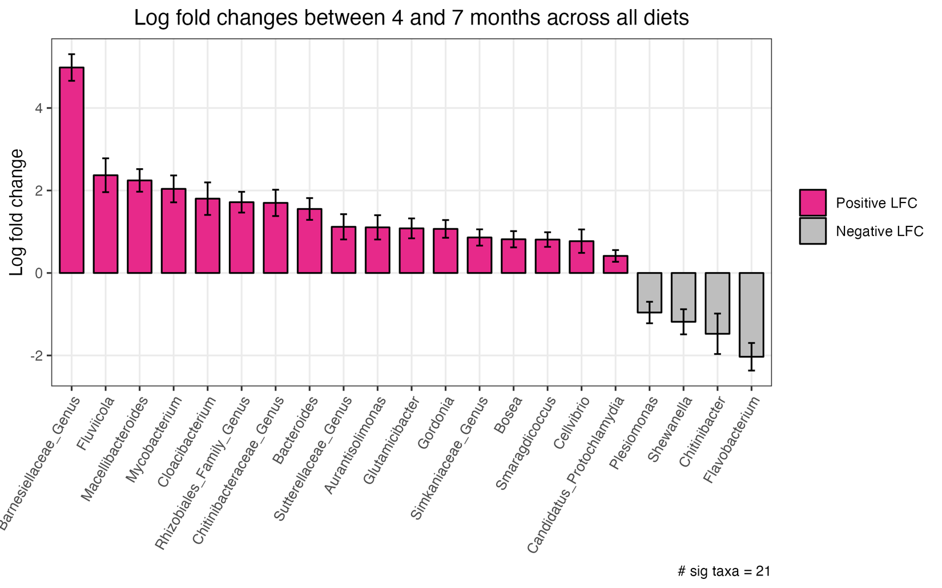

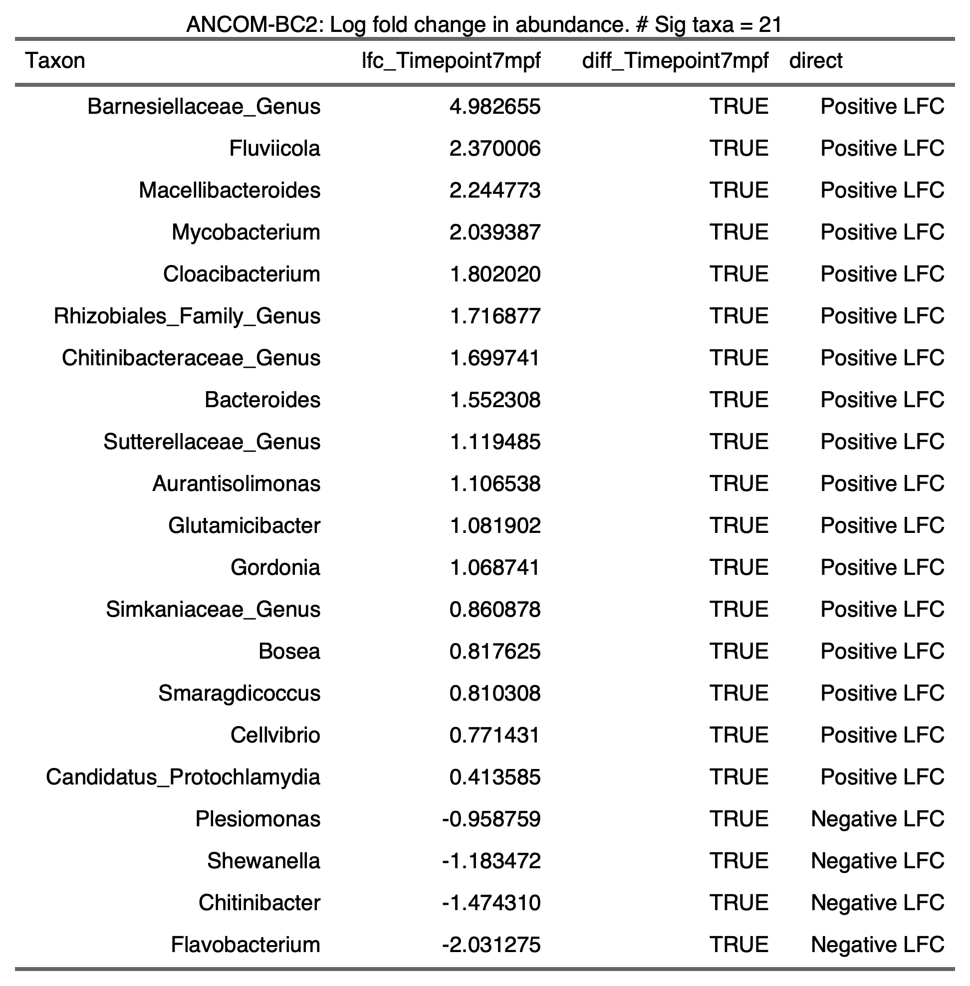

2.6.2.5)

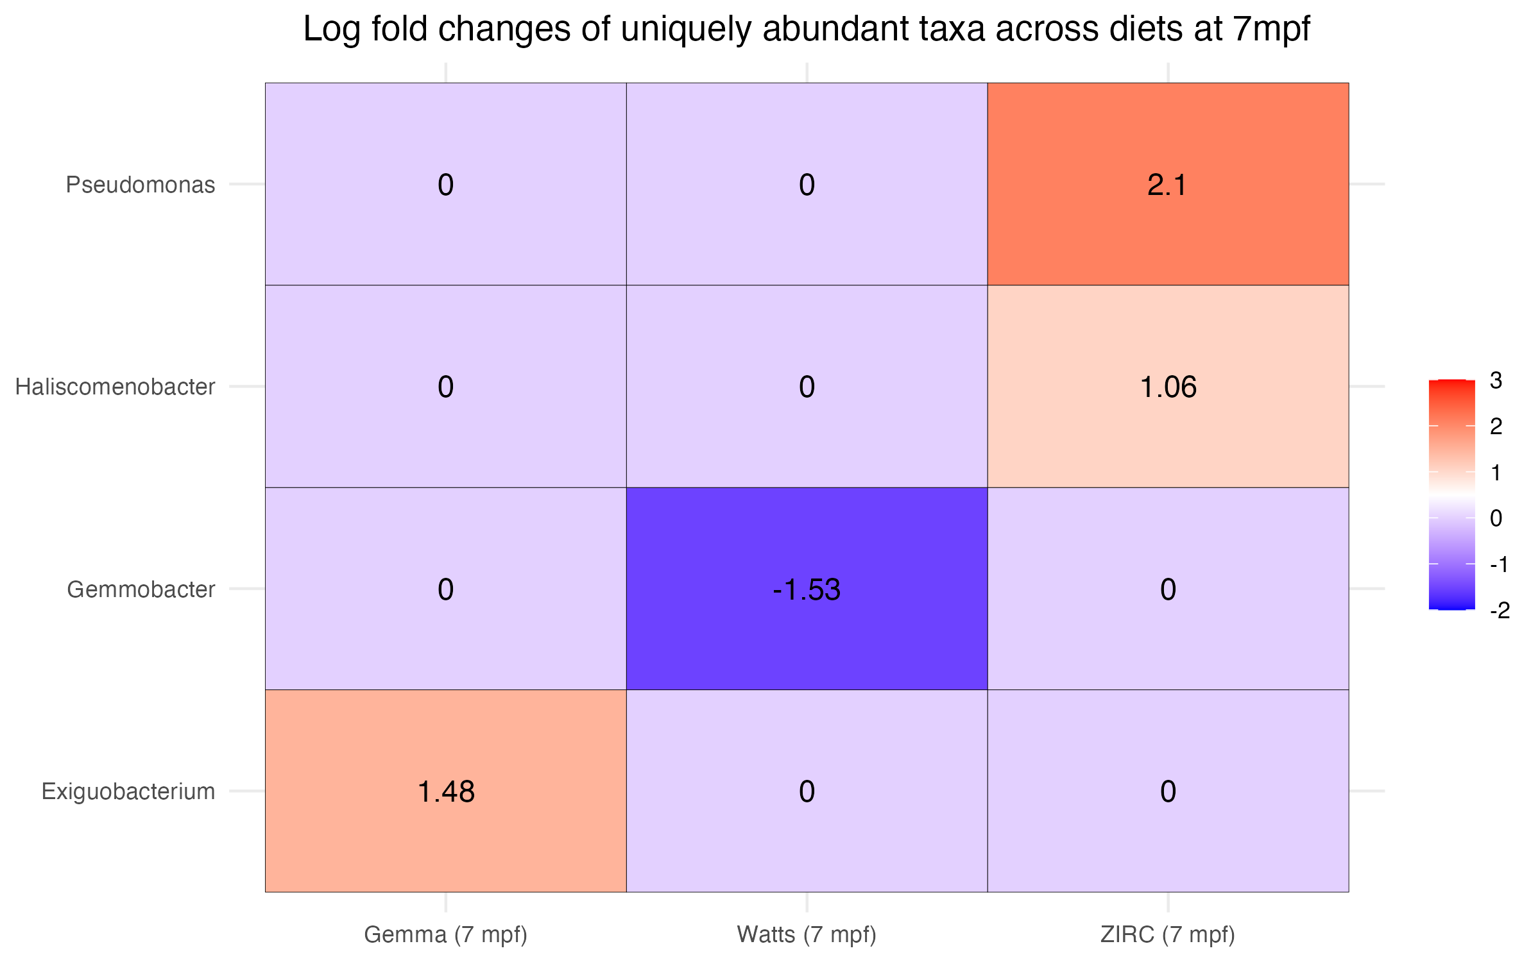

2.7) 7 Month Analysis

2.7.1) Physiology

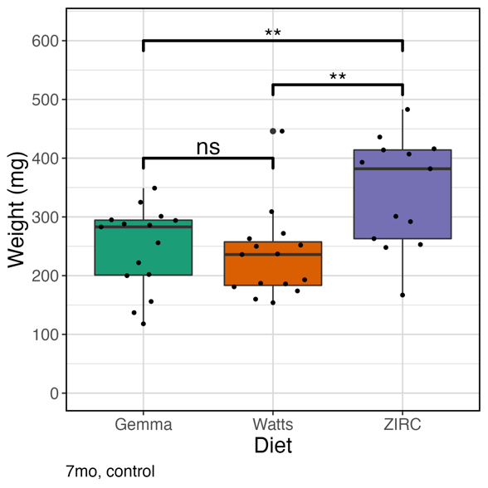2.7.1.1) Weight ~ Diet

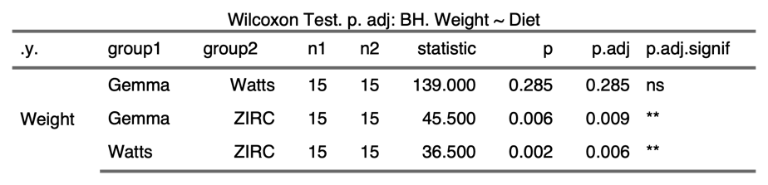

2.7.1.2) Weight ~ Sex

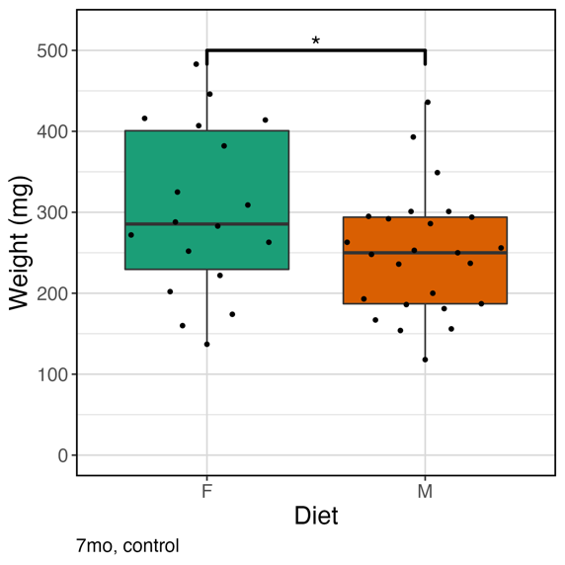

2.7.1.3) Body Condition Score ~ Diet

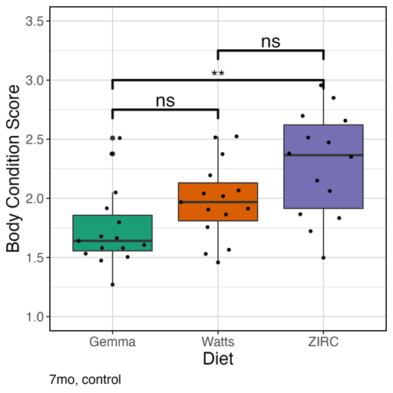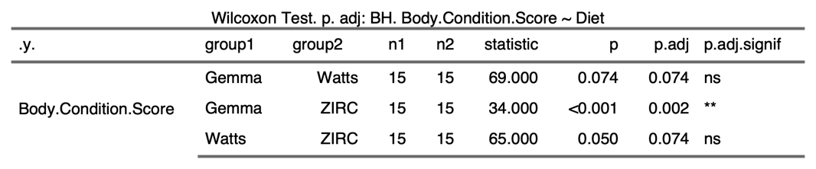

2.7.1.4) Body Condition Score ~ Sex

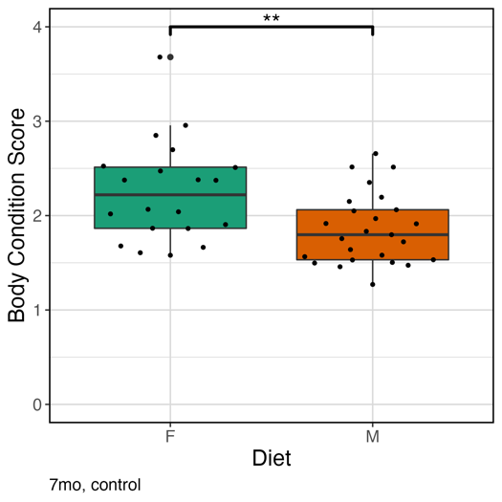

2.7.2) Alpha-Diversity

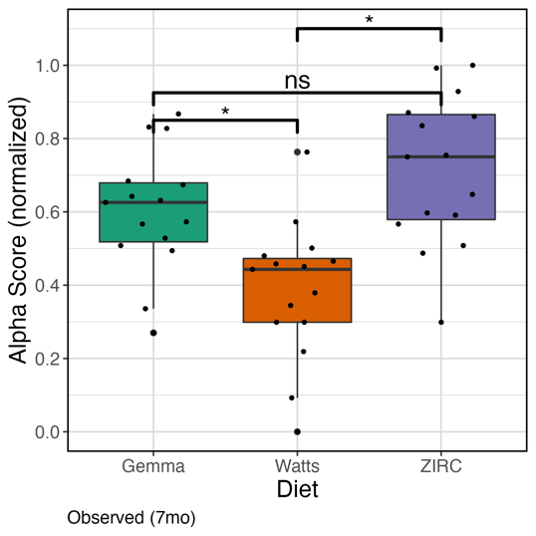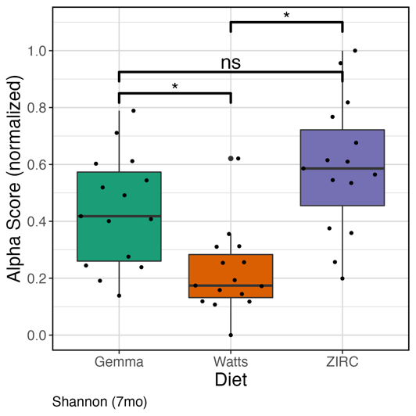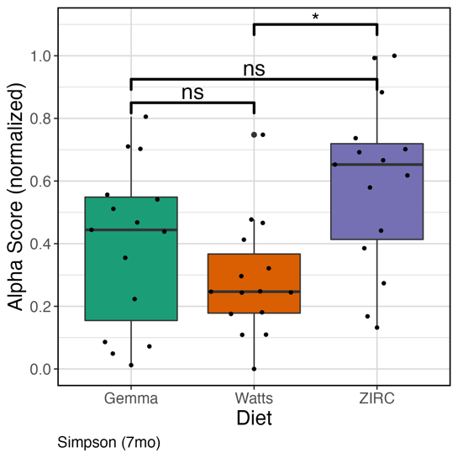

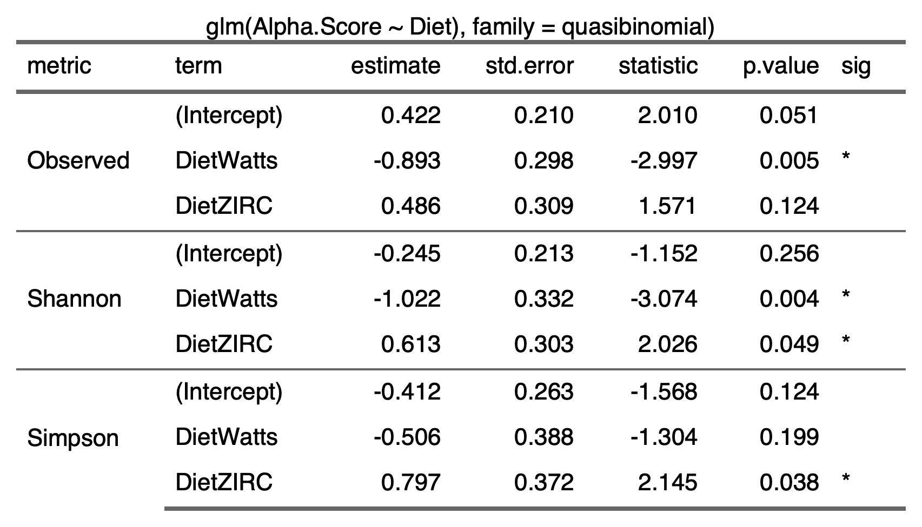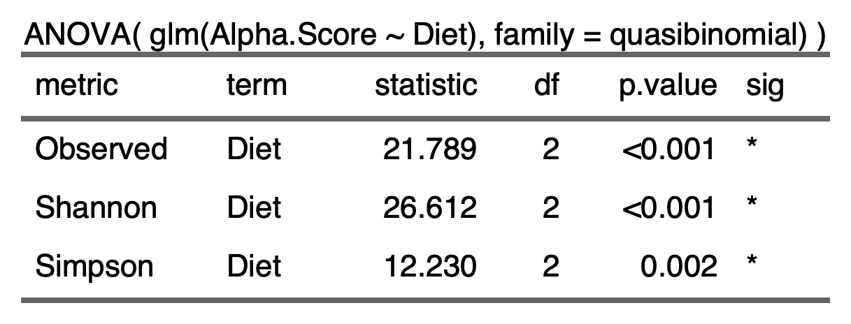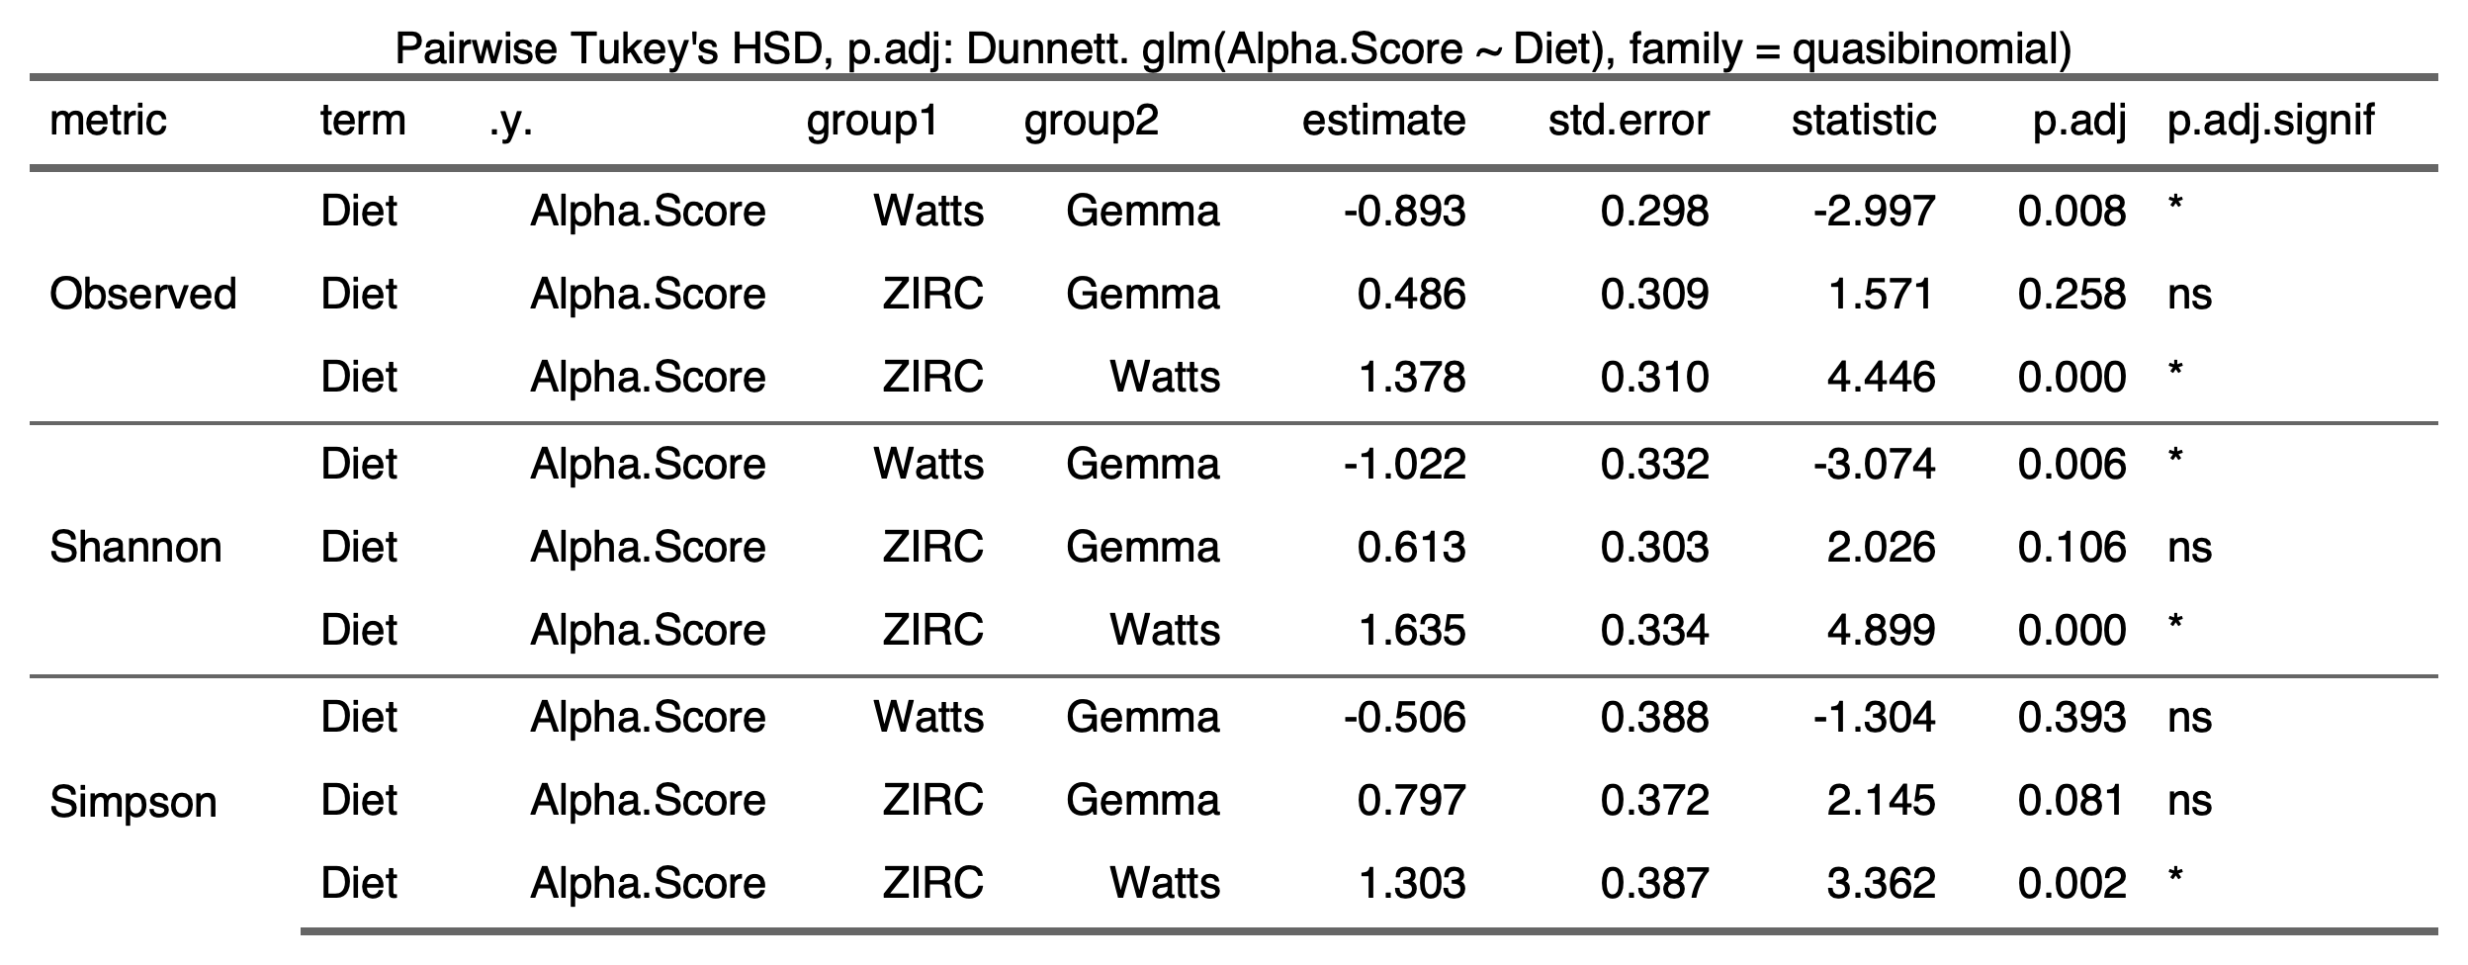

2.7.3) Beta-Diversity

2.7.3.1)

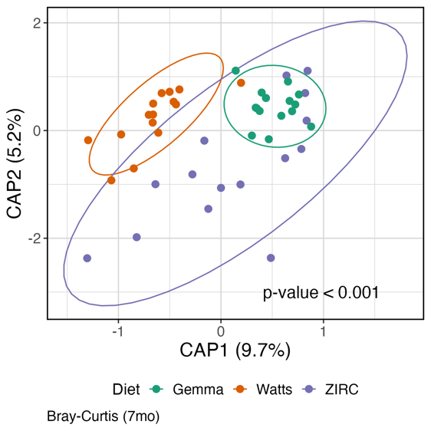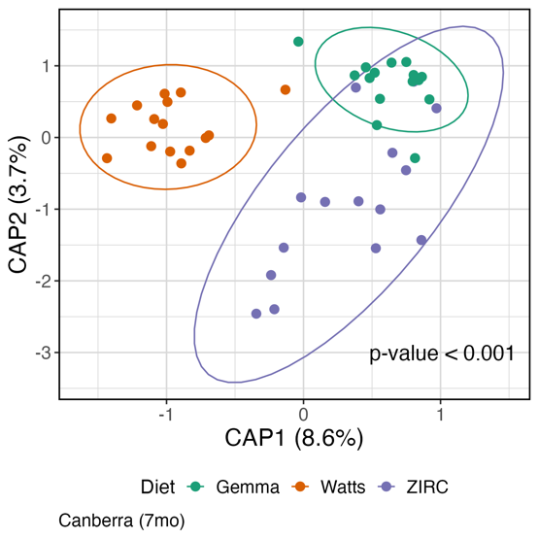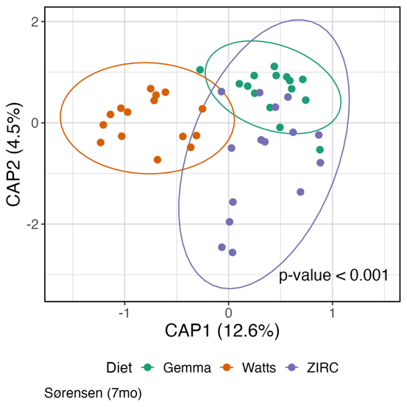

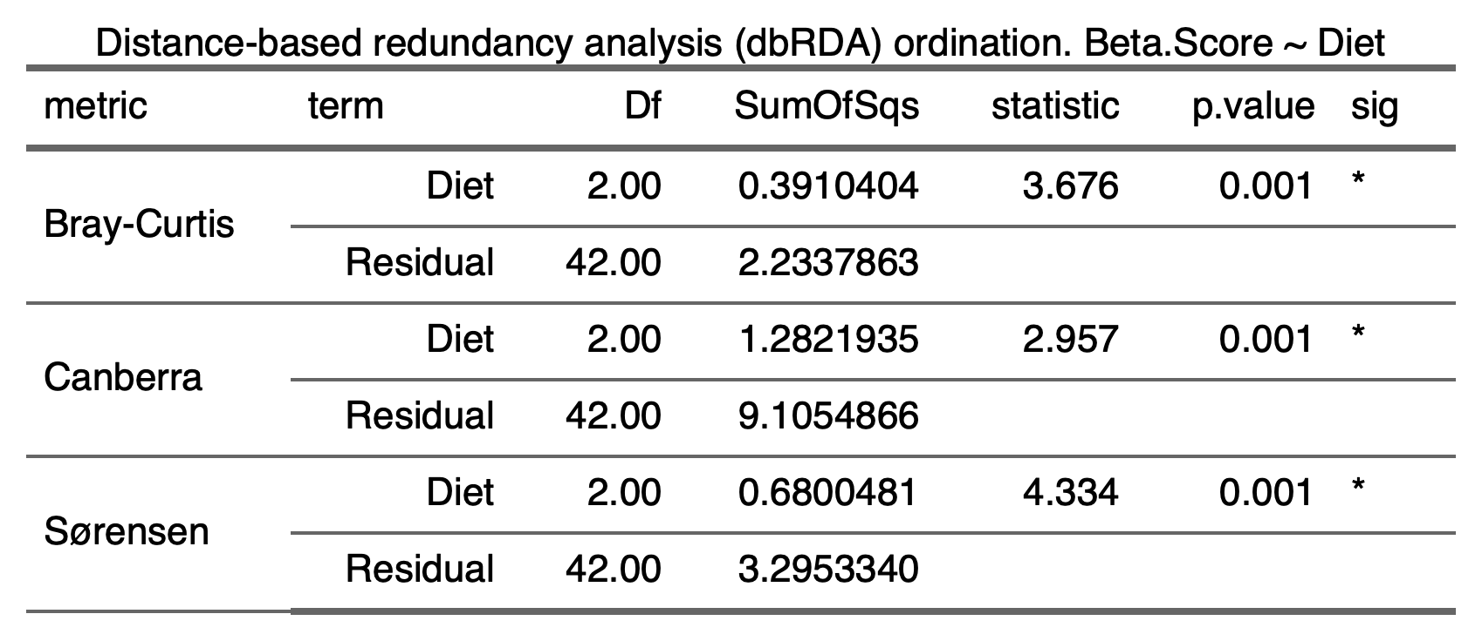

2.7.3.2) Beta-dispersion (Bray, Canberra, Sorensen)

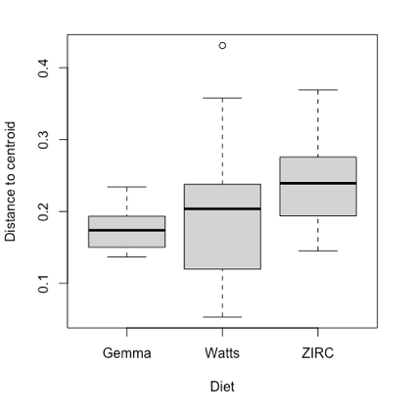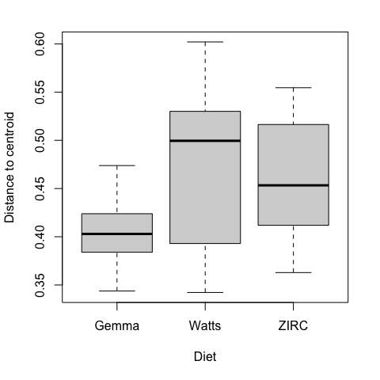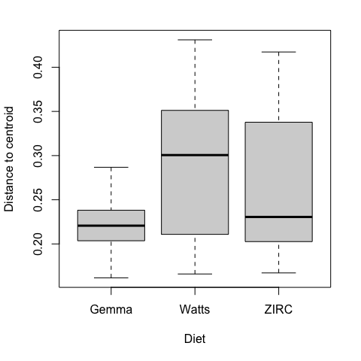

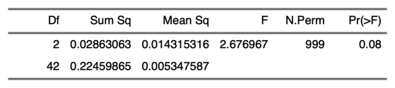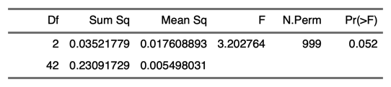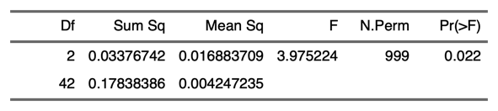

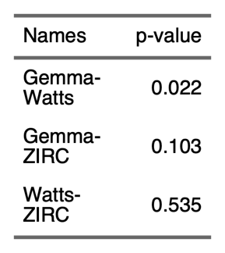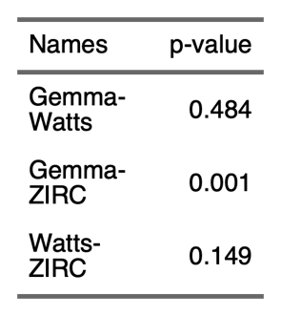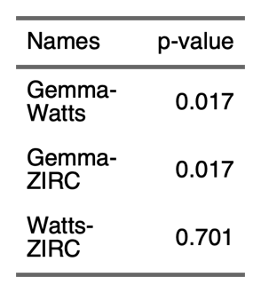

2.7.4) Differential Abundance

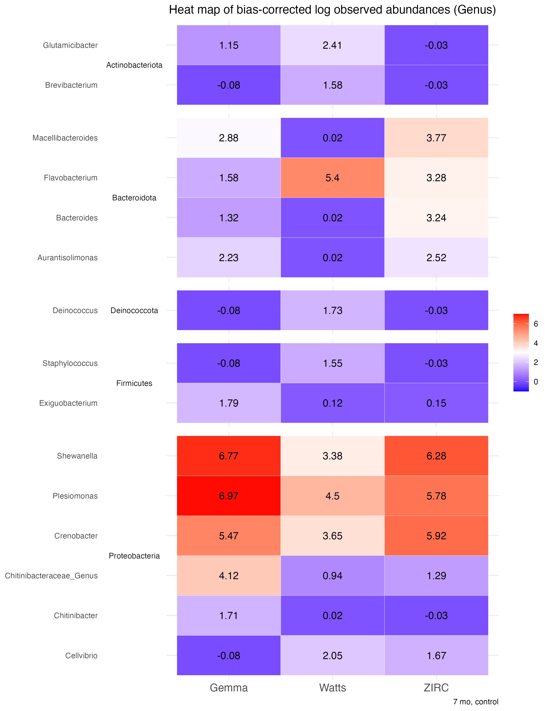

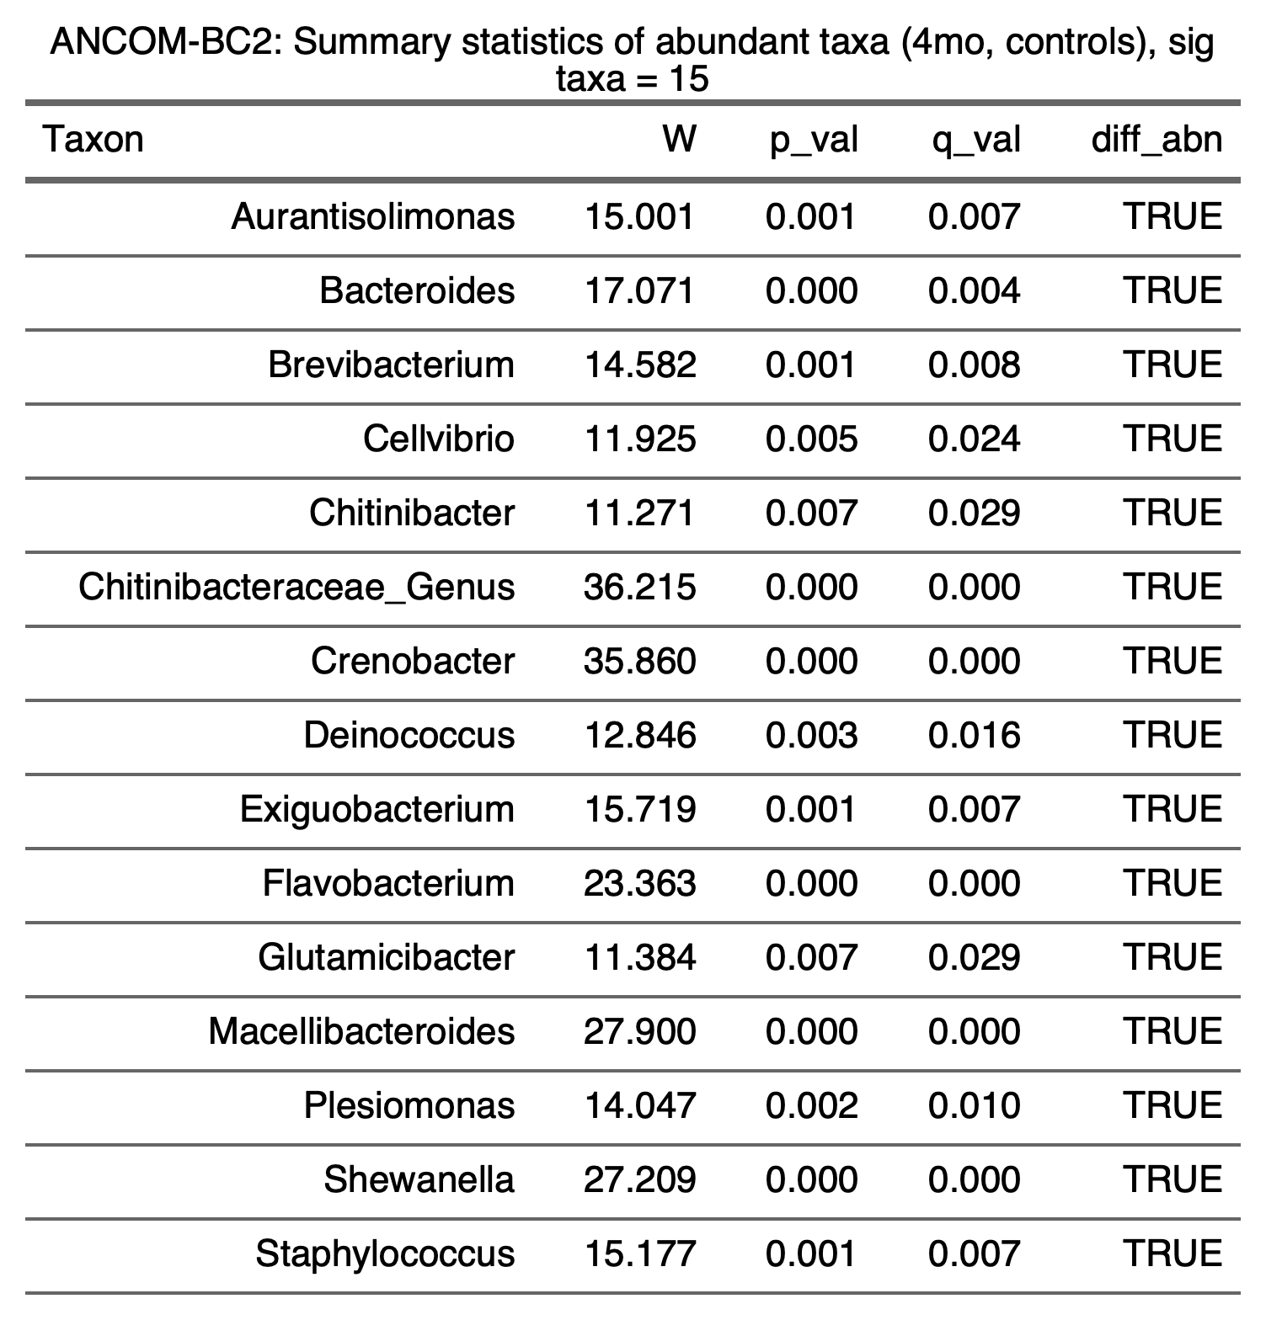

**3) Exposure**

**3.1) Alpha-diversity**

**3.1.1) Exposure**

3.1.1.1) 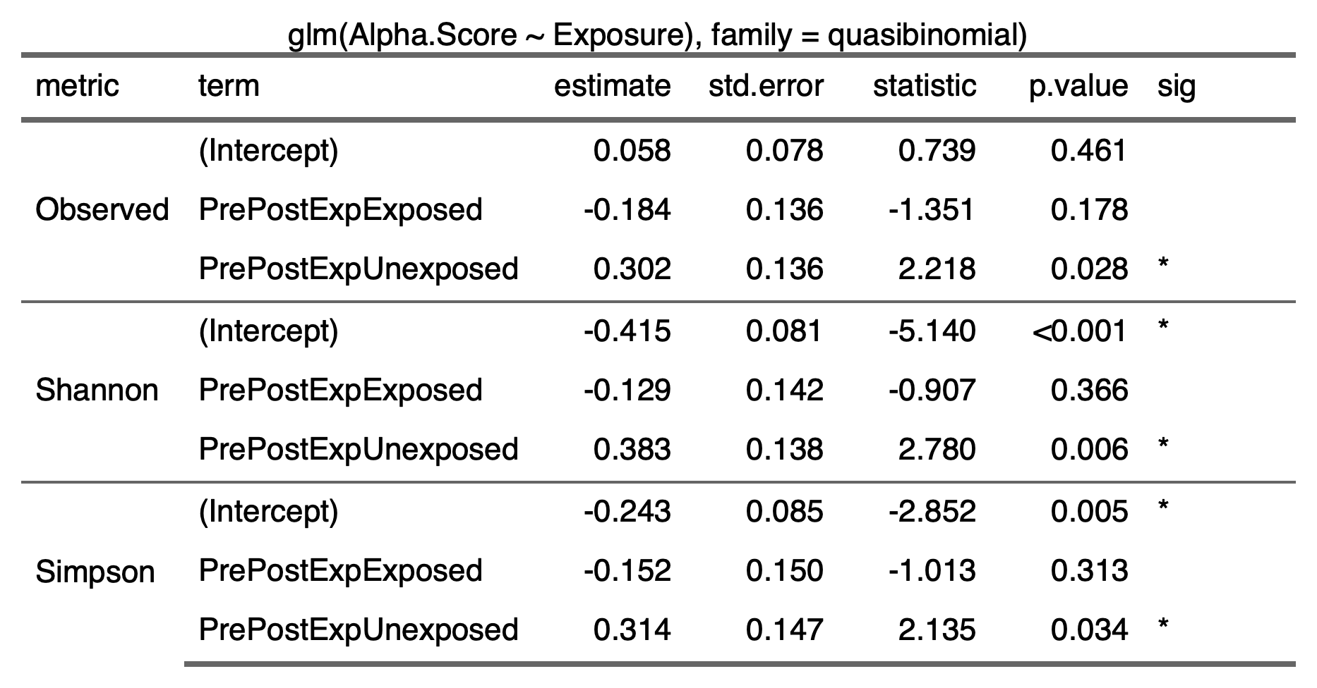

3.1.1.2) 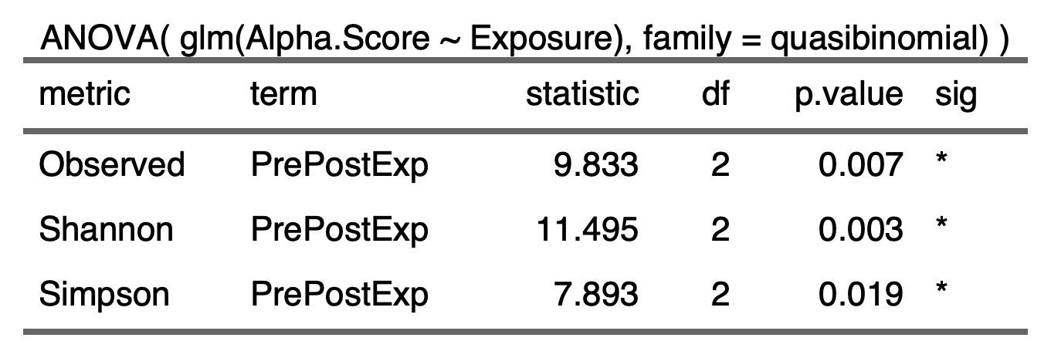

3.1.1.3) 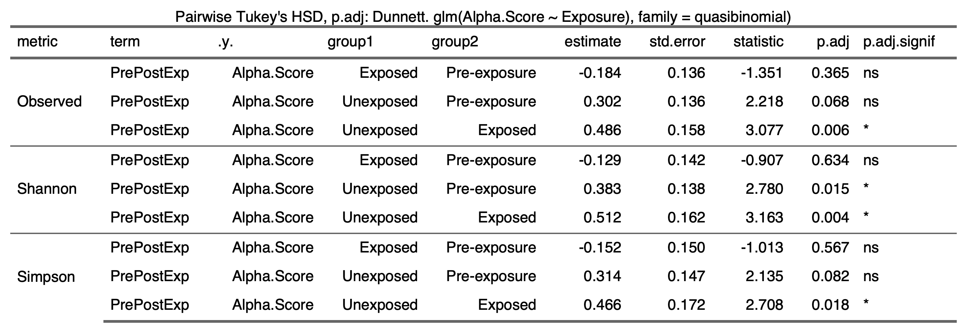

3.1.2) Diet:Exposure

3.1.2.1) 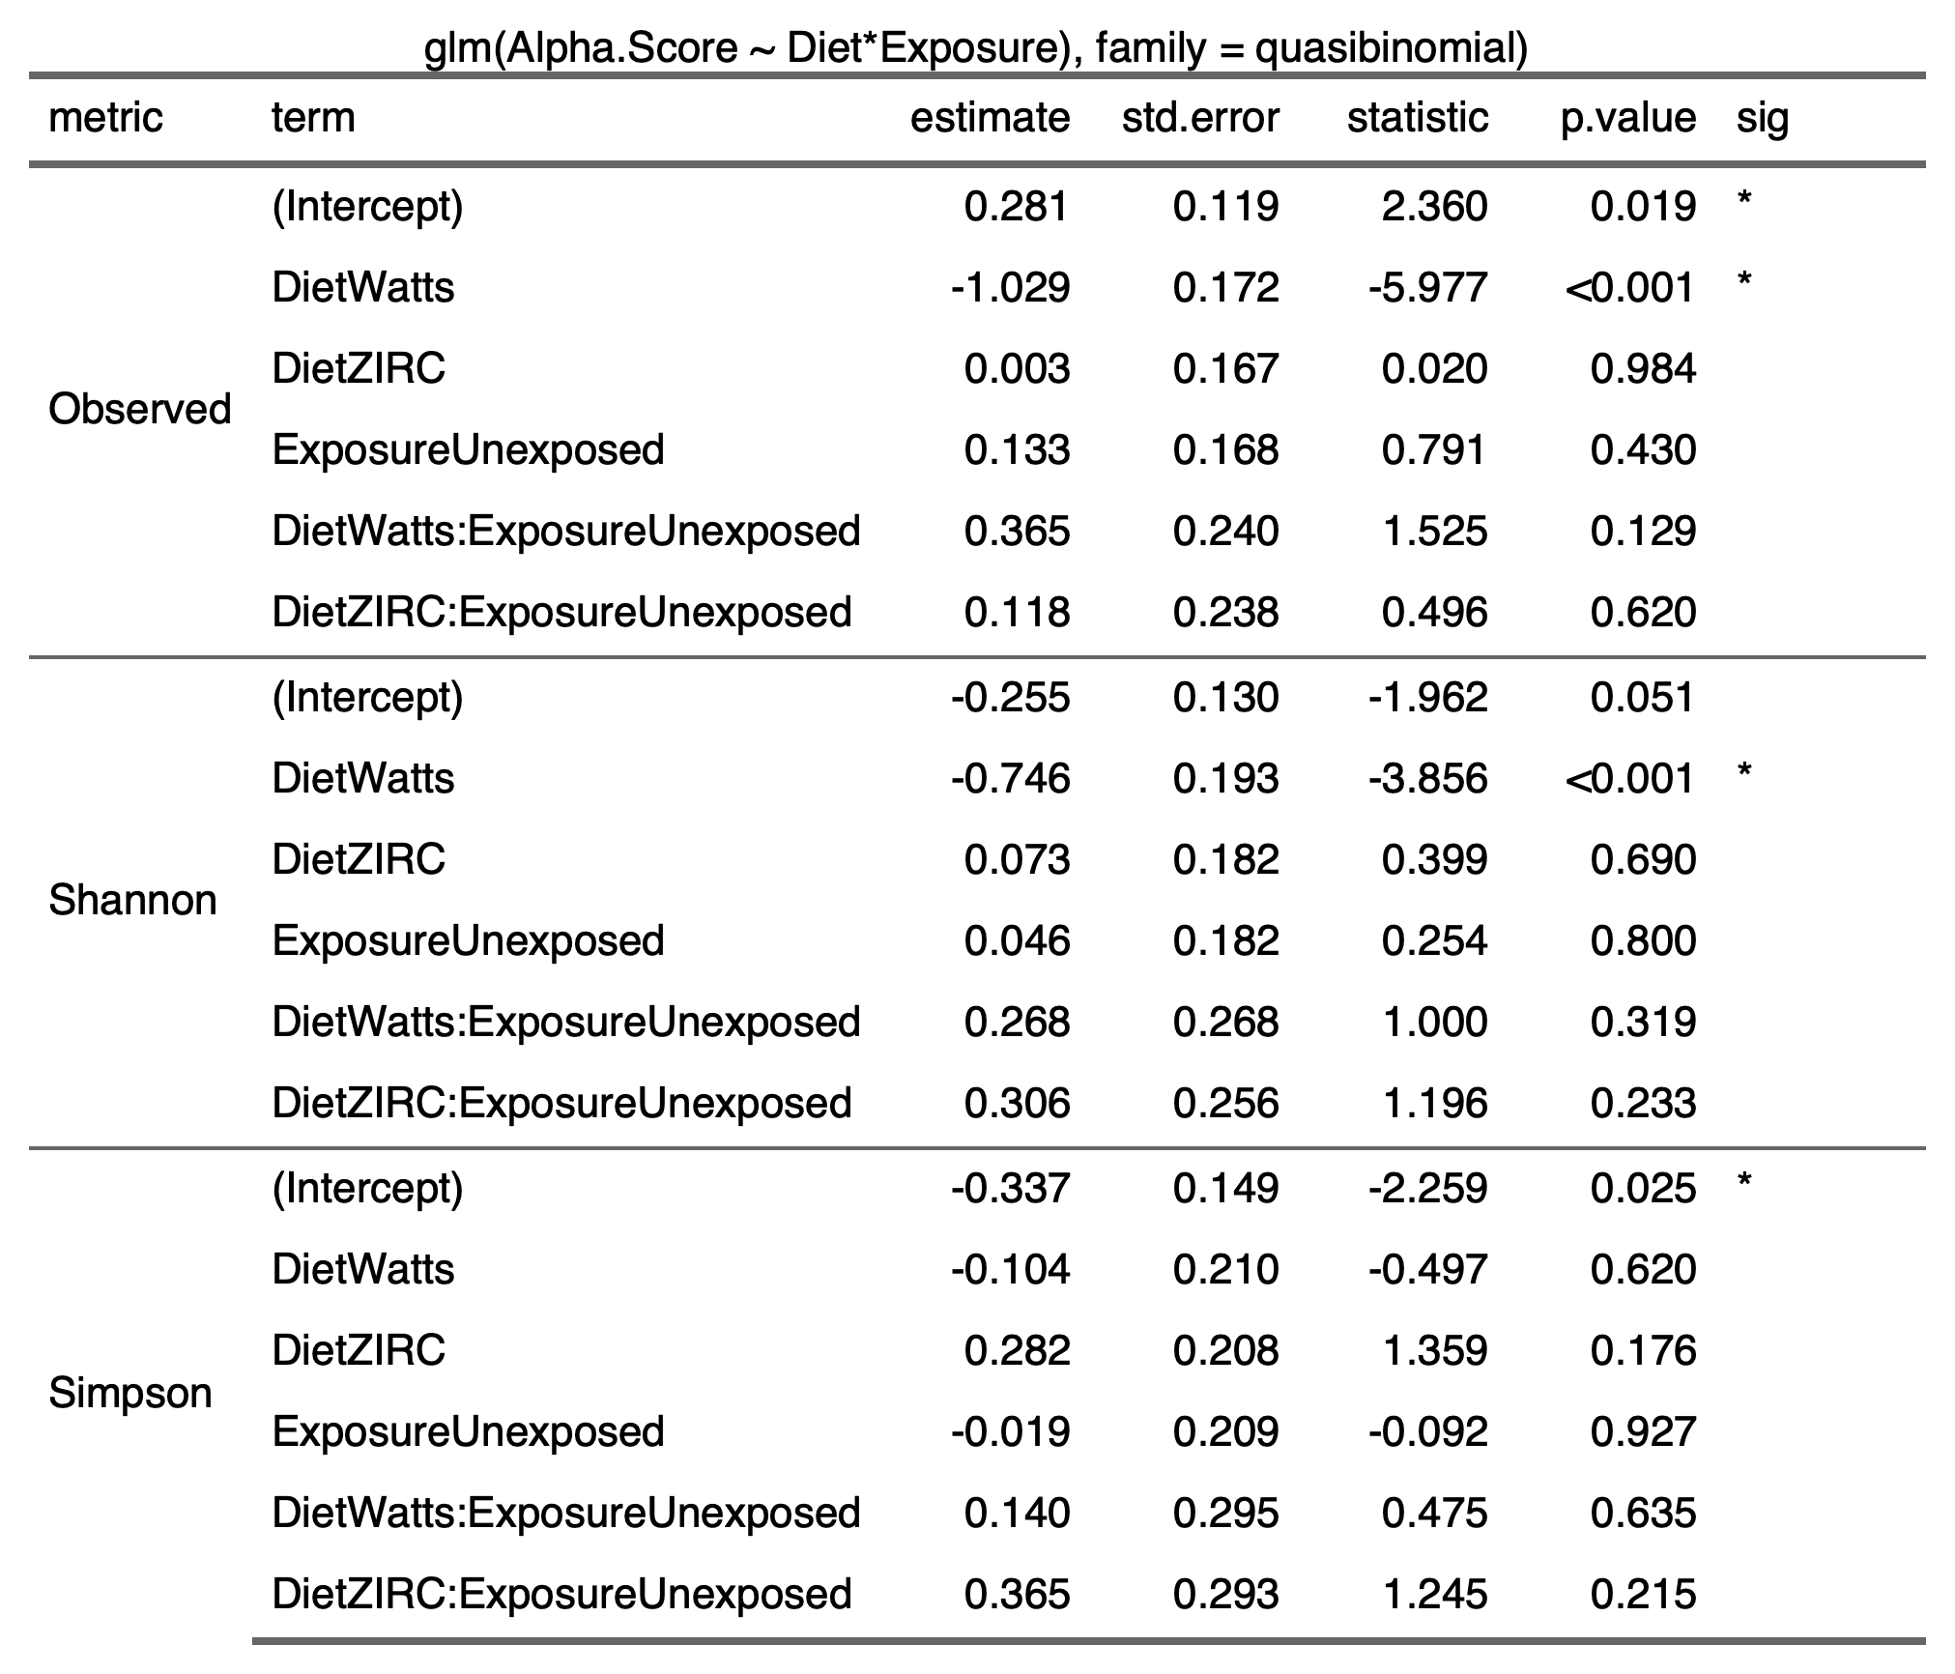

3.1.2.2) 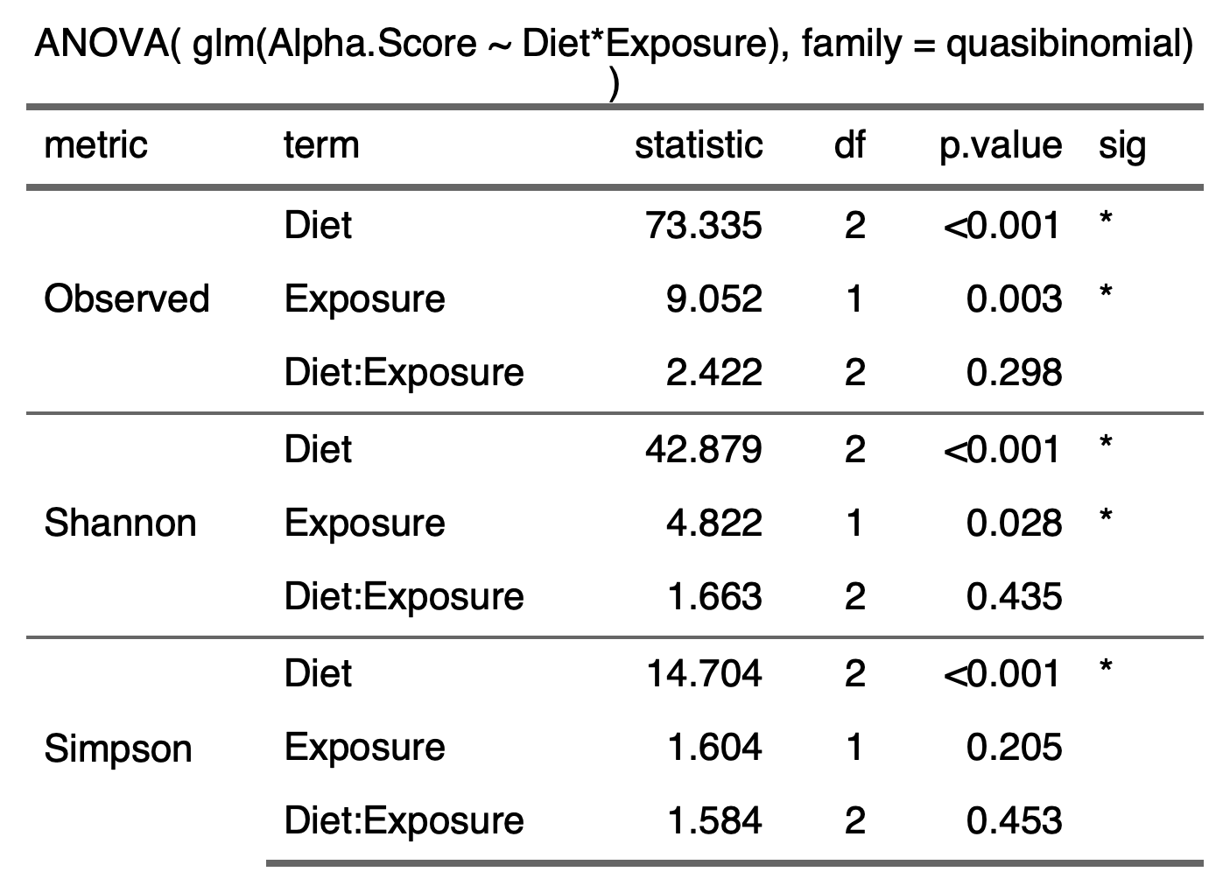

3.1.2.3) 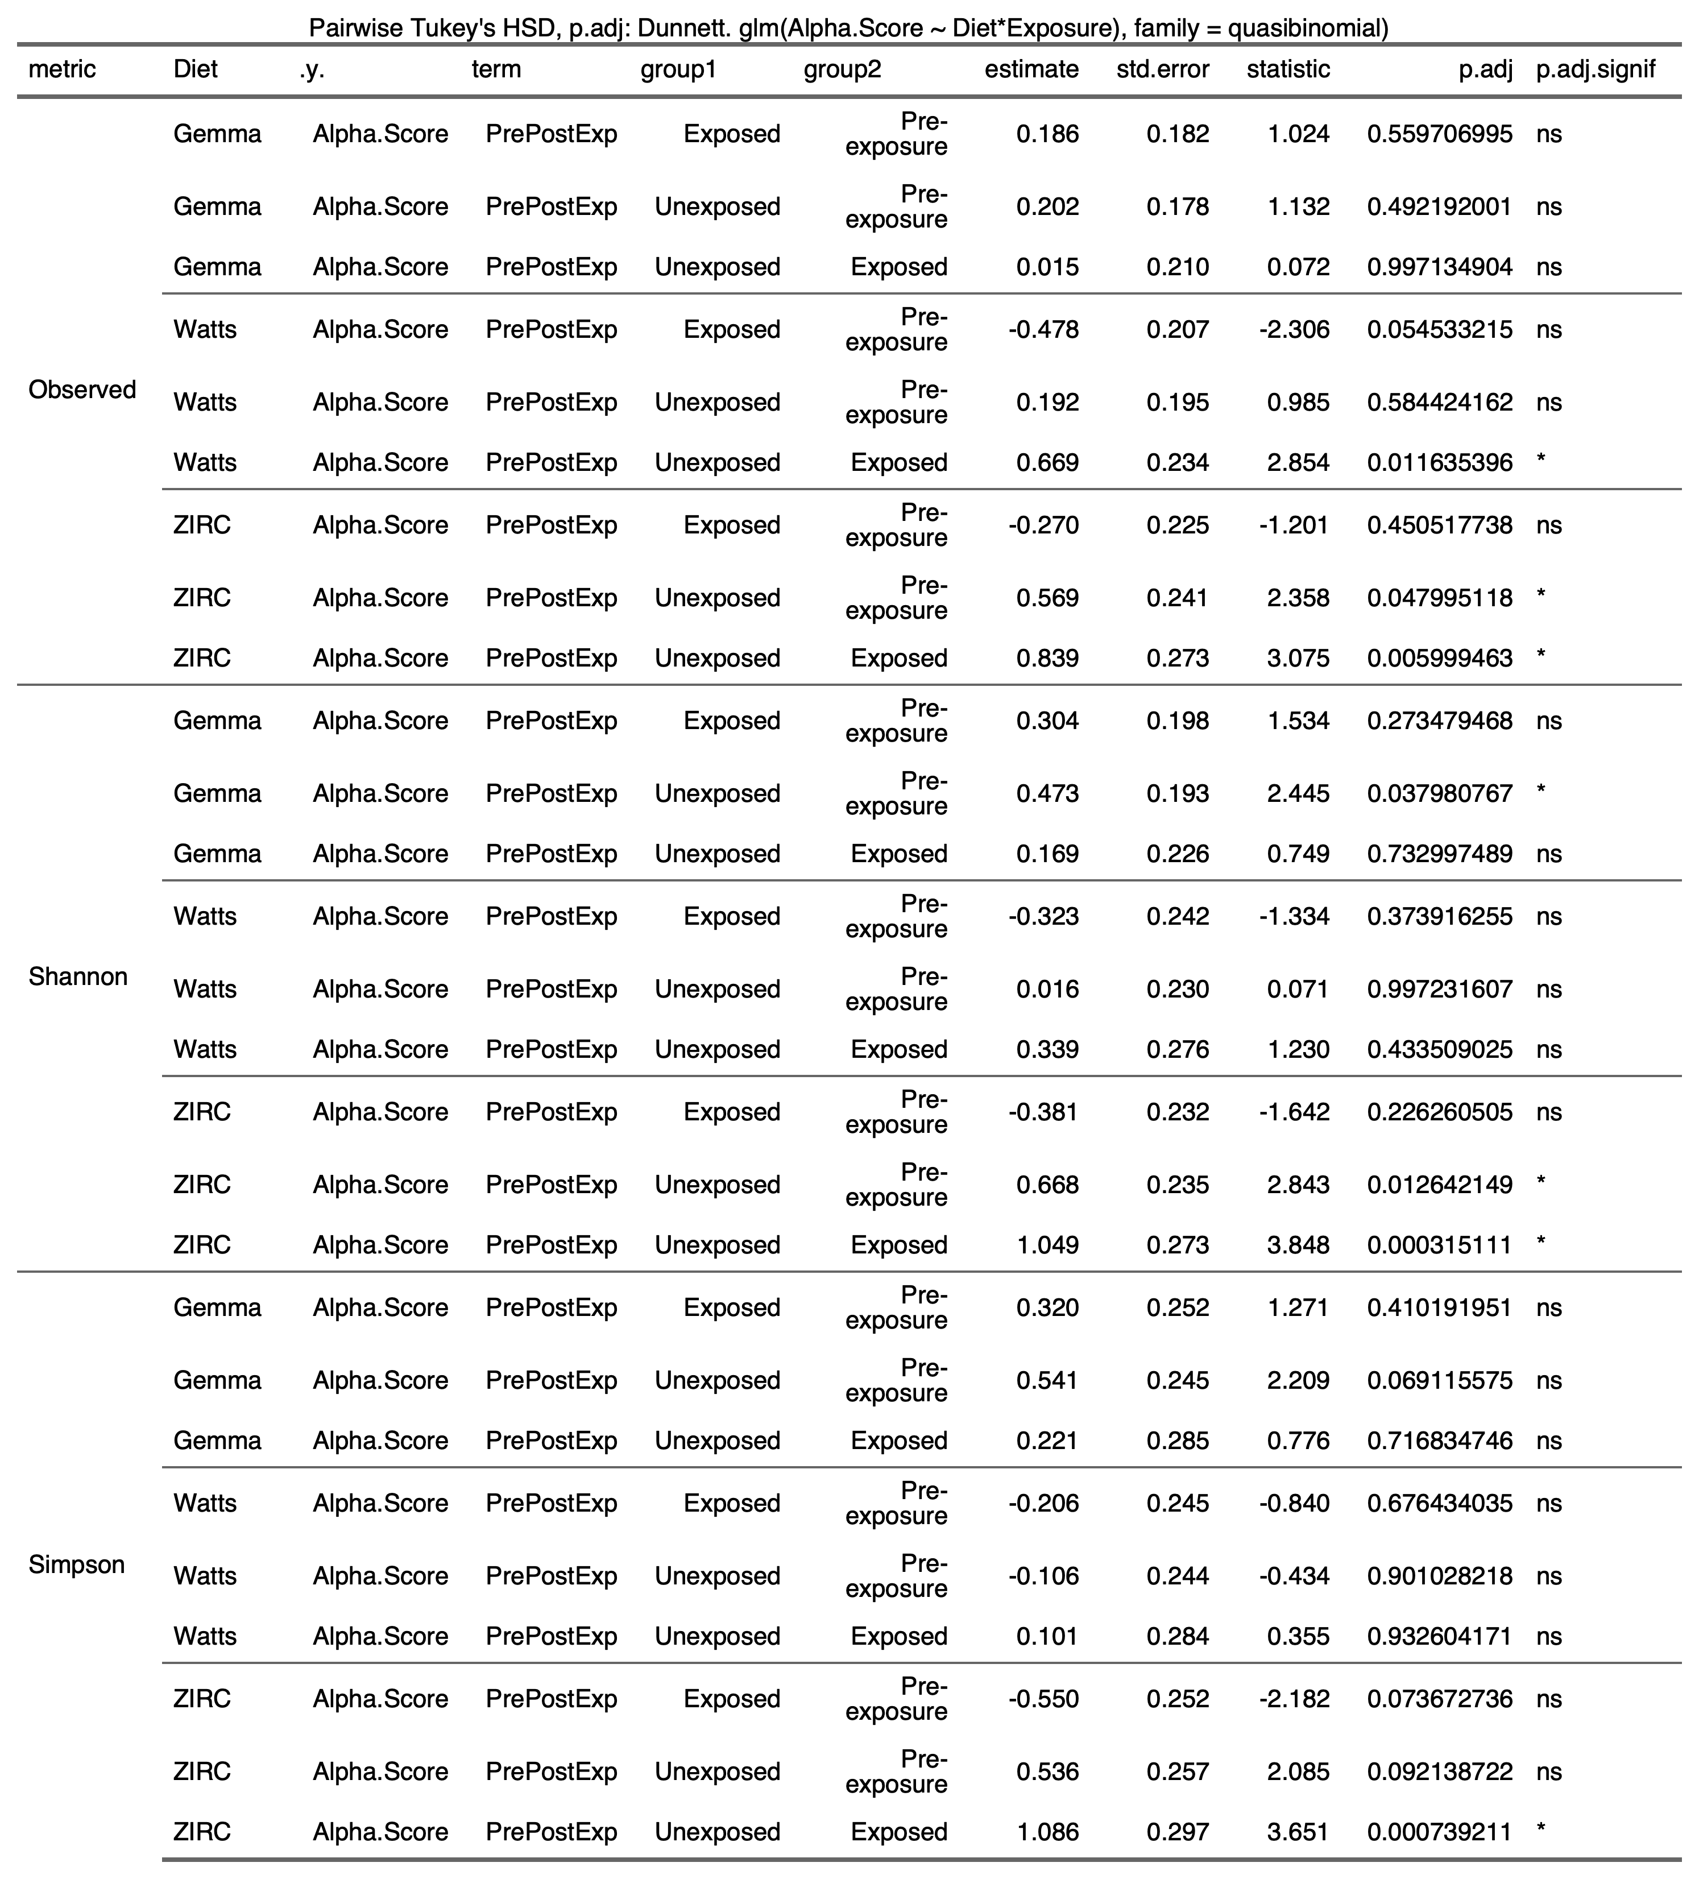

**3.2) Beta-diversity**

3.2.1) 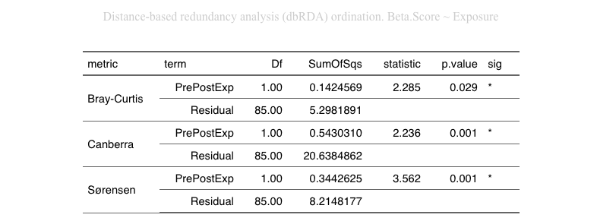

3.2.2) 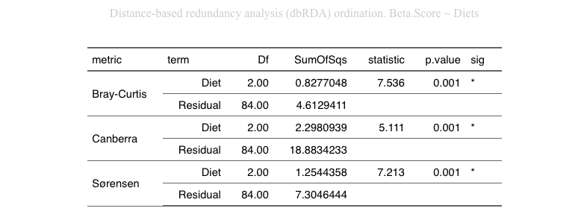

3.2.3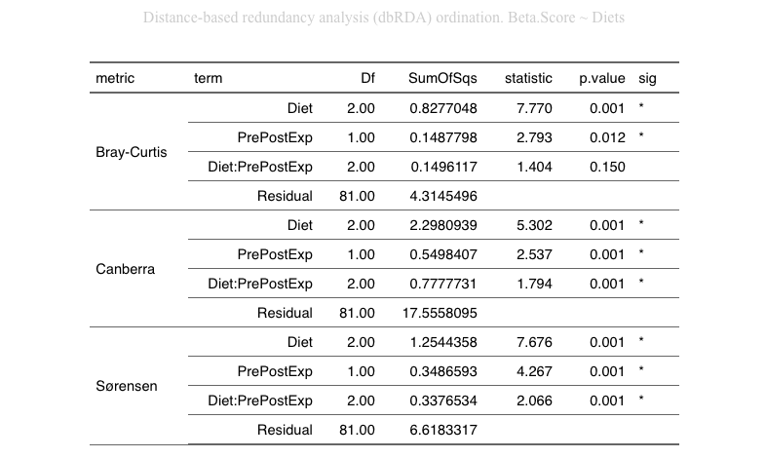

**3.3) Beta-Dispersion**

3.3.1) Exposure

|  |  |
| --- | --- |
|  |  |
|  |  |

3.3.2) Diet:Exposure

|  |  |
| --- | --- |
| Bray-Curtis   |  |
| Canberra   |  |
| Sorensen   |  |

**3.4) Differential Abundance**

3.4.1)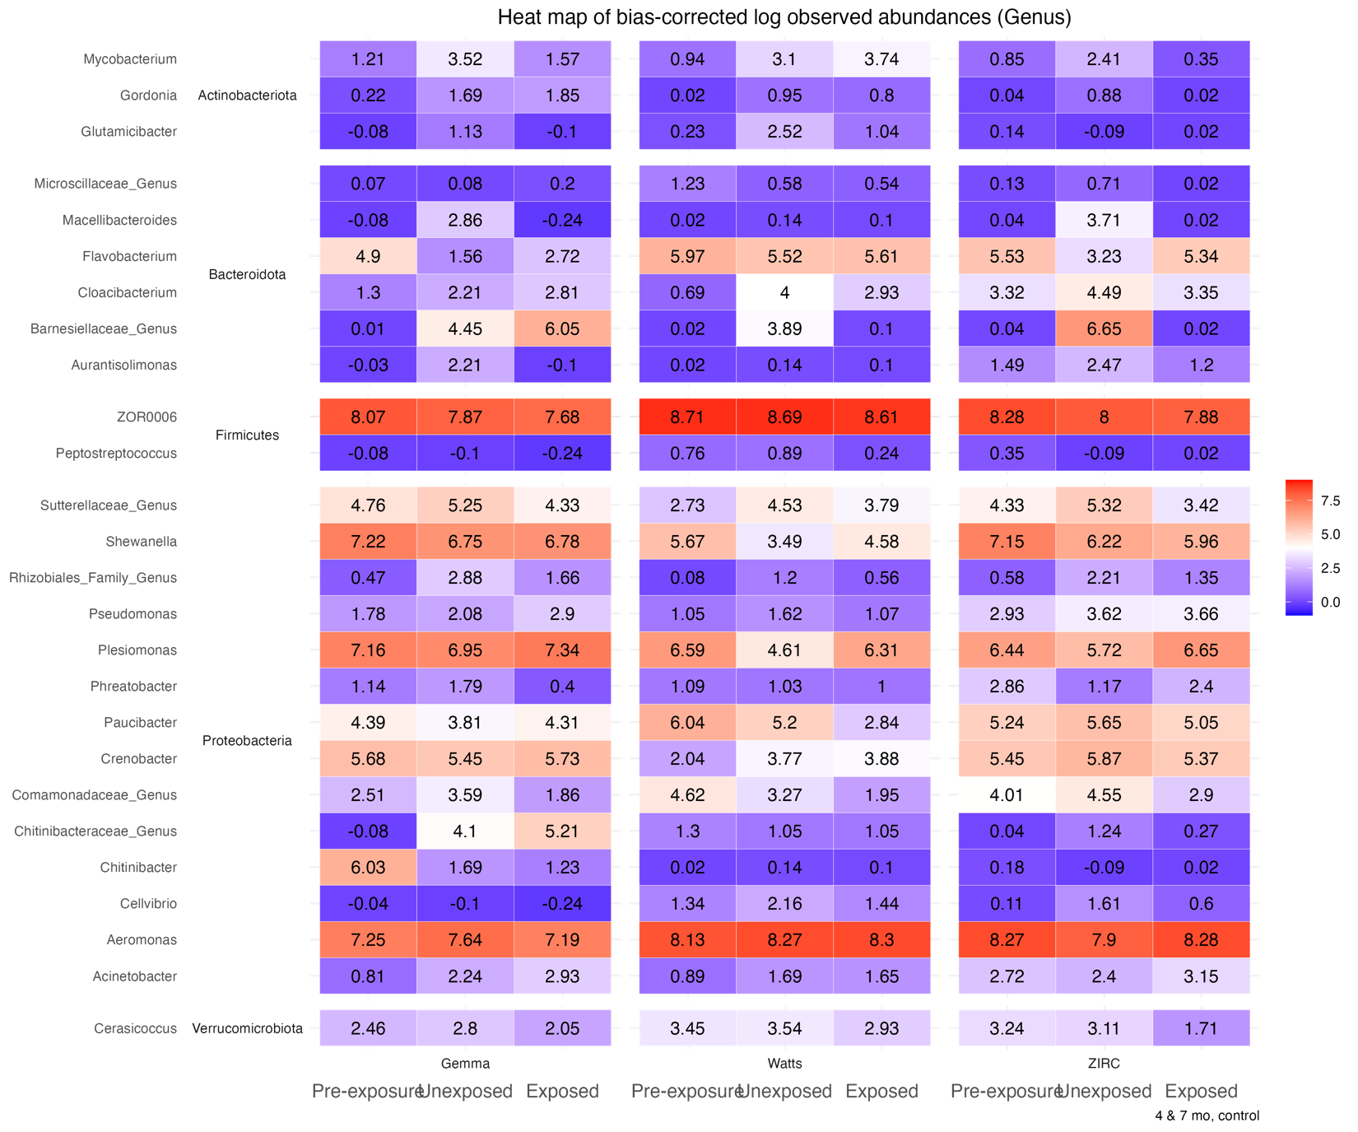

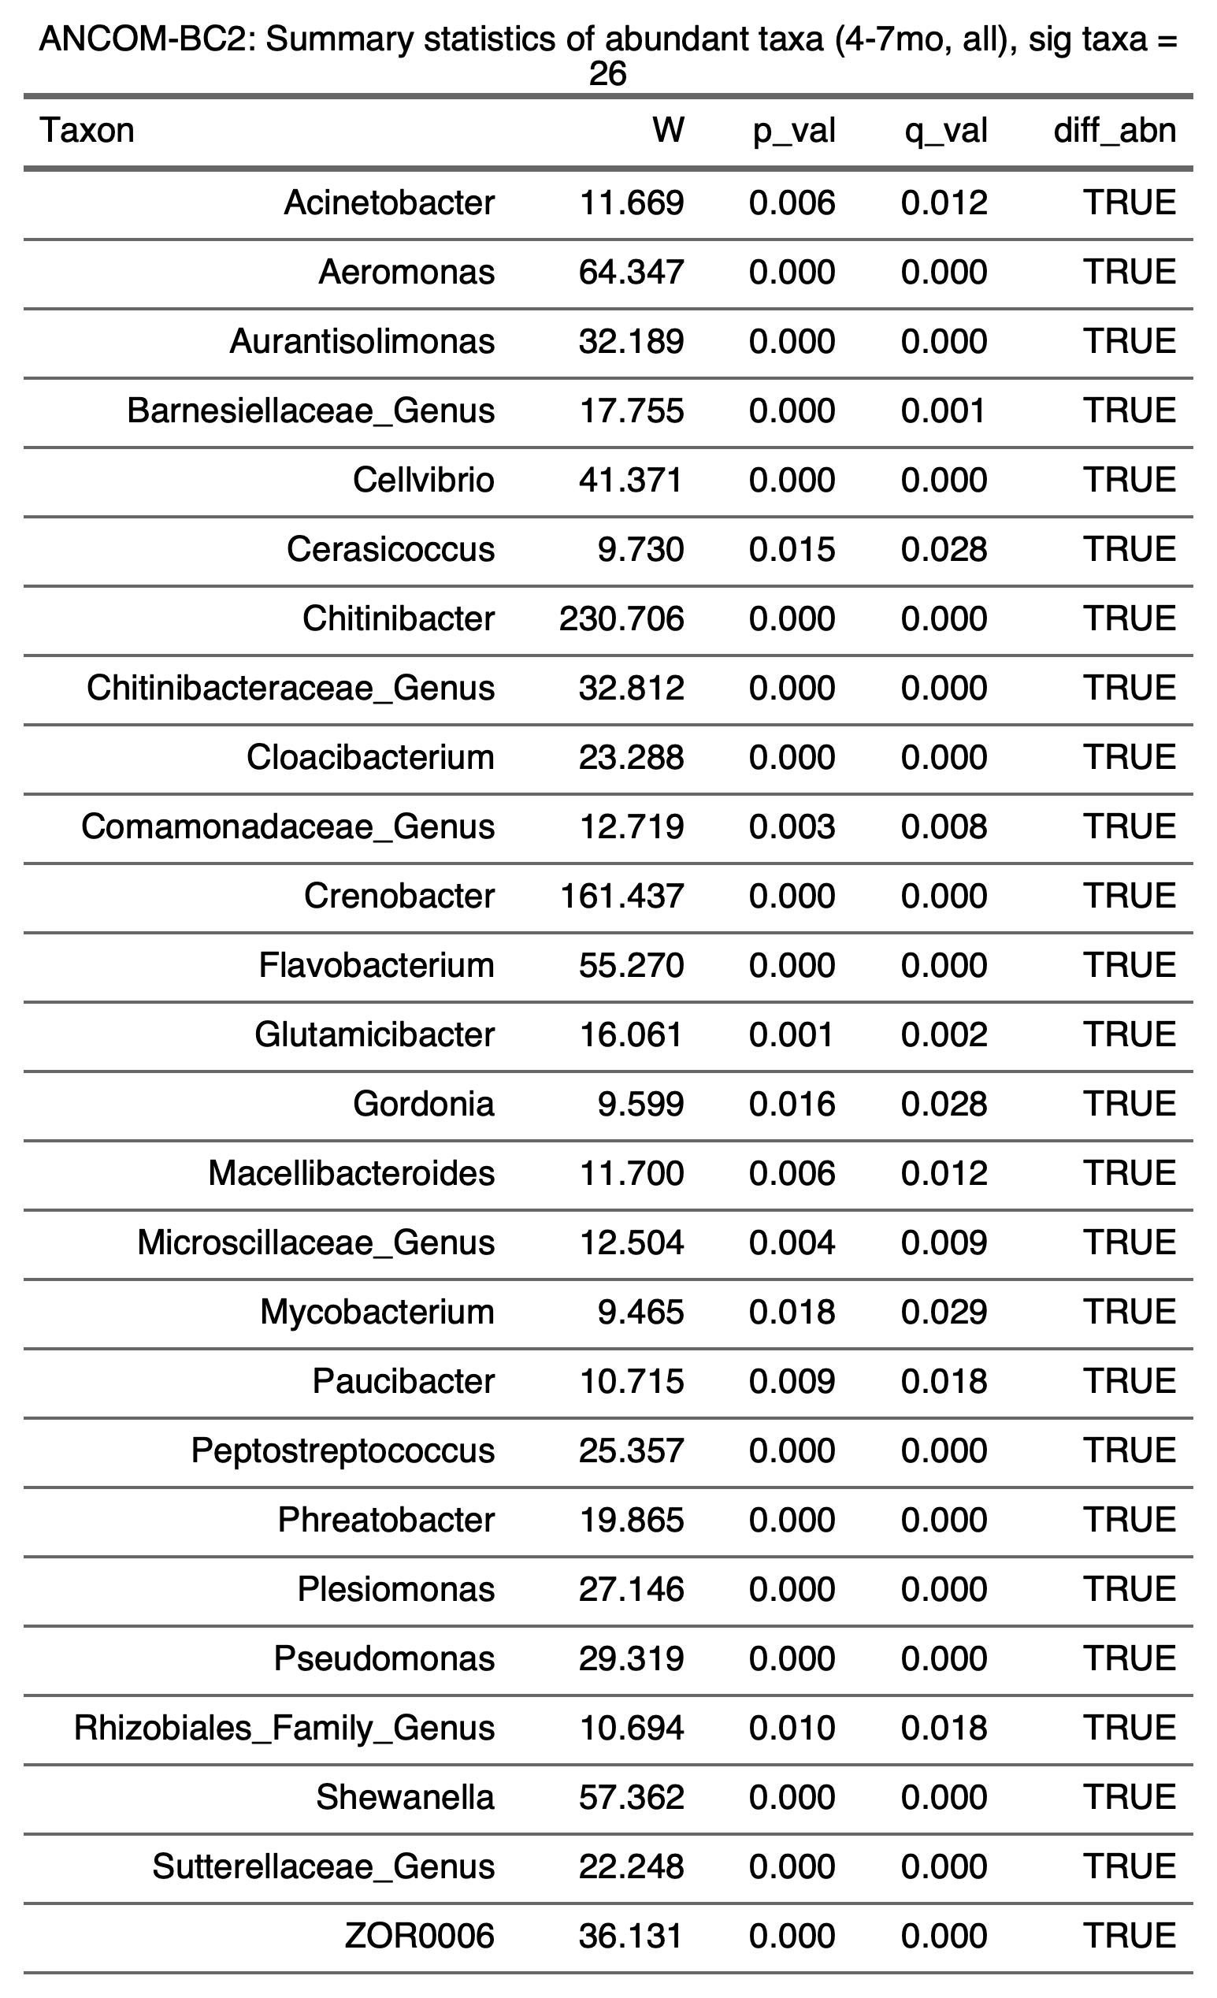

3.4.2) 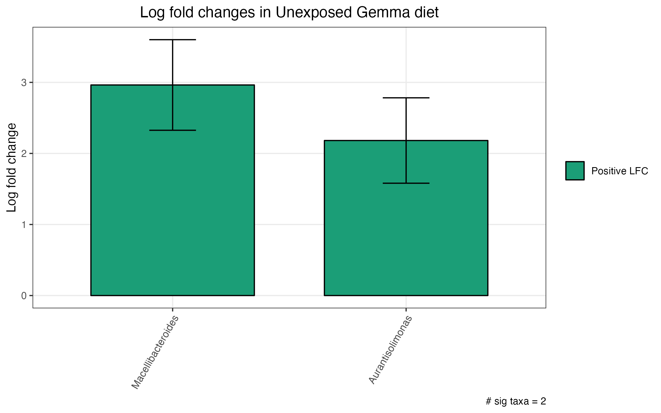

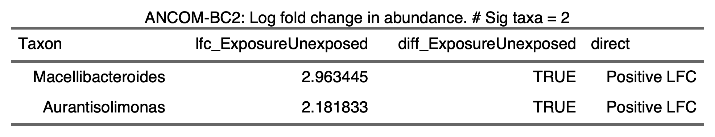

3.4.3) 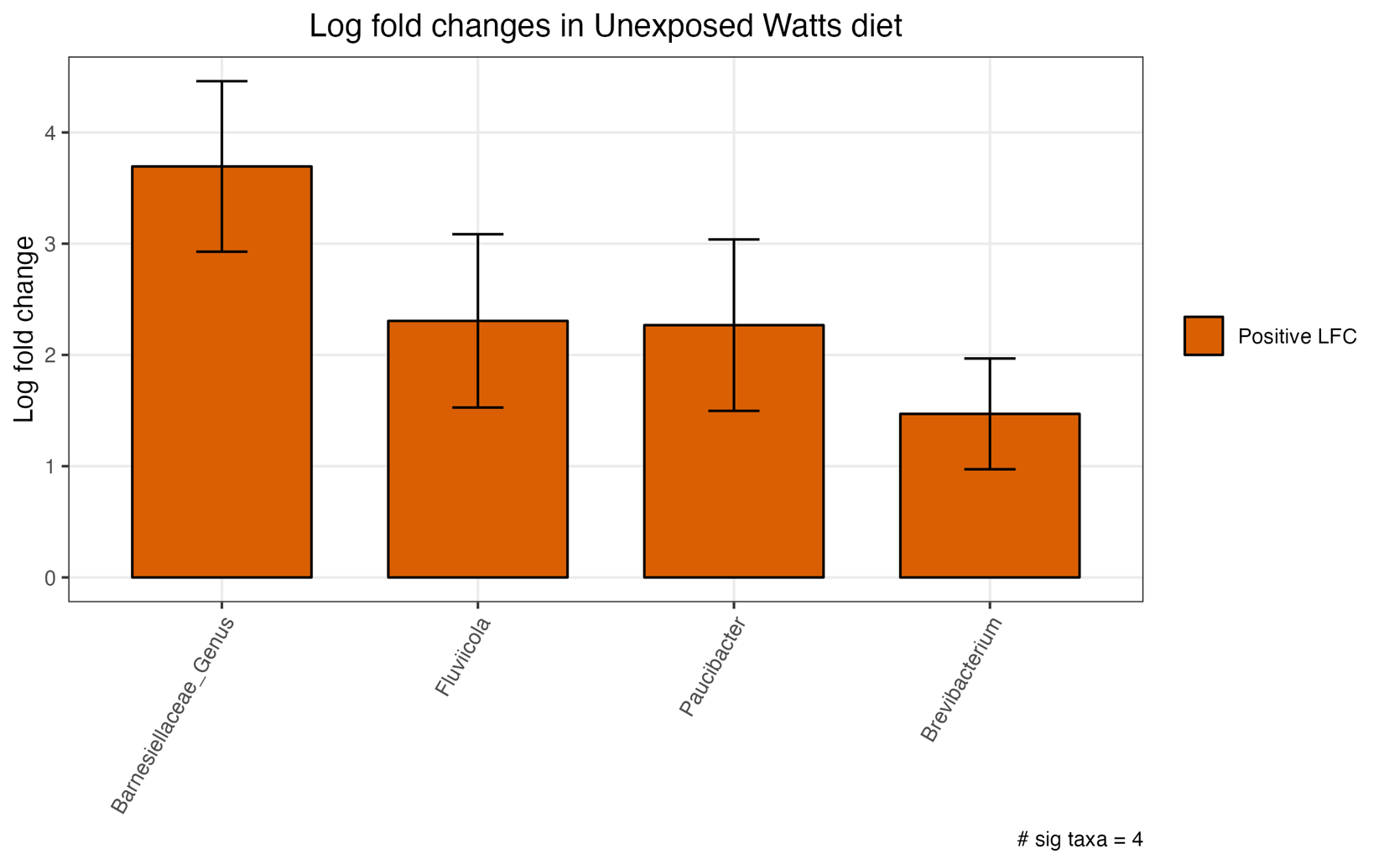

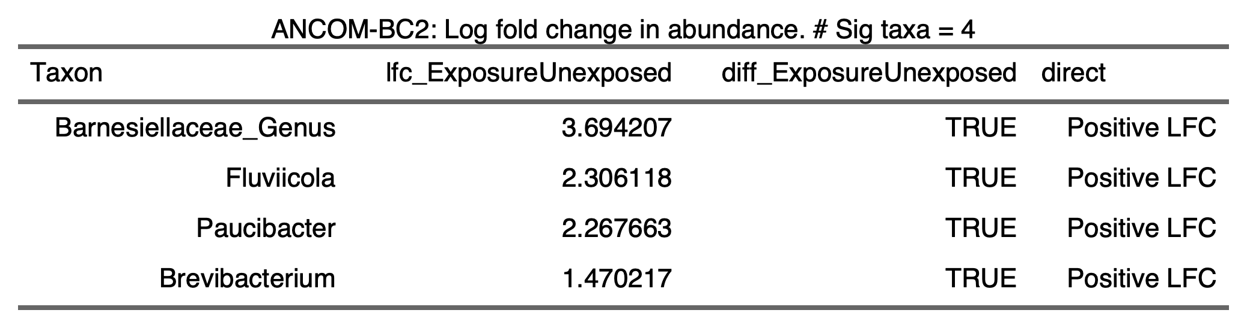

3.4.4) 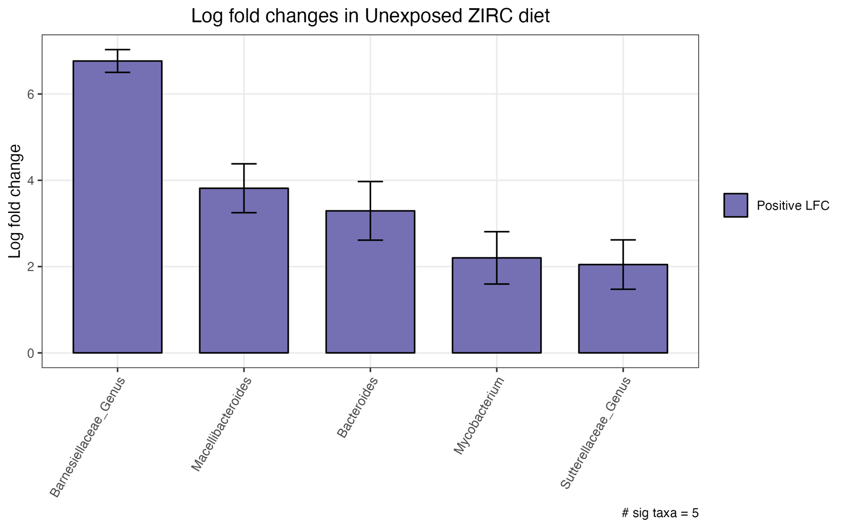

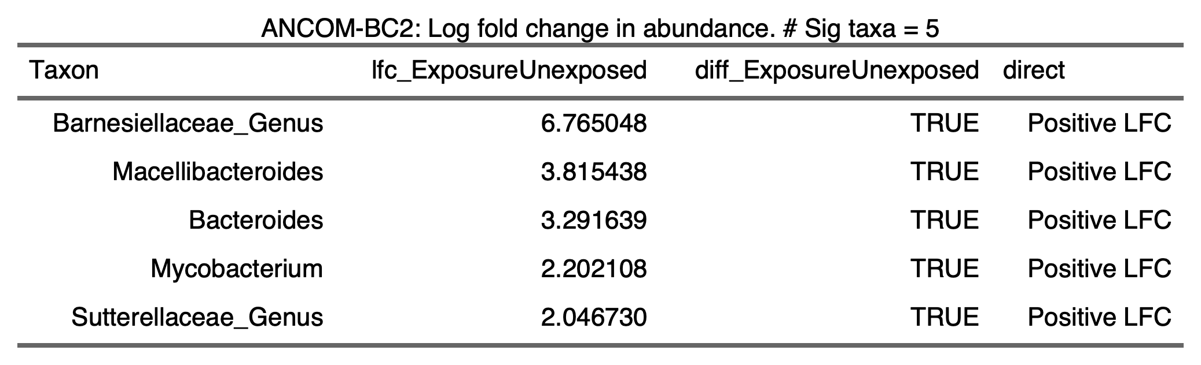

3.4.5) 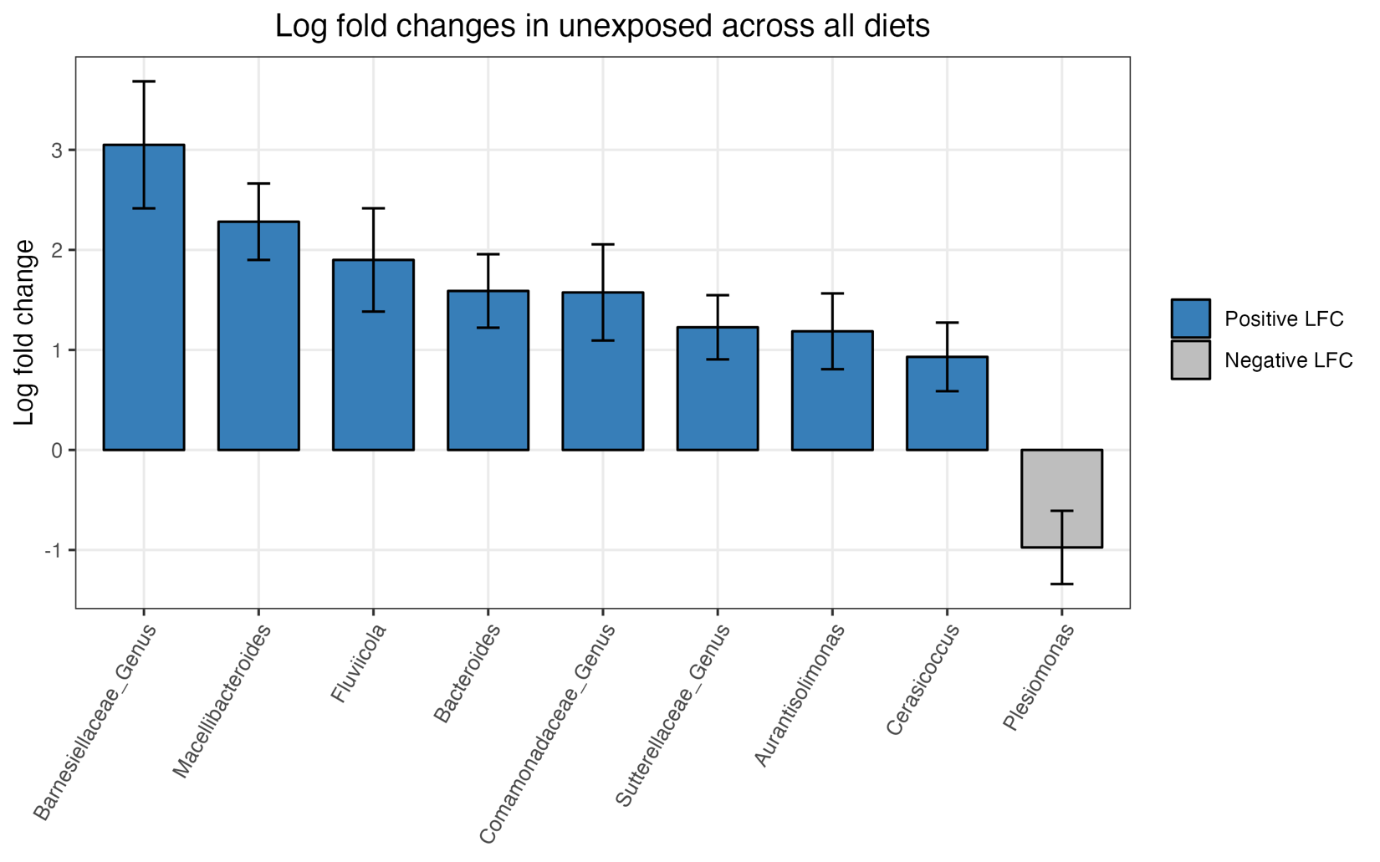

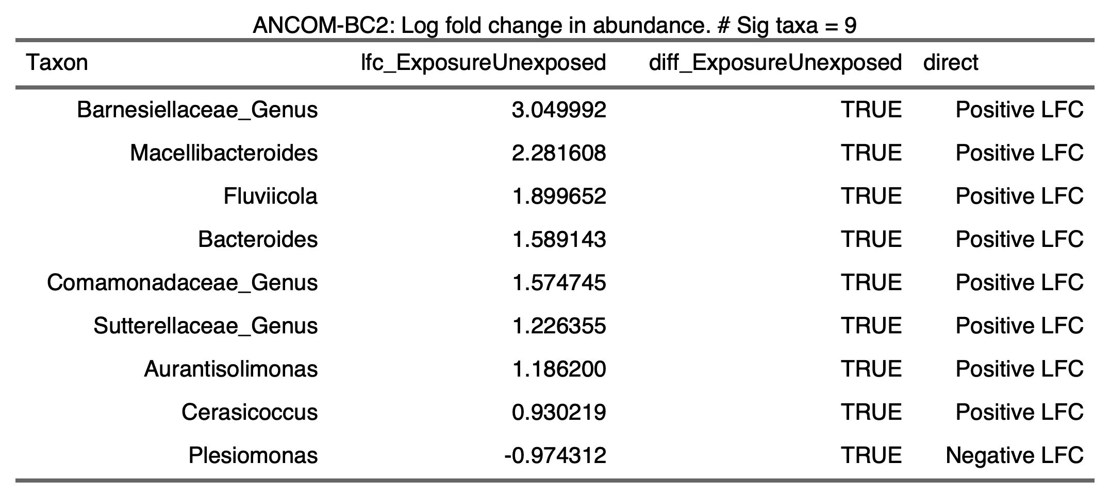

3.4.6) 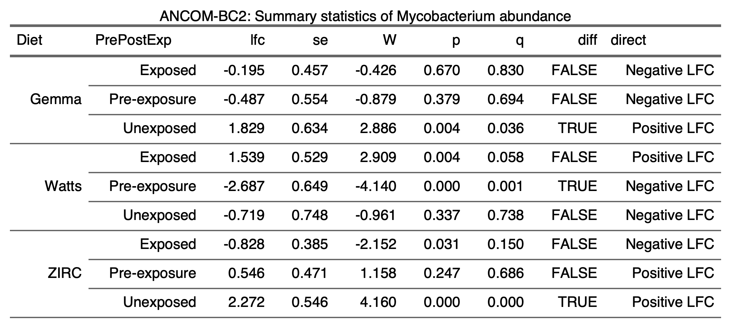

3.5) Infection

3.5.1)

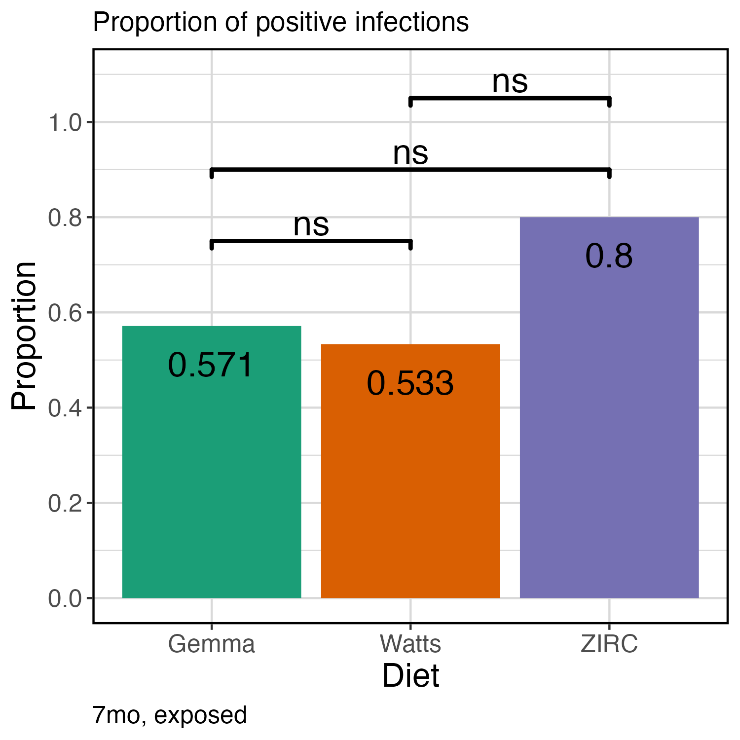

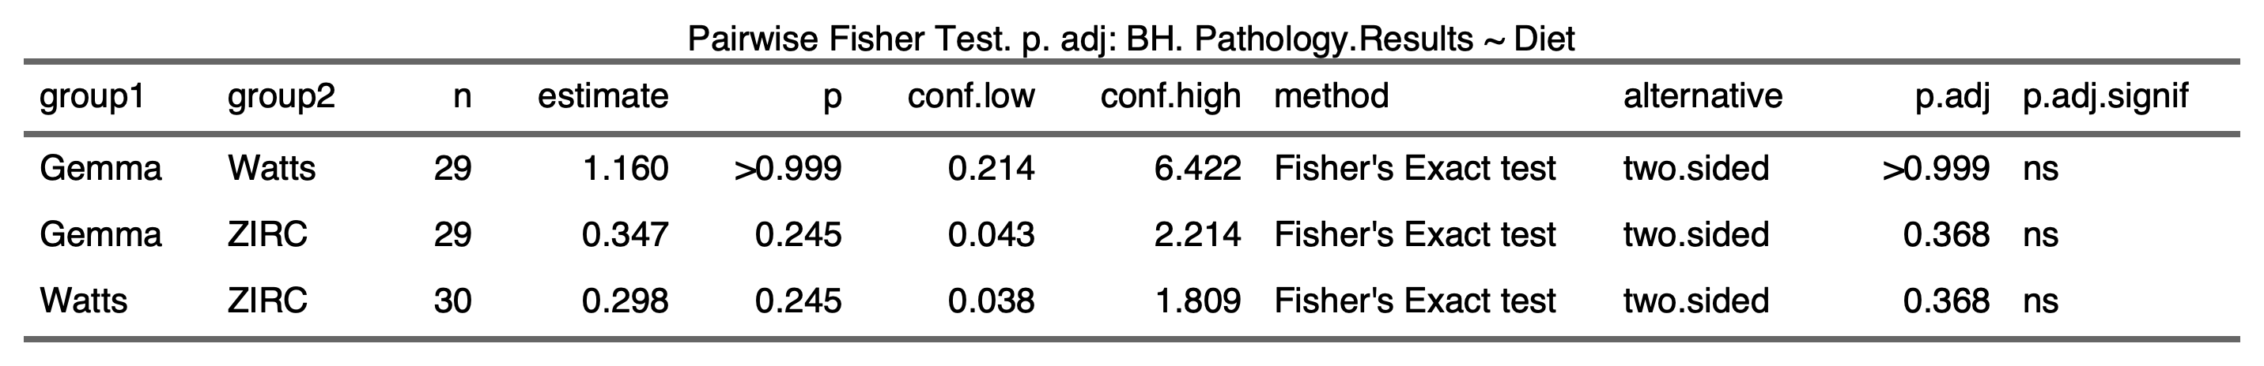

3.5.2)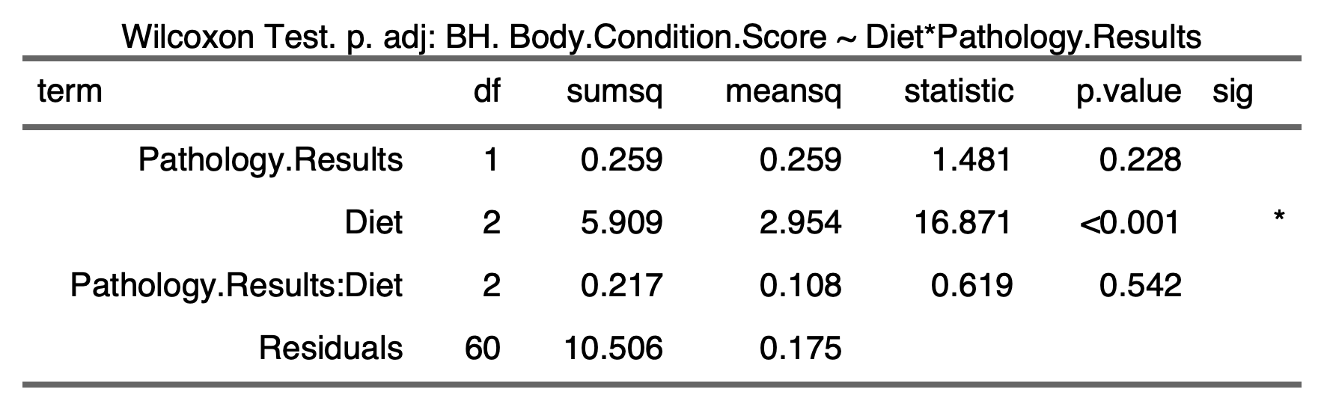

3.5.3)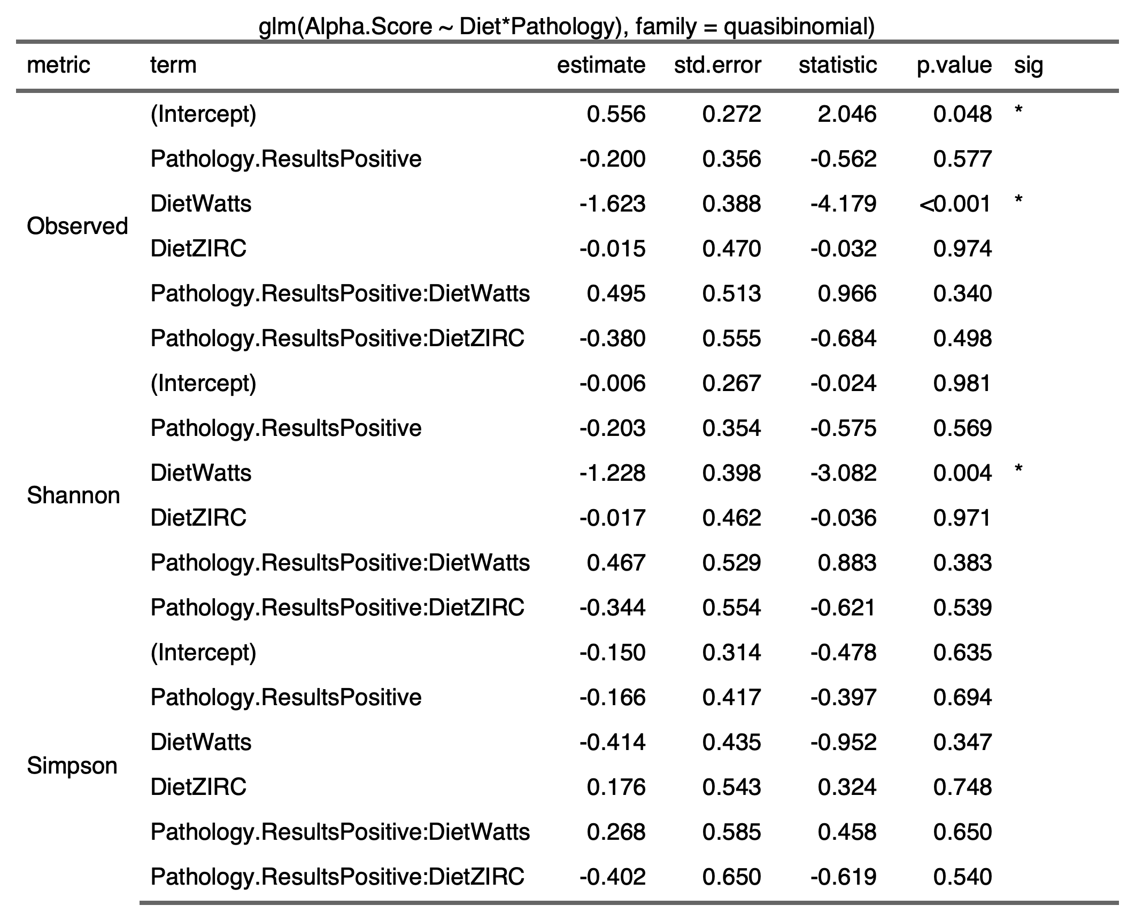

3.5.4) 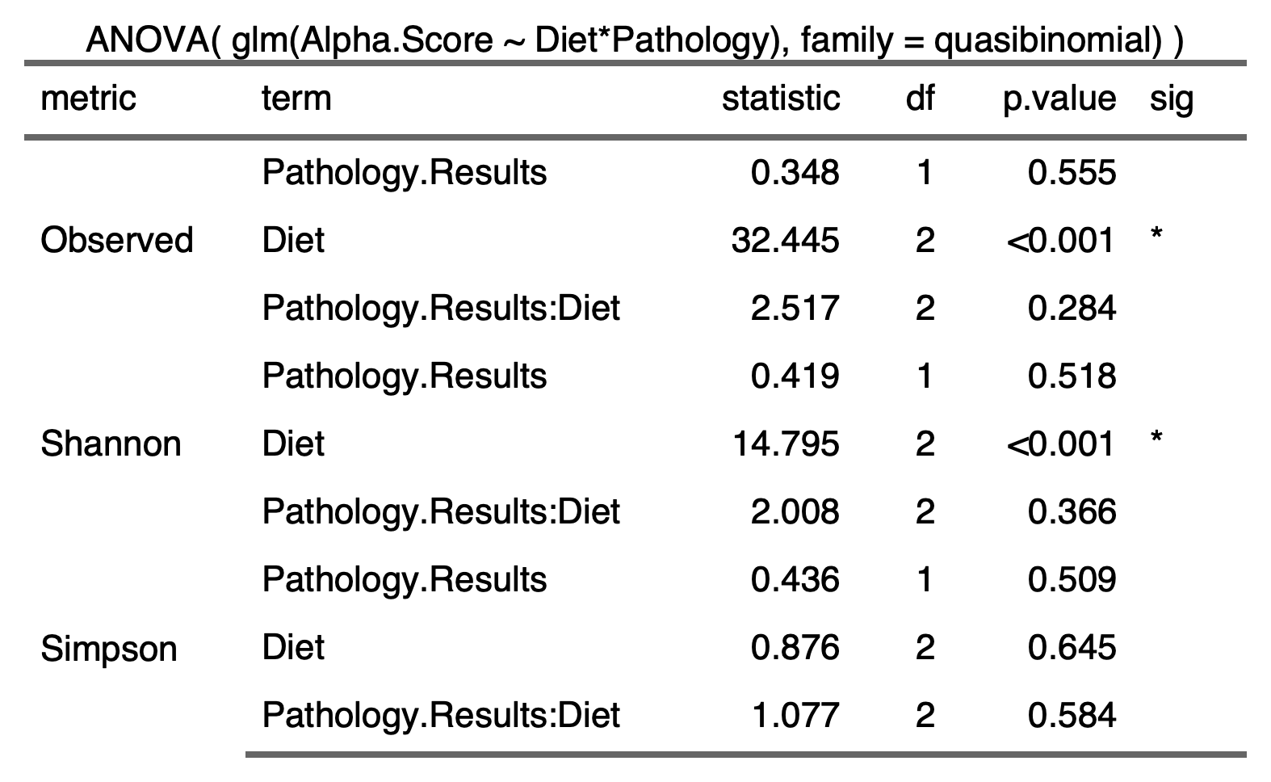

3.5.5) 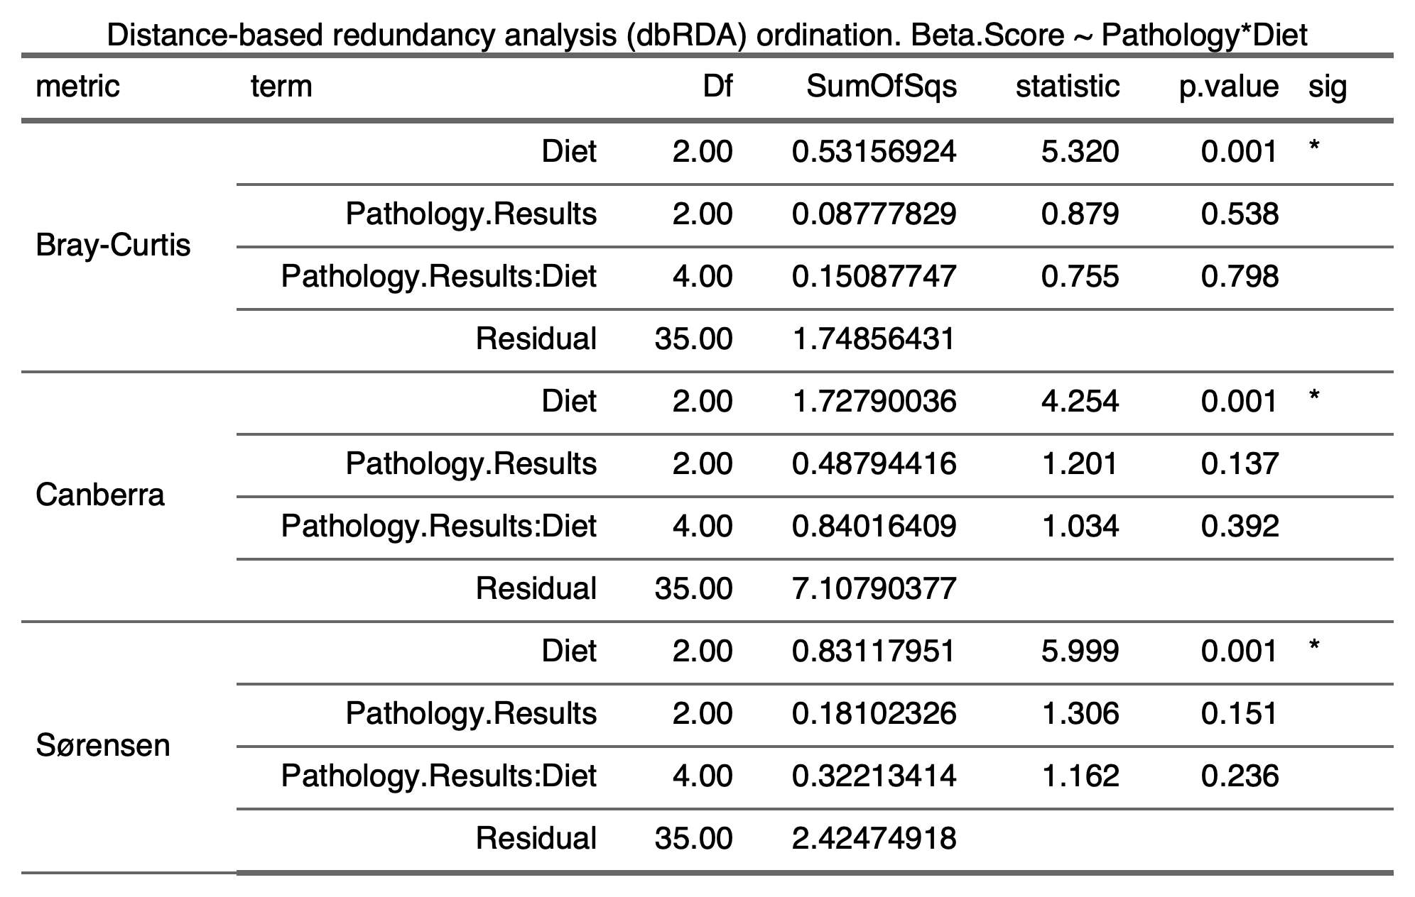

3.6) Physiology

3.6.1) 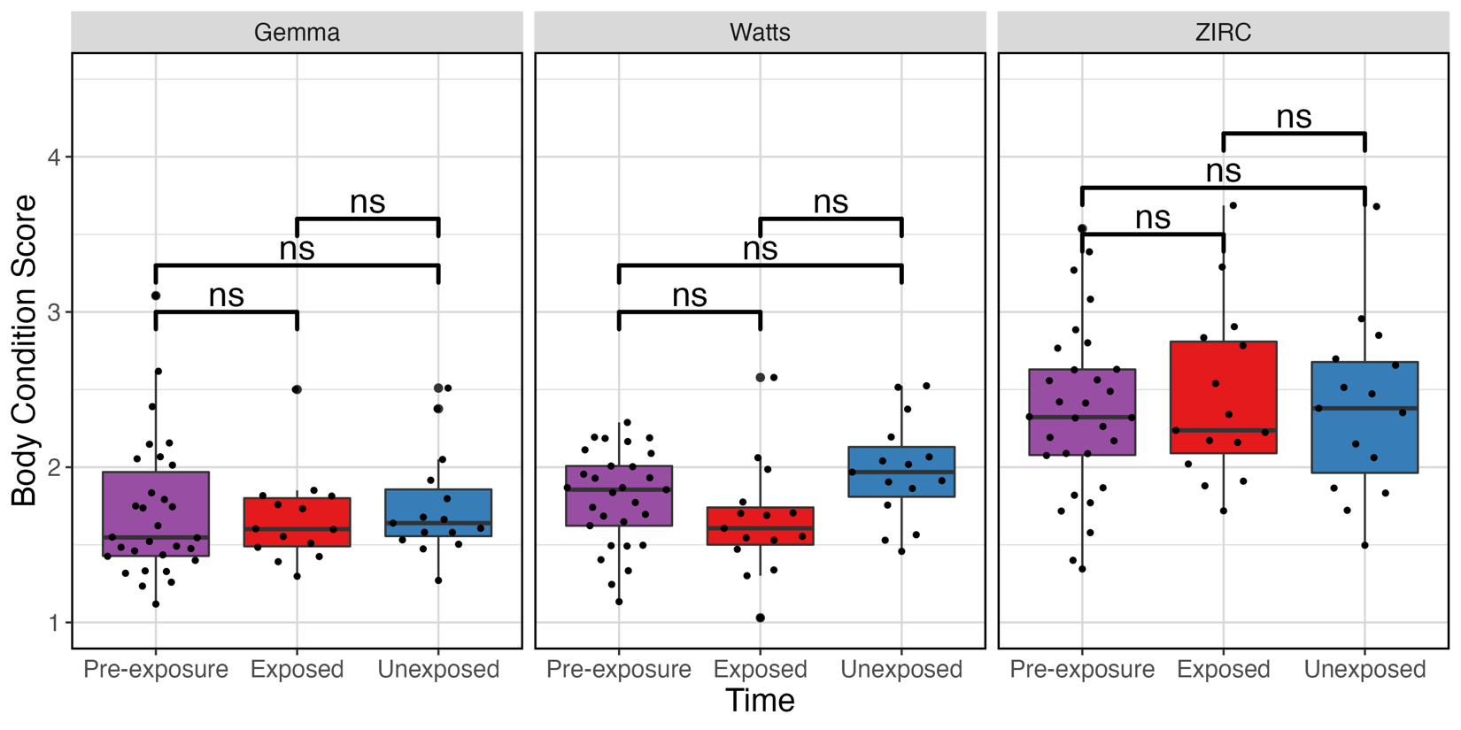

3.6.2) 